There’s a Santa Who Looks a Lot Like Elvis (A Parody by Bob Rivers)
There’s A Santa That Looks A Lot Like Elvis by Bob Rivers from “More Twisted Christmas”

Intro: Gm7 C7 F ( C7 ↓ )  F Bb F A7 Bb D7  There’s a Santa who looks a lot like Elvis, the King of Rock and Roll  Gm7 C7 F Dm  Take a look at the double chin, he's weighing about 310  C G7 C C7  With golden chains and sequined belt below.  F Bb F A7 Bb D7  There's a Santa who looks a lot like Elvis, down at the K-mart store  Gm7 Fº7 F D7 Gm7 C7 F  But the scariest sight to see, is that jolly VIP, in a pom – pa - dour.  Chorus  A7  A pair of blue suede boots and a beard with black roots,  Dm A7 Dm  And a face you knew way back when  G7  A drawl in his talk and a swaggering walk,  C7 G7 C7  And the hips that wiggled back then  C C7  My mom and dad can barely wait to see the King again.  F Bb F A7 Bb D7  He's a Santa who sounds a lot like Elvis, with every ho ho ho  Gm7 C7 F Dm  There's that faint peanut butter smell, when-ever he says "Noel"  C G7 C C7  Those lips are always twitching to and fro |  |  |  |  |  |  | 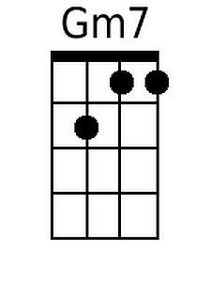 | 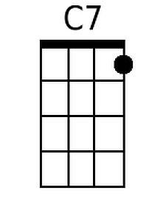
 |  |  |  |  |  |  | 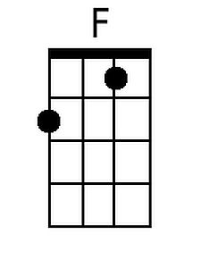 | 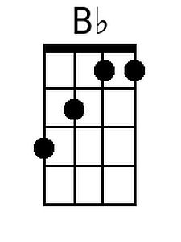
 |  |  |  |  |  |  | 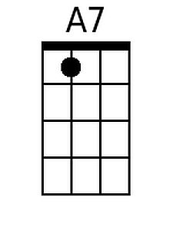 | 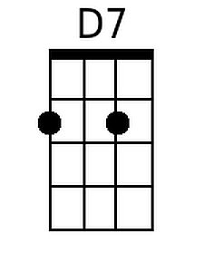
 |  |  |  |  |  |  | 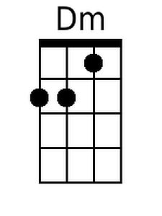 | 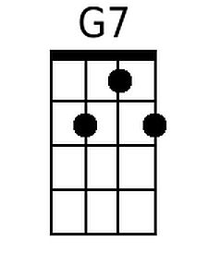
 |  |  |  |  |  |  | 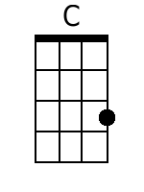 | 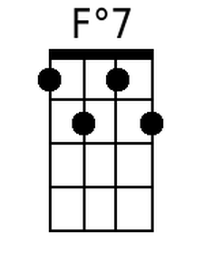
 |  |  |  |  |  |  | 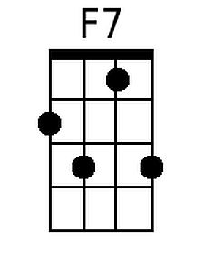
Baritone
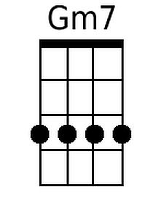 | 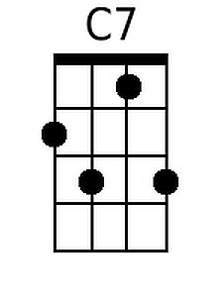 | 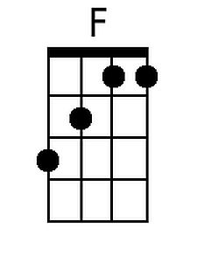 | 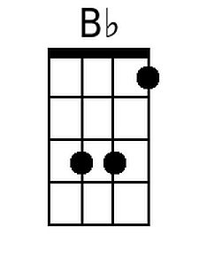 | 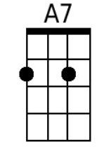 | 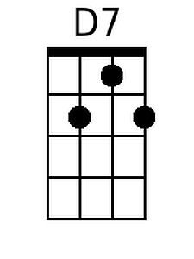
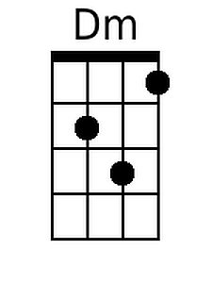 | 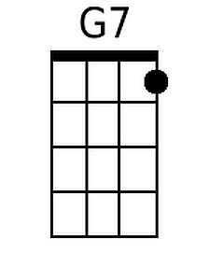 | 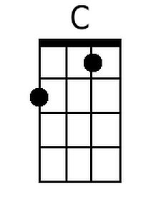 | 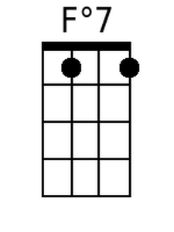 | 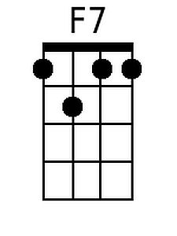

There’s A Santa Who Looks A Lot Like Elvis – Page 2

F Bb F A7 Bb D7
There's a Santa who looks a lot like Elvis, soon the band will start
Gm7 Fº7 F Dm
And the thing that would pleasure Bing, is a carol by the King
Gm7 C7 F
Right here in K - mart

[Interlude to the tune of “You Ain’t Nothin’ But a Hound Dog”]

F F7
You ain't nothin’ but a reindeer, flying all the time.
Bb F
You ain't nothin’ but a reindeer,flying all the time.
C7 Bb F C7
Well you ain't never brought a present, and you ain't no friend of mine.

(Hey, we're here every day from 2 to 4. If you want to feed the reindeer just leave ‘em a peanut butter and ‘nanner sandwich and they'll eat it later)

F Bb F
He's a Santa who looks a lot like Elvis, (Well, thank you very much. Thank you)
A7 Bb D7
Signs you can't ig-nore (Well, I have put on a few pounds)
Gm7 C7 Fº7 Dm
It's the wackiest thing to see, Buddy Holly's on his knee
(Boy, you're a skinny little feller, aren't you?)
Gm7 C7 A7 Gm7 C7 F
And I'm al - most sure, sure it's Elvis once more.

Ho- Ho- Ho, Ho- Ho- Ho Thank you, Thank you very much

