These Boots Were Made for Walkin’ (Lee Hazelwood) (A)
These Boots Were Made for Walking by Nancy Sinatra (In F)

(C-Tuning):  Intro on C (3rd) string: 9 9 8 8 7 7 6 6 5 5 4 4 3 3 2 0 A (4 measures)  (G-Tuning):  Intro on B (2nd) string: 10 10 9 9 8 8 7 7 6 6 5 5 4 4 3 1 A (4 measures)  A  You keep saying you've got something for me  A - A7  Something you call love but confess  D  You've been messin' where you shouldn't have been a mess in'  A  And now someone else is gettin' all your best  Chorus  C A  These boots are made for walkin’  C A  And that's just what they'll do  C A  One of these days these boots are gonna  Walk all over you. (Walkdown – 8 Measures)  A  You keep lying when you oughta be truthin'  - A7  And you keep losin' when you oughta not bet  D  You keep same-in' when you oughta be changing'  A  Now what's right is right but you ain't been right yet Chorus  A  You keep playin' where you shouldn't be playin'  A7  And you keep thinkin' that you'll never get burnt. Ha!  D  I just found me a brand new box of matches, yeah  A  And what he knows you ain't had time to learn. Chorus  Outro  Are ya ready boots? Start walking!  (8 Measures of A, progressively softer). | 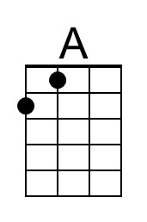 | 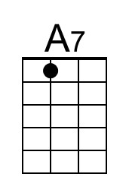
 | 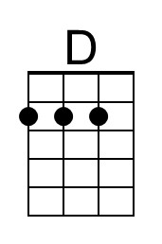 | 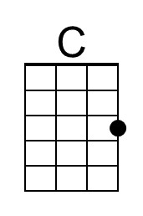
 | Bari
 | 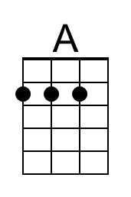 | 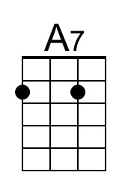
 | 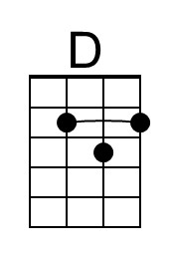 | 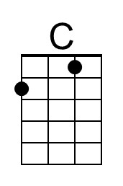

These Boots Were Made for Walkin’ (Lee Hazelwood) (D)
These Boots Were Made for Walking by Nancy Sinatra (In F)

Intro on E string 10 10 9 9 8 8 7 7 6 6 5 5 4 4 3 1 D (4 measures)  (E String for both C-Tuning (2nd) and G-Tuning (1st)  D  You keep saying you've got something for me  D - D7  Something you call love but confess  G  You've been messin' where you shouldn't have been a mess in'  D  And now someone else is gettin' all your best  Chorus  F D  These boots are made for walkin'  F D  And that's just what they'll do  F D  One of these days these boots are gonna  Walk all over you  D  You keep lying when you oughta be truthin'  - D7  And you keep losin' when you oughta not bet  G  You keep same-in' when you oughta be changing'  D  Now what's right is right but you ain't been right yet  Chorus  D  You keep playin' where you shouldn't be playin'  D7  And you keep thinkin' that you'll never get burnt. Ha!  G  I just found me a brand new box of matches, yeah  D  And what he knows you ain't had time to learn. Chorus  Outro  Are ya ready boots? Start walking!  (8 Measures of D, progressively softer). |  | 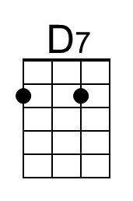
 | 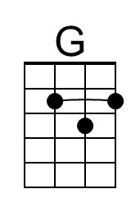 | 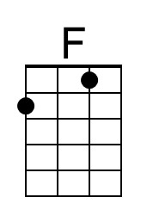
 | Bari
 |  | 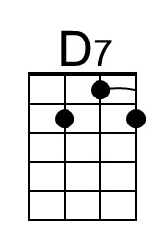
 | 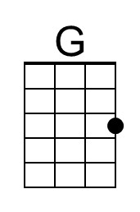 | 