This Boy (Ringo’s Theme) (John Lennon & Paul McCartney) (C)
This Boy by The Beatles (1963) (D)
4/4 – 110 BPM

Intro (three strums): C¹ Gsus4 C¹  | C² Am | Dm7 G7 | (2x)  C Am Dm7 G7 C - Am  That boy __ took my love a-way.  Dm7 G7 C - Am  Though he'll regret it some-day,  Dm7 G C Am | Dm7 G |  But this boy, wants you back a-gain.  C Am Dm7 G7 C - Am  That boy __ isn't good for you.  Dm7 G7 C - Am  Though he may want you, too,  Dm7 G C | C7  This boy, wants you back a-gain.  Bridge  F E  Oh, and this boy would be happy  Am C7  Just to love you, but oh my-y-y-y  F D  That boy won't be happy  G  'Til he's seen you cry-y-y.  C Am Dm7 G7 C - Am  This boy __ wouldn't mind the pain,  Dm7 G7 C - Am  Would always feel the same,  F G7 C Am | Dm7 G7 |  If this boy, gets you back a-gain.  C - Am | Dm G | C - Am | Dm G |  This boy. This boy.  C - Am | F G | C  This boy. | 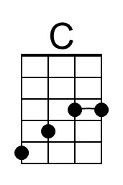 | 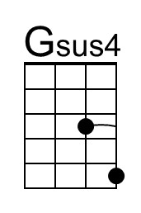 | 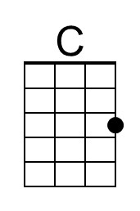
 | 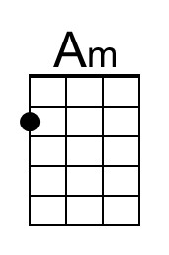 | 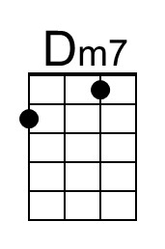 | 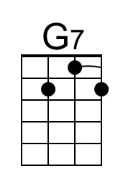
 | 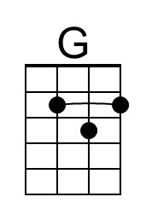 | 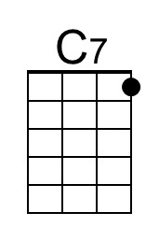 | 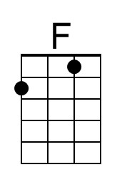
 | 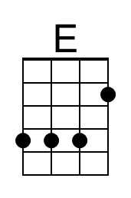 | 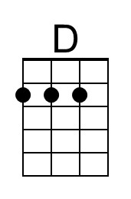
 | Bari
 | 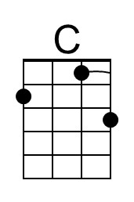 | 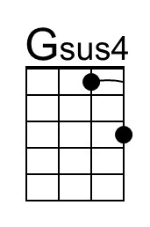 | 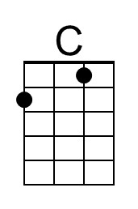
 | 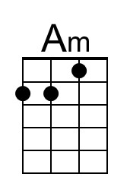 | 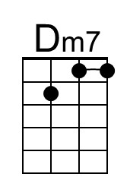 | 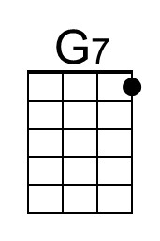
 | 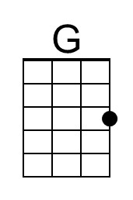 | 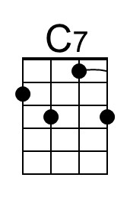 | 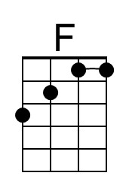
 | 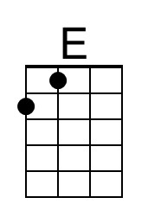 | 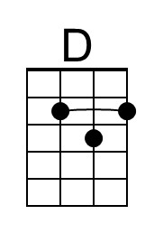

The 1st form of the C listed is only played in the Introduction; thereafter, use the 2nd form.
This Boy (Ringo’s Theme) (John Lennon & Paul McCartney) (D)
This Boy by The Beatles (1963) (D)
6/8 or 12/8 – 110 BPM

Intro (three strums): D¹ Asus4 D¹  | D² Bm | Em7 A7 | (2x)  D Bm Em7 A7 D - Bm  That boy __ took my love a-way.  Em7 A7 D - Bm  Though he'll regret it some-day,  Em7 A D Bm | Em7 A |  But this boy, wants you back a-gain.  D Bm Em7 A7 D - Bm  That boy __ isn't good for you.  Em7 A7 D - Bm  Though he may want you, too,  Em7 A D | D7  This boy, wants you back a-gain.  Bridge  G F#  Oh, and this boy would be happy  Bm D7  Just to love you, but oh my-y-y-y  G E  That boy won't be happy  A  'Til he's seen you cry-y-y.  D Bm Em7 A7 D - Bm  This boy __ wouldn't mind the pain,  Em7 A7 D - Bm  Would always feel the same,  G A7 D Bm | Em7 A7 |  If this boy, gets you back a-gain.  D - Bm | Em A | D - Bm | Em A |  This boy. This boy.  D - Bm | G A | D  This boy. | 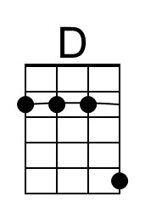 | 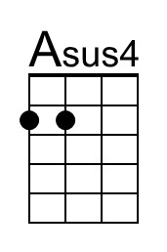
 | 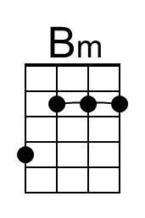 | 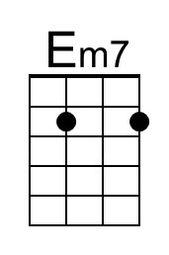 | 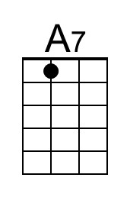
 | 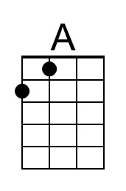 | 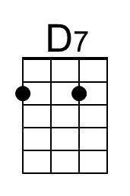
 | 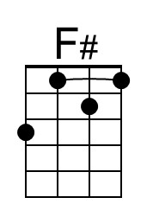
 | Bari
 | 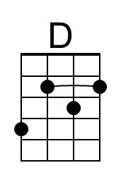 | 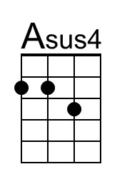
 | 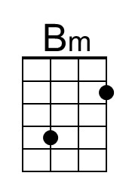 | 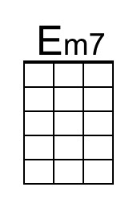 | 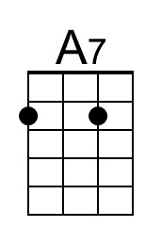
 | 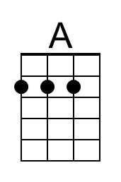 | 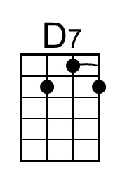
 | 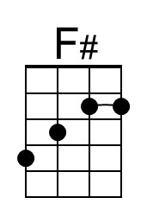

The 1st form of the D listed is only played in the Introduction; thereafter, use the 2nd form.
This Boy (Ringo’s Theme) (John Lennon & Paul McCartney) (G)
This Boy by The Beatles (1963) (D)
4/4 – 110 BPM

Intro (three strums): G¹ Dsus4 G¹  | G² Em | Am7 D7 | (2x)  G Em Am7 D7 G - Em  That boy __ took my love a-way.  Am7 D7 G - Em  Though he'll regret it some-day,  Am7 D G Em | Am7 D |  But this boy, wants you back a-gain.  G Em Am7 D7 G - Em  That boy __ isn't good for you.  Am7 D7 G - Em  Though he may want you, too,  Am7 D G | G7  This boy, wants you back a-gain.  Bridge  C B  Oh, and this boy would be happy  Em G7  Just to love you, but oh my-y-y-y  C A  That boy won't be happy  D  'Til he's seen you cry-y-y.  G Em Am7 D7 G - Em  This boy __ wouldn't mind the pain,  Am7 D7 G - Em  Would always feel the same,  C D7 G Em | Am7 D7 |  If this boy, gets you back a-gain.  G - Em | Am D | G - Em | Am D |  This boy. This boy.  G - Em | C D | G  This boy. | 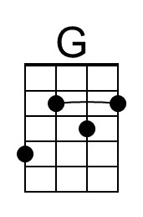 | 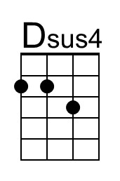
 | 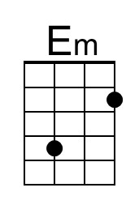 | 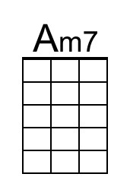
 | 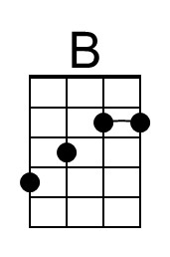
 | Bari
 | 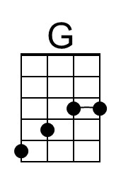 | 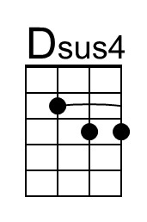
 | 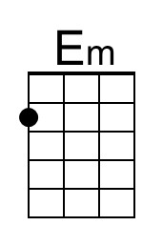 | 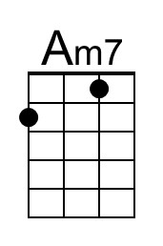
 | 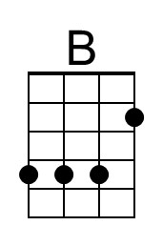

The 1st form of the G listed is only played in the Introduction; thereafter, use the 2nd form.

