**This Boy (Ringo’s Theme) (John Lennon / Paul McCartney)**

**C Am F G (2x)**



C

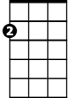

Am

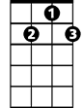

G7

F



**C Am F G7 C Am**

That boy took my love away.

**F G7 C Am**

Though he'll regret it someday,

E7

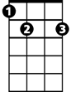

**F G C Am F G**

Em7

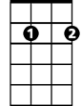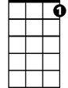

C7

This boy wants you back again.

**C Am F G7 C Am**

That boy isn't good for you.

**F G7 C Am**

Though he may want you, too,

**F G C Am C7**

This boy, wants you back again.

**BARITONE**

C

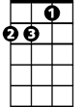

Am



F



G7

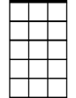

Em7

**C7 F E7**

Oh, and this boy would be happy

**Am G7**

Just to love you, but oh my-y-y-y

**F E7**

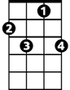

C7

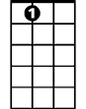

E7

That boy won't be happy

**G7 Em7**

'Til he's seen you cry-y-y-oh

**C Am F G7 C Am**

This boy wouldn't mind the pain,

**F G7 C Am**

Would always feel the same,

**F G C Am F G**

'Til this boy, gets you back again.

**C Am F G**

This boy

**C Am F G**

This boy

**C Am F G C**

This boy