This Magic Moment (Jerome ‘Doc’ Pomus & Mort Shuman, 1959) (C)
This Magic Moment by The Drifters (1960) (C) 136 BPM
This Magic Moment by Jay and The Americans (1968) (C) 123 BPM

Intro C | C | Am | Am | F | F | G | G  Tacet C Am  This magic moment, so different and so new,  F G  Was like any other until I kissed you.  Tacet C Am  And then it happened, it took me by surprise;  F G  I knew that you felt it too, by the look in your eyes.  Bridge  Tacet Am  Sweeter than wine (sweeter than wine)  F  Softer than a summer night (softer than a summer night)  C  Everything I wanna have (everything, everything)  G | G  Whenever I hold you tight.  Tacet C  This magic moment (this magic moment)  Am  while your lips are close to mine  F  Will last for-ever, (this magic moment)  G C  for-ever 'till the end of time. (magic)  Am F  Oh-oh-oh-oh-oh (magic). Oh-oh-oh-oh-oh. (magic)  G  Oh-oh-oh-oh-oh (moment)  Repeat from Bridge.  Outro  C Am  Oh-oh-oh-oh-oh (magic). Oh-oh-oh-oh-oh. (magic)  F G | Am | F | G | C  Oh-oh-oh-oh-oh (magic). Oh-oh-oh-oh-oh. (moment) | 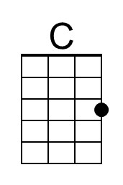
 | 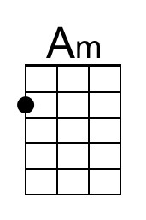
 | 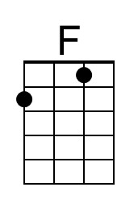
 | 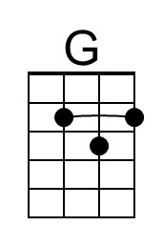
 | Bari
 | 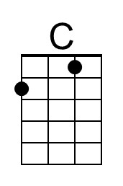
 | 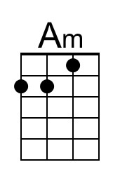
 | 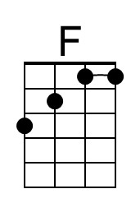
 | 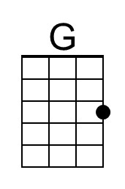

This Magic Moment (Jerome ‘Doc’ Pomus & Mort Shuman, 1959) (G)
This Magic Moment by The Drifters (1960) (C) 136 BPM
This Magic Moment by Jay and The Americans (1968) (C) 123 BPM

Intro G | G | Em | Em | C | C | D | D

Tacet G Em
This magic moment, so different and so new,
C D
Was like any other until I kissed you.
Tacet G Em
And then it happened, it took me by surprise;
C D
I knew that you felt it too, by the look in your eyes.

Bridge
Tacet Em
Sweeter than wine (sweeter than wine)
C
Softer than a summer night (softer than a summer night)
G
Everything I wanna have (everything, everything)
D | D
Whenever I hold you tight.

Tacet G
This magic moment (this magic moment)
Em
while your lips are close to mine
C
Will last for-ever, (this magic moment)
D G
for-ever 'till the end of time.
Em C
Oh-oh-oh-oh-oh (magic). Oh-oh-oh-oh-oh. (magic)
D
Oh-oh-oh-oh-oh (moment)

Repeat from Bridge.

Outro
G Em
Oh-oh-oh-oh-oh (magic). Oh-oh-oh-oh-oh. (magic)
D G Em | C | D | G
Oh-oh-oh-oh-oh (magic). Oh-oh-oh-oh-oh. (moment)
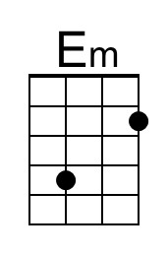
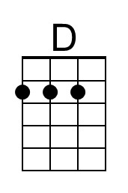
Bari
