**This Masquerade (Leon Russell) Key Am**

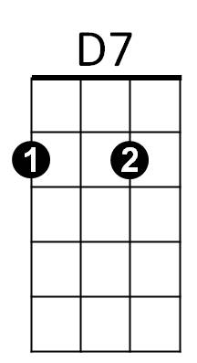**Intro: Am – D7 - F7 - E7 - Am**

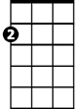

Am

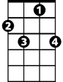

F7

E7

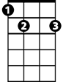

**Am D7**

Are we really happy with this lonely game we play?

**Am F7 E7**

Looking for words to say?

**Am D7**

Searching but not finding understanding any way,

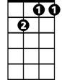

Gm7

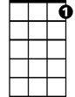

C7

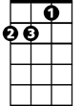

Dm

**F7 E7 Am**

We're lost in this masquerade

**Bridge:**

**Gm7 C7 Fmaj7 Dm**

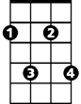

F#m7

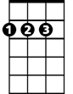

D

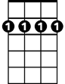

Bm7

Both afraid to say we're just too far away**,**

**Gm7 C7 Fmaj7**

From being close together from the start

**F#m7 B7 E7**

We tried to talk it over, but the words got in the way,

**D B7 E7 Bm7 E7**

We're lost inside this lonely game we play.

**Am D7**

Thoughts of leaving disappear every time I see your eyes,

**Am F7**  **E7**

**BARITONE**

No matter how hard I try

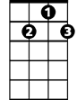

D7



Am

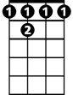

F 7

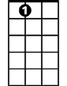

E7

**Am D7**

To understand the reason that we carry on this way,

**F7 E7 Am**

We're lost in this masquerade

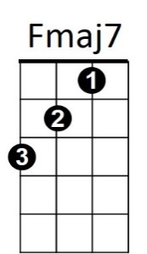**Bridge)**

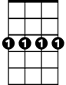

Gm7



C7

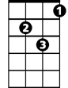

Dm

**Am**

Thoughts of leaving disappear

**D7**

Every time I see your face,

**Am F7 E7**

No matter how hard I try



D

B7



Bm7

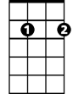

F#m7

**Am D7**

We can just start over but it’s oh so hard to do

**F7 E7 Am**

When you’re lost in a masquerade

**F7 E7 Am**

When you’re lost in a masquerade

**This Masquerade (Leon Russell) Key Dm**



Dm

**Intro: Dm – G7 - Bb7 - A7 - Dm**



A7



Bb7



G7

**Dm G7**

Are we really happy with this lonely game we play?

**Dm Bb7 A7**

Looking for words to say?

**Dm G7**

Searching but not finding understanding any way,



Cm7



Gm



F7

**Bb7 A7 Dm**

We're lost in this masquerade

**Bridge:**

**Cm7 F7 Bbmaj7 Gm**



G

E7



Both afraid to say we're just too far away**,**

Em7



Bm7

**Cm7 F7 Bbmaj7**

From being close together from the start

**Bm7 E7 A7**

We tried to talk it over, but the words got in the way,

**G E7 A7 Em7 A7**

We're lost inside this lonely game we play.

**Dm G7**

Thoughts of leaving disappear every time I see your eyes,

**Dm Bb7**  **A7**

No matter how hard I try

**BARITONE**

**Dm G7**

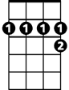

A7

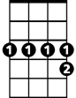

Bb7



G7



Dm

To understand the reason that we carry on this way,

**Bb7 A7 Dm**

We're lost in this masquerade

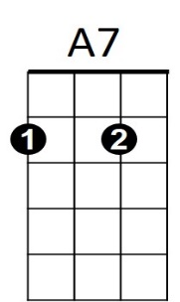

**(Bridge)**



F7

**Dm**

Cm7

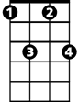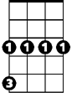

Gm

Thoughts of leaving disappear

**G7**

Every time I see your face,

**Dm Bb7 A7**

No matter how hard I try

**Dm G7**

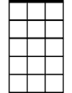

Em7

Bm7



G



E7

We can just start over but it’s oh so hard to do

**Bb7 A7 Dm**

When you’re lost in a masquerade

**Bb7 A7 Dm**

When you’re lost in a masquerade