
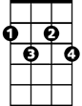
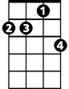


Those Lazy, Hazy, Crazy Days Of Summer (Hans Carste, Charles Tobias, 1962-3)
C
Cdim
Dm7
E7
G7
First Chorus
C↓ Cdim↓ G7↓ C D7
Roll out those lazy, hazy, crazy days of summer,
G7 Dm7 C
Those days of soda and pretzels and beer
C↓ Cdim↓ G7↓ C D7

Roll out those lazy, hazy, crazy days of summer,
G7 Dm7 G7 C
Dust off the sun and moon and sing a song of cheer.

E7
Just fill your basket full of sandwiches and weenies
Am

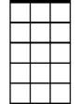
Then lock the house up, now you're set.
Am
Am7
D7 Am7 D7
And on the beach you'll see the girls in their bi-kinis,
G7
As cute as ever but they never get them wet.

Second Chorus
C↓ Cdim↓ G7↓ C D7
BARITONE



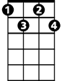

Roll out those lazy, hazy, crazy days of summer,
G7
Am7
Am
C
Cdim
D7
E7
G7 Dm7 C
Those days of soda and pretzels and beer
C↓ Cdim↓ G7↓ C D7
Roll out those lazy, hazy, crazy days of summer,
G7 Dm7 C
You'll wish that summer could al-ways be here.
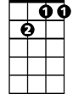
Dm7
E7
Don't have to tell a girl and feller 'bout a drive-in
Am
Or some romantic movie scene
D7 Am7 D7
Why from the moment that those lovers start ar-rivin'
G7
You'll see more kissing in the cars than on the screen. Second Chorus then First Chorus

E7
And there's the good old fashioned picnic,
Am
And they still go, always will go any time
D7 Am7 D7
And there will always be a moment that can thrill so
G7
As when the old quartet sings out "Sweet Ade-line" Second Chorus

Outro (Retard)
G7 C
You'll wish that summer could always be here.
Those Lazy, Hazy, Crazy Days Of Summer (Hans Carste, Charles Tobias, 1962-3)

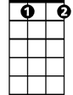
First Chorus
G
Gdim
G↓ Gdim↓ D7↓ G A7
Roll out those lazy, hazy, crazy days of summer,
D7 Am7 G
Those days of soda and pretzels and beer.
G↓ Gdim↓ D7↓ G A7
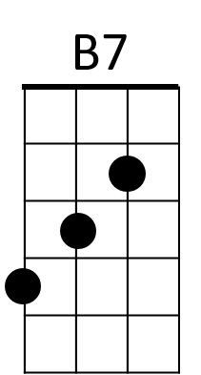
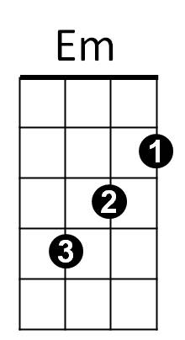
Roll out those lazy, hazy, crazy days of summer,
D7 Am7 D7 G
A7
Dust off the sun and moon and sing a song of cheer.

B7
Just fill your basket full of sandwiches and weenies
Em
Then lock the house up, now you're set
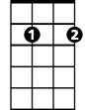
A7 Em7 A7
Am7
Em7
And on the beach you'll see the girls in their bi-kinis,
D7
As cute as ever but they never get them wet.

Second Chorus
G↓ Gdim↓ D7↓ G A7
Roll out those lazy, hazy, crazy days of summer,
D7 Am7 G
Those days of soda and pretzels and beer.
G↓ Gdim↓ D7↓ G A7
Roll out those lazy, hazy, crazy days of summer,
D7 Am7 G
You'll wish that summer could al-ways be here.
BARITONE
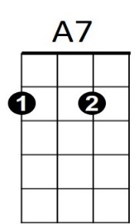
G
Gdim
D7
B7
Em
Am7
B7
Em7
Don't have to tell a girl and feller 'bout a drive-in
Em
Or some romantic movie scene
A7 Em7 A7
Why from the moment that those lovers start ar-rivin'
D7
You'll see more kissing in the cars than on the screen. Second Chorus then First Chorus

B7
And there's the good old fashioned picnic,
Em
And they still go, always will go any time
A7 Em7 A7
And there will always be a moment that can thrill so,
D7
As when the old quartet sings out "Sweet Ade-line". Second Chorus

Outro (Retard)
D7 G
You'll wish that summer could always be here.

