**Those Were the Days (All in the Family) (Lee Adams / Charles Strouse)**

**F**

Boy, the way Glen Miller played.

**Dm F**

Songs that made the Hit Parade.

**Dm A7 G7**

Guys like us, we had it made.

**C7 F F7**

Those were the days

**F**

Didn't need no welfare state.

**Dm F**

Everybody pulled his weight

**Dm A7 G7**

Gee, our old LaSalle ran great.

**C7 F F7**

Those were the days

**Bb**

And you knew where you were then

**G7 C7 F**

Girls were girls and men were men.

**Dm**

Mist er, we could use a man like

**F G7 C C7**

Herbert Hoover again.

**F**

People seemed to be content.

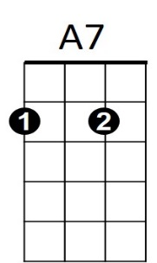 **Dm F**



F

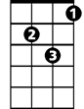

Dm

**BARITONE**

Fifty dollars paid the rent.

**Dm A7 G7**

Freaks were in a circus tent.

**C7 F F7**

Those were the days

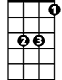

Bb

C

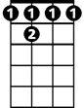

F7

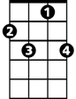

C7

**Bb**

Take a little Sunday spin,

**G7 C7 F**

Go to watch the Dodgers win.

**Dm**

Have yourself a dandy day

**F G7 C C7**

That cost you under a fin.

**F**

Hair was short and skirts were long.

**Dm F**

Kate Smith really sold a song.

**Dm A7 G7**

I don't know just what went wrong

**C7 F**

Those were the days



C

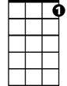

C7



F7



Bb

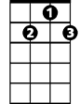

G7

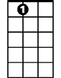

A7

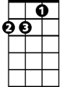

Dm

F



G7