Ticket To Ride (A)
(John Lennon and Paul McCartney, 1965)
Ticket To Ride by The Beatles (from "Help")
Ticket To Ride by The Beatles (Live at Wembley, London, 1965)

Introduction (4 measures): | A Asus2 | (4x)

A Asus2 A Asus2 A - Asus2 | A Asus2
1. I think I'm gonna be sad, I think it's to-day, yeah
A Asus2 A Asus2 Bm – E
The girl that's driving me mad is going a-way

Chorus 1
F#m G6 – D7 (G6)
She's got a ticket to ride
F#m G6 – Gmaj7
She's got a ticket to ride
F#m E
She's got a ticket to ride
A Asus2 | A Asus2 |
But she don't care

A Asus2 A Asus2 A - Asus2 | A Asus2 |
2. She said that living with me is bringing her down yeah
A Asus2 A Asus2 Bm – E
For she would never be free when I was a-round. Chorus

Chorus 2
F#m G6 – D7 (G6)
She's got a ticket to ride
F#m G6 – Gmaj7
She's got a ticket to ride
F#m E
She's got a ticket to ride
A A7 | A A7sus2 |
But she don't care

Bridge
D D7 D D7
I don't know why she's ridin' so high
D E E7
She ought to think right, she ought to do right by me
D D7 D D7
Be-fore she gets to saying good-bye
D E E5
She ought to think right, she ought to do right by me

A Asus2 A Asus2 A - Asus2 | A Asus2
3. I think I'm gonna be sad, I think it's to-day, yeah
A Asus2 A Asus2 Bm – E
The girl that's driving me mad is going a-way

Ticket To Ride (A) – Page 2

Chorus 1
F#m G6 – D7 (G6)
She's got a ticket to ride
F#m G6 – Gmaj7
She's got a ticket to ride
F#m E
She's got a ticket to ride
A Asus2 | A Asus2 |
But she don't care

Bridge
D D7 D D7
I don't know why she's ridin' so high
D E E7
She ought to think right, she ought to do right by me
D D7 D D7
Be-fore she gets to saying good-bye
D E E5
She ought to think right, she ought to do right by me

A Asus2 A Asus2 A - Asus2 | A Asus2 |
4. She said that living with me is bringing her down yeah
A Asus2 A Asus2 Bm – E
For she would never be free when I was a-round. Chorus

Chorus 2
F#m G6 – D7 (G6)
She's got a ticket to ride
F#m G6 – Gmaj7
She's got a ticket to ride
F#m E
She's got a ticket to ride
A A7 | A A7sus2 |
But she don't care

Outro.
NC A Asus2 A Asus2 A Asus2
My baby don't care. _ My baby don't care.
A Asus2 A Asus2 A Asus2 A Asus2 A
_ My baby don't care. _ My baby don't care.

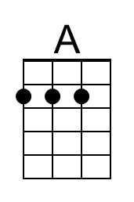 | 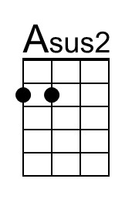 | 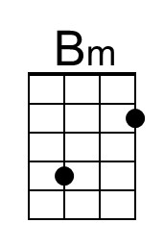 | 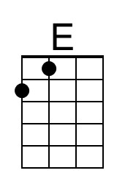 | 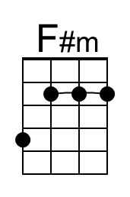 | 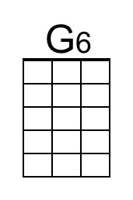 | 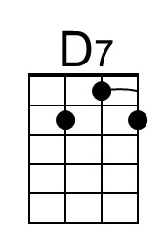 | 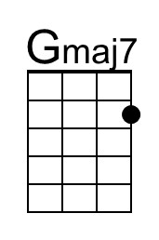
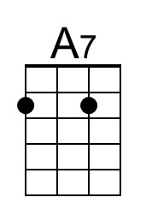 | 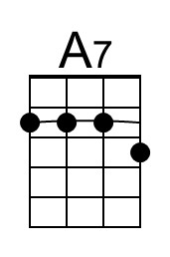 | 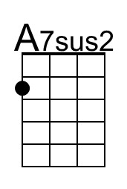 | 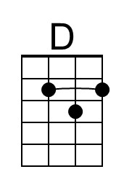 | 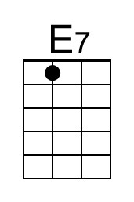 | E5  (I just play the major chord, above)

