Ticket To Ride (A)
(John Lennon and Paul McCartney, 1965) – C Tuning Chords
Ticket To Ride by The Beatles (from "Help")
Ticket To Ride by The Beatles (Live at Wembley, London, 1965)
4/4 Time – Tempo = 125 bpm
Introduction (4 measures): | A Asus2 | (4x)  A Asus2 A Asus2 A - Asus2 | A Asus2  1. I think I'm gonna be sad, I think it's to-day, yeah  A Asus2 A Asus2 Bm | E  The girl that's driving me mad is going a-way  Chorus 1  F#m G6 – D7  She's got a ticket to ride  F#m G6 – Gmaj7  She's got a ticket to ride  F#m E  She's got a ticket to ride  A Asus2 | A Asus2 |  But she don't care  A Asus2 A Asus2 A - Asus2 | A Asus2 |  2. She said that living with me is bringing her down yeah  A Asus2 A Asus2 Bm | E  For she would never be free when I was a-round. Chorus  Chorus 2  F#m G6 – D7 (G6)  She's got a ticket to ride  F#m G6 – Gmaj7  She's got a ticket to ride  F#m E  She's got a ticket to ride  A A7 | A A7sus2 |  But she don't care  Bridge  D D7 D D7  I don't know why she's ridin' so high  D7 E E7  She ought to think right, she ought to do right by me  D D7 D D7  Be-fore she gets to saying good-bye  D D7 E | E5  She ought to think right, she ought to do right by me | 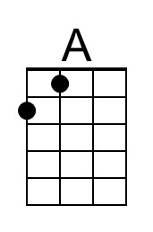 | 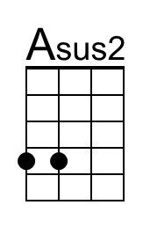
 | 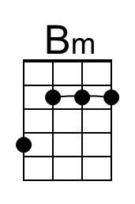 | 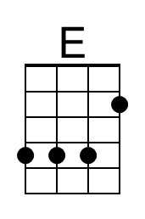
 | 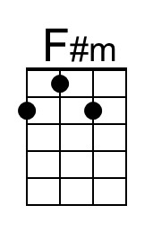 | 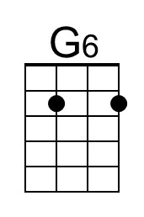
 | 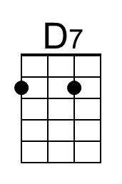 | 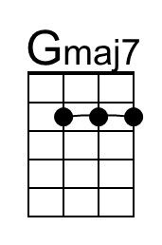
 | 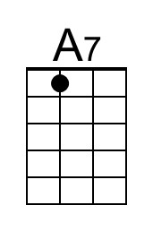 | 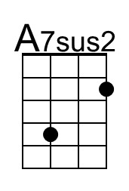
 | 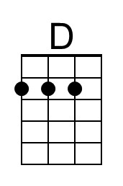 | 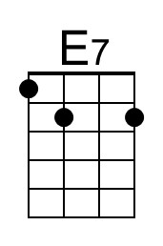

Ticket To Ride (A) – Page 2

A Asus2 A Asus2 A - Asus2 | A Asus2
3. I think I'm gonna be sad, I think it's to-day, yeah
A Asus2 A Asus2 Bm | E
The girl that's driving me mad is going a-way

Chorus 1
F#m G6 – D7
She's got a ticket to ride
F#m G6 – Gmaj7
She's got a ticket to ride
F#m E
She's got a ticket to ride
A Asus2 | A Asus2 |
But she don't care

Bridge
D D7 D D7
I don't know why she's ridin' so high
D7 E E7
She ought to think right, she ought to do right by me
D D7 D D7
Be-fore she gets to saying good-bye
D D7 E | E5
She ought to think right, she ought to do right by me

A Asus2 A Asus2 A - Asus2 | A Asus2 |
4. She said that living with me is bringing her down yeah
A Asus2 A Asus2 Bm | E
For she would never be free when I was a-round. Chorus

Chorus 2
F#m G6 – D7 (G6)
She's got a ticket to ride
F#m G6 – Gmaj7
She's got a ticket to ride
F#m E
She's got a ticket to ride
A Asus2 |
But she don't care

Outro.
NC A Asus2 A Asus2 A Asus2
My baby don't care. _ My baby don't care.
A Asus2 A Asus2 A Asus2 A Asus2 A
_ My baby don't care. _ My baby don't care.

Ticket To Ride (A)
(John Lennon and Paul McCartney, 1965) – G Tuning Chords
Ticket To Ride by The Beatles (from "Help")
Ticket To Ride by The Beatles (Live at Wembley, London, 1965)
4/4 Time – Tempo = 125 bpm
Introduction (4 measures): | A Asus2 | (4x)  A Asus2 A Asus2 A - Asus2 | A Asus2  1. I think I'm gonna be sad, I think it's to-day, yeah  A Asus2 A Asus2 Bm | E  The girl that's driving me mad is going a-way  Chorus 1  F#m G6 – D7  She's got a ticket to ride  F#m G6 – Gmaj7  She's got a ticket to ride  F#m E  She's got a ticket to ride  A Asus2 | A Asus2 |  But she don't care  A Asus2 A Asus2 A - Asus2 | A Asus2 |  2. She said that living with me is bringing her down yeah  A Asus2 A Asus2 Bm | E  For she would never be free when I was a-round. Chorus  Chorus 2  F#m G6 – D7 (G6)  She's got a ticket to ride  F#m G6 – Gmaj7  She's got a ticket to ride  F#m E  She's got a ticket to ride  A A7 | A A7sus2 |  But she don't care  Bridge  D D7 D D7  I don't know why she's ridin' so high  D7 E E7  She ought to think right, she ought to do right by me  D D7 D D7  Be-fore she gets to saying good-bye  D D7 E | E5  She ought to think right, she ought to do right by me | 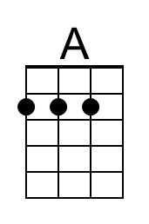 | 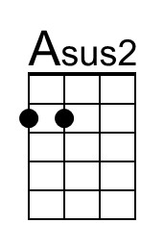
 | 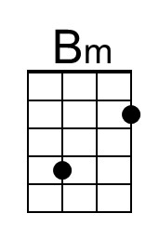 | 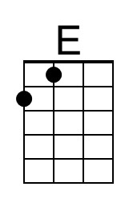
 | 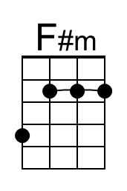 | 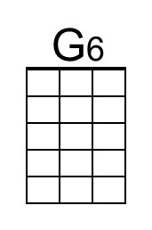
 | 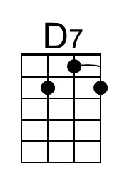 | 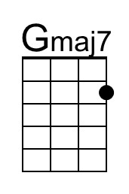
 | 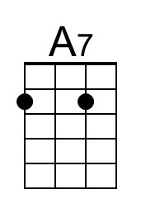 | 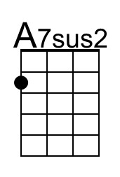
 | 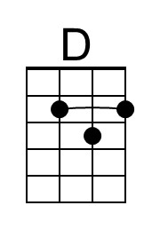 | 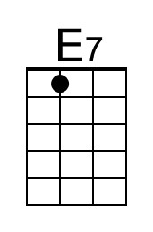

Ticket To Ride (A) – Page 2

A Asus2 A Asus2 A - Asus2 | A Asus2
3. I think I'm gonna be sad, I think it's to-day, yeah
A Asus2 A Asus2 Bm | E
The girl that's driving me mad is going a-way

Chorus 1
F#m G6 – D7
She's got a ticket to ride
F#m G6 – Gmaj7
She's got a ticket to ride
F#m E
She's got a ticket to ride
A Asus2 | A Asus2 |
But she don't care

Bridge
D D7 D D7
I don't know why she's ridin' so high
D7 E E7
She ought to think right, she ought to do right by me
D D7 D D7
Be-fore she gets to saying good-bye
D D7 E | E5
She ought to think right, she ought to do right by me

A Asus2 A Asus2 A - Asus2 | A Asus2 |
4. She said that living with me is bringing her down yeah
A Asus2 A Asus2 Bm | E
For she would never be free when I was a-round. Chorus

Chorus 2
F#m G6 – D7 (G6)
She's got a ticket to ride
F#m G6 – Gmaj7
She's got a ticket to ride
F#m E
She's got a ticket to ride
A Asus2 |
But she don't care

Outro.
NC A Asus2 A Asus2 A Asus2
My baby don't care. _ My baby don't care.
A Asus2 A Asus2 A Asus2 A Asus2 A
_ My baby don't care. _ My baby don't care.

