Ticket To Ride (Lennon-McCartney, 1965)
The Beatles: Ticket To Ride (From “Help,” Remastered)
The Beatles: Ticket To Ride (Live at Wembley, 1965)

Introduction (4 Measures): C

Riff x 4
A-------11—8-----------11-
E—9------------9—11-------
C-------------------------
G-------------------------

C  1. I think I'm gonna be sad, I think it's today, yeah  C7 Dm G7  The girl that's driving me mad, is going a-way  Am F Am A#  She's got a ticket to ride, she's got a ticket to ride  Am G7 C Riff  She's got a ticket to ride, but she don't care  C  2. She said that living with me, was bringing her down yeah  C7 Dm G7  For she would never be free, when I was a-round  Am F Am A#  She's got a ticket to ride, she's got a ticket to ride  Am G7 C Riff  She's got a ticket to ride, but she don't care  Chorus  F  I don't know why she's ridin' so high  G7  She ought to think twice She ought to do right by me  F  Be-fore she gets to saying goodbye  G7  She ought to think twice, she ought to do right by me  Repeat Verse 1. Chorus. Repeat Verse 2. Outro:  C C C  My baby don't care ,My baby don't care, My baby don't care  Bari |  |  |  |  |  | 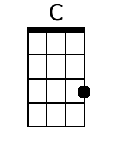
 |  |  |  |  |  | 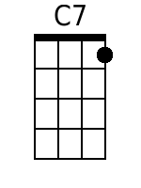
 |  |  |  |  |  | 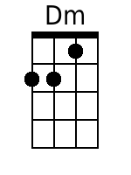
 |  |  |  |  |  | 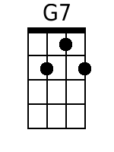
 |  |  |  |  |  | 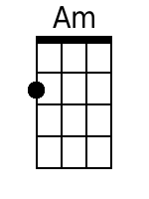
 |  |  |  |  |  | 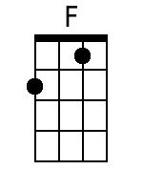
 |  |  |  |  |  | 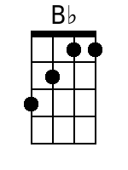
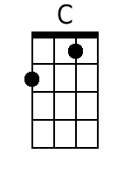 | 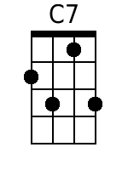 | 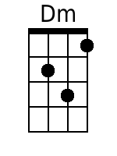 | 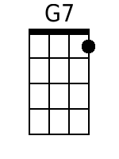 | 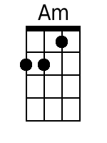 | 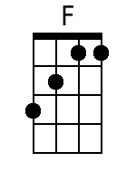 | 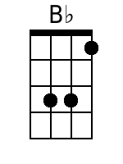

Ticket To Ride (Lennon-McCartney, 1965)
The Beatles: Ticket To Ride (From “Help,” Remastered)
The Beatles: Ticket To Ride (Live at Wembley, 1965)

Introduction (4 Measures): G

Riff x 4
A-------5—2-------------5-
E—3------------3—5--------
C-------------------------
G-------------------------

G  1. I think I'm gonna be sad, I think it's today, yeah  G7 Am D7  The girl that's driving me mad, is going a-way  Em C Em F  She's got a ticket to ride, she's got a ticket to ride  Em D7 G Riff  She's got a ticket to ride, but she don't care  G  2. She said that living with me, was bringing her down yeah  G7 Am D7  For she would never be free, when I was a-round  Em C Em F  She's got a ticket to ride, she's got a ticket to ride  Em D7 G Riff  She's got a ticket to ride, but she don't care  Chorus  C  I don't know why she's ridin' so high  D7  She ought to think twice, she ought to do right by me  C  Before she gets to saying goodbye  D7  She ought to think twice, she ought to do right by me  Repeat Verse 1. Chorus. Repeat Verse 2. Outro:  G G G  My baby don't care ,My baby don't care, My baby don't care.  Bari |  |  |  |  |  | 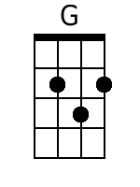
 |  |  |  |  |  | 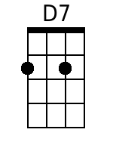
 |  |  |  |  |  | 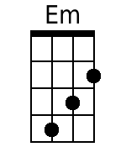
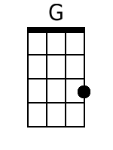 |  |  | 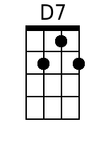 | 