**Ticket To Ride Intro Tabs (C)**

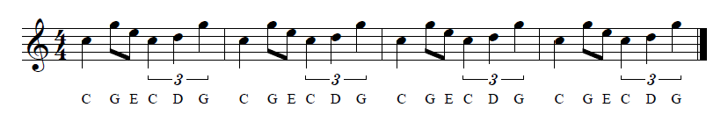

Sequenced in “[Noteworthy Composer](https://noteworthycomposer.com/),” music notation software

**C-Tuning**

| C G E C D G | C G E C D G | C G E C D G | C G E C D G |

A |-------------|-------------|-------------|-------------|

E |---3-0-----3-|---3-0-----3-|---3-0-----3-|---3-0-----3-|

C |-0-----0-2---|-0-----0-2---|-0-----0-2---|-0-----0-2---|

G |-------------|-------------|-------------|-------------|

0 0 3 0

0 2 3 0

**G-Tuning**

| C G E C D G | C G E C D G | C G E C D G | C G E C D G |

E |---3-0-----3-|---3-0-----3-|---3-0-----3-|---3-0-----3-|

B |-1-----1-3---|-1-----1-3---|-1-----1-3---|-1-----1-3---|

G |-------------|-------------|-------------|-------------|

D |-------------|-------------|-------------|-------------|

0 0 1 3

0 0 3 3

**C-Tuning**

| C G E C D G | C G E C D G |

A |-------------|-------------|

E |---3-0-----3-|---3-0-----3-|

C |-0-----0-2---|-0-----0-2---|

G |-------------|-------------|

0 0 3 0

0 2 3 0

**G-Tuning**

| C G E C D G | C G E C D G |

E |---3-0-----3-|---3-0-----3-|

B |-1-----1-3---|-1-----1-3---|

G |-------------|-------------|

D |-------------|-------------|

0 0 1 3

0 0 3 3

**Ticket To Ride Intro Tabs (G)**

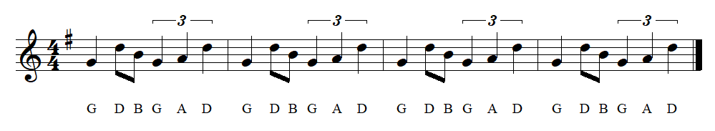

Sequenced in “[Noteworthy Composer](https://noteworthycomposer.com/),”   
music notation software that   
I’ve used for some years.

**C-Tuning**

| G D B G A D | G D B G A D | G D B G A D | G D B G A D |

A |-------------|-------------|-------------|-------------|

E |-------------|-------------|-------------|-------------|

C |---2-------2-|---2-------2-|---2-------2-|---2-------2-|

G |-0---4-0-2---|-0---4-0-2---|-0---4-0-2---|-0---4-0-2---|

**G-Tuning**

| G D B G A D | G D B G A D | G D B G A D | G D B G A D |

E |-------------|-------------|-------------|-------------|

B |-------------|-------------|-------------|-------------|

G |-------------|-------------|-------------|-------------|

D |-------------|-------------|-------------|-------------|