
Ticket to Ride (John Lennon & Paul McCartney, 1965) (C)
Ticket To Ride by The Beatles
Tempo = 125 bpm
Intro | C Csus2 | (4x)  C C - Csus2 C  I think I'm gonna be sad, I think it's to-day, yeah  C7 Dm | G  The girl that's driving me mad is going away.  Chorus  Am F Am Bbmaj7  She's got a ticket to ride she's got a ticket to ri-i-de  Am Gm C  She's got a ticket to ride, and she don't care.  C C - Csus2 | C  She says that living with me is bringing her down, yeah  C7 Dm | G  But she will never be free when I was a-round. Chorus  Bridge  F  I don't know why she's riding so high  G  She ought to think twice, she ought to do right by me  F  Before she gets to saying goodbye  G | G  She ought to think twice, she ought to do right by me  Repeat First Verse. Chorus. Bridge.  Repeat Second Verse. Chorus  Outro  TACET C Csus2  My baby don’t care.  C Csus2 C Csus2  __ My baby don’t care. (3x) End on C  Intro - C-Tuning  | C G E C D G | C G E C D G | (2X)  A |-------------|-------------|  E |---3-0-----3-|---3-0-----3-|  C |-0-----0-2---|-0-----0-2---|  G |-------------|-------------| | 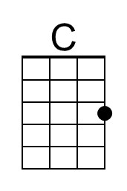 | 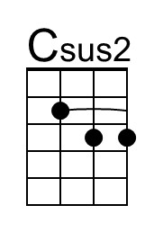 | 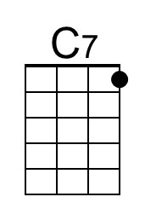
 | 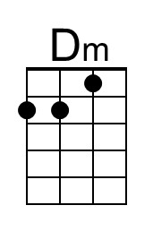 | 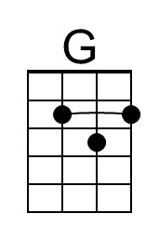 | 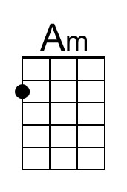
 | 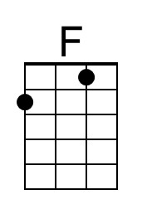 | 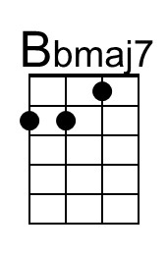 | 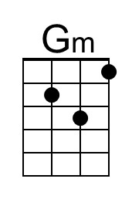
 | 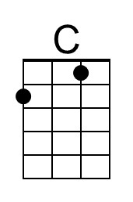 | 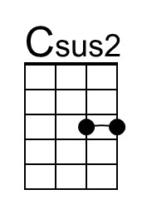 | 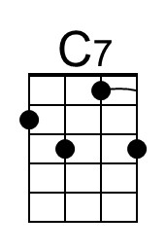
 | 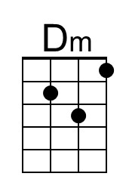 | 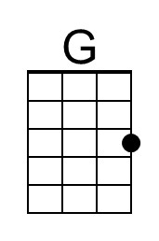 | 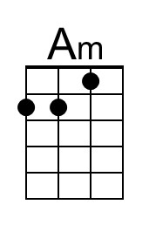
 | 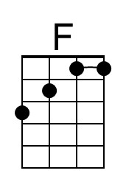 | 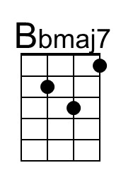 | 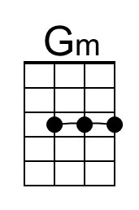

Ticket to Ride (John Lennon & Paul McCartney, 1965) (G)
Ticket To Ride by The Beatles
Tempo = 125 bpm
Intro | G Gsus2 | (4x)  G G - Gsus2 G  I think I'm gonna be sad, I think it's to-day, yeah  G7 Am | D  The girl that's driving me mad is going away.  Chorus  Em C Em Fmaj7  She's got a ticket to ride she's got a ticket to ri-i-de  Em Dm G  She's got a ticket to ride, and she don't care.  G G - Gsus2 G  She says that living with me is bringing her down, yeah  G7 Am | D  But she will never be free when I was a-round. Chorus  Bridge  C  I don't know why she's riding so high  D  She ought to think twice, she ought to do right by me  C  Before she gets to saying goodbye  D | D  She ought to think twice, she ought to do right by me  Repeat First Verse. Chorus. Bridge.  Repeat Second Verse. Chorus  Outro  TACET G Gsus2  My baby don’t care.  G Gsus2 G Gsus2  __ My baby don’t care. (3x) End on G  Intro - C-Tuning  | G D B G A D | G D B G A D | (2x)  A |-------------|-------------|  E |-------------|-------------|  C |---2-------2-|---2-------2-|  G |-0---4-0-2---|-0---4-0-2---| |  | 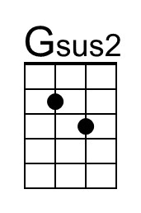 | 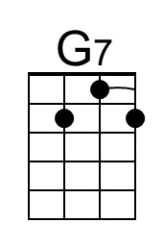
 |  | 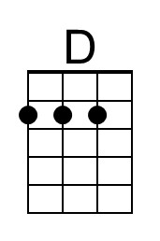 | 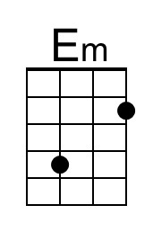
 |  | 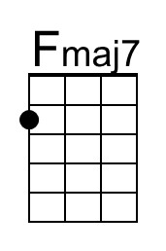
 |  | 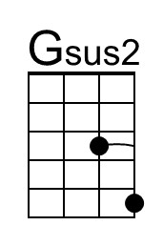 | 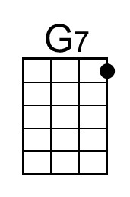
 |  | 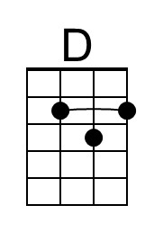 | 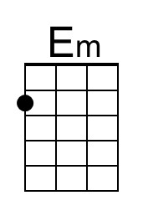
 |  | 