Ticket to Ride (John Lennon & Paul McCartney, 1965) (C)
Ticket To Ride by The Beatles (A)
4/4 Time – Tempo 125 bpm

Intro | C Csus4 | (4x)

C C - Csus4 C
I think I'm gonna be sad, I think it's to-day, yeah
C7 Dm | G
The girl that's driving me mad is going away.

Chorus
Am F Am Bbmaj7
She's got a ticket to ride she's got a ticket to ri-i-de
Am Gm C | C
She's got a ticket to ride, and she don't care.

C C - Csus4 | C
She says that living with me is bringing her down, yeah
C7 Dm | G
But she will never be free when I was a-round. Chorus

Bridge
F
I don't know why she's riding so high
G
She ought to think right, she ought to do right by me
F
Be-fore she gets to saying good-bye
G | G
She ought to think right, she ought to do right by me

C C - Csus4 C
I think I'm gonna be sad, I think it's to-day, yeah
C7 Dm | G
The girl that's driving me mad is going a-way. Chorus

 | 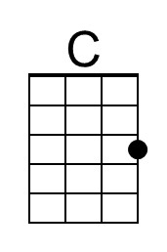 | 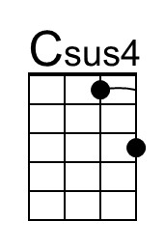 | 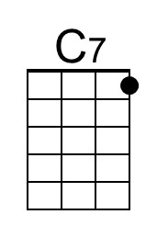 | 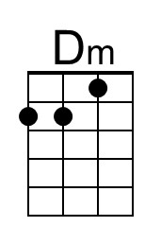 | 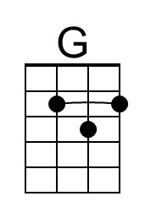
 | 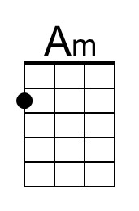 | 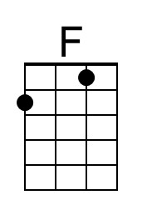 | 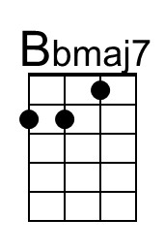 | 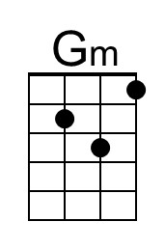
Ticket To Ride (C) – Page 2

Bridge
F
I don't know why she's riding so high
G
She ought to think right, she ought to do right by me
F
Be-fore she gets to saying good-bye
G | G
She ought to think right, she ought to do right by me

C C - Csus4 | C
She says that living with me is bringing her down, yeah
C7 Dm | G
But she will never be free when I was a-round.

Chorus
Am F Am Bbmaj7
She's got a ticket to ride she's got a ticket to ri-i-de
Am Gm C | C
She's got a ticket to ride, and she don't care

Outro
Tacet C Csus4
My baby don’t care.
C Csus4 C Csus4 (3x) End on C
__ My baby don’t care.

C-Tuning Intro (2x)  | C G E C D G | C G E C D G |  A |-------------|-------------|  E |---3-0-----3-|---3-0-----3-|  C |-0-----0-2---|-0-----0-2---|  G |-------------|-------------| | G-Tuning Intro (2x)  | C G E C D G | C G E C D G |  E |---3-0-----3-|---3-0-----3-|  B |-1-----1-3---|-1-----1-3---|  G |-------------|-------------|  D |-------------|-------------|

 |  | Bari | 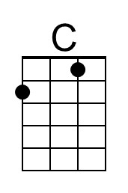 | 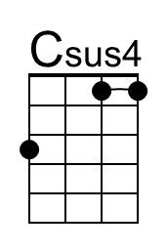 | 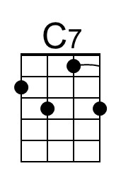 | 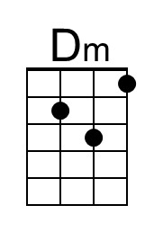 | 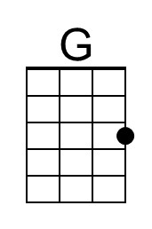
 |  |  | 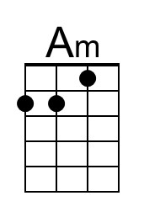 | 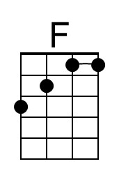 | 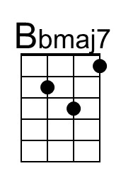 | 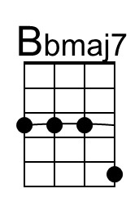 | 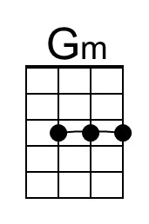

Ticket to Ride (John Lennon & Paul McCartney, 1965) (A)
Ticket To Ride by The Beatles (A) – C Tuning Chords
4/4 Time – Tempo 125 bpm

Introduction (4 measures): | A Asus2 | (4x)  A Asus2 A Asus2 A - Asus2 | A Asus2  1. I think I'm gonna be sad, I think it's to-day, yeah  A Asus2 A Asus2 Bm | E  The girl that's driving me mad is going a-way  Chorus 1  F#m G6 – D7  She's got a ticket to ride  F#m G6 – Gmaj7  She's got a ticket to ride  F#m E  She's got a ticket to ride  A Asus2 | A Asus2 |  But she don't care  A Asus2 A Asus2 A - Asus2 | A Asus2 |  2. She said that living with me is bringing her down yeah  A Asus2 A Asus2 Bm | E  For she would never be free when I was a-round. Chorus  Chorus 2  F#m G6 – D7 – G6  She's got a ticket to ride  F#m G6 – Gmaj7  She's got a ticket to ride  F#m E  She's got a ticket to ride  A A7 | A A7sus2 |  But she don't care  Bridge  D D7 D D7  I don't know why she's ridin' so high,  |¯¯¯¯ 3 ¯¯¯¯| D |¯¯¯¯ 3 ¯¯¯¯| D7 E E7  She ought to think right, She ought to do right by me.  D D7 D D7  Be-fore she gets to saying good-bye,  |¯¯¯¯ 3 ¯¯¯¯| D |¯¯¯¯ 3 ¯¯¯¯| D7 E E5  She ought to think right, She ought to do right by me. | 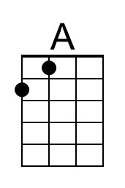 | 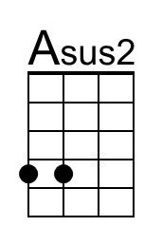
 | 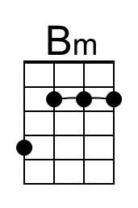 | 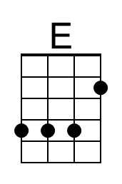
 | 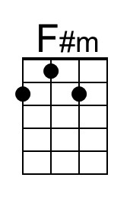 | 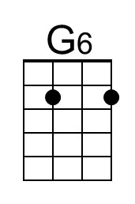
 | 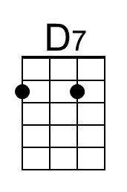 | 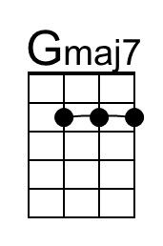
 | 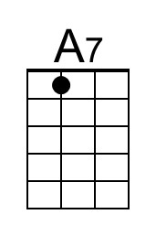 | 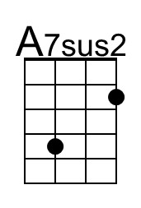
 | 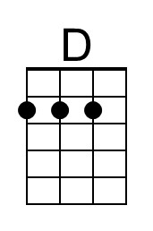 | 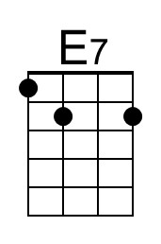

Ticket To Ride (A_C Tuning Chords) – Page 2

A Asus2 A Asus2 A - Asus2 | A Asus2
3. I think I'm gonna be sad, I think it's to-day, yeah
A Asus2 A Asus2 Bm | E
The girl that's driving me mad is going a-way

Chorus 1
F#m G6 – D7 F#m G6 – Gmaj7
She's got a ticket to ride. She's got a ticket to ride.
F#m E
She's got a ticket to ride
A Asus2 | A Asus2 |
But she don't care

Bridge
D D7 D D7
I don't know why she's ridin' so high,
|¯¯¯¯ 3 ¯¯¯¯| D |¯¯¯¯ 3 ¯¯¯¯| D7 E E7
She ought to think right, She ought to do right by me.
D D7 D D7
Be-fore she gets to saying good-bye,
|¯¯¯¯ 3 ¯¯¯¯| D |¯¯¯¯ 3 ¯¯¯¯| D7 E E5
She ought to think right, She ought to do right by me.

A Asus2 A Asus2 A - Asus2 | A Asus2 |
4. She said that living with me is bringing her down yeah
A Asus2 A Asus2 Bm | E
For she would never be free when I was a-round. Chorus

Chorus 2
F#m G6 – D7 – G6 F#m G6 – Gmaj7
She's got a ticket to ride. She's got a ticket to ride
F#m E A Asus2 |
She's got a ticket to ride. But she don't care.

Outro.
NC A Asus2 A Asus2 A Asus2
My baby don't care. _ My baby don't care.
A Asus2 A Asus2 A Asus2 A Asus2 A
_ My baby don't care. _ My baby don't care.
Ticket to Ride (John Lennon & Paul McCartney, 1965) (A)
Ticket To Ride by The Beatles (A) – G Tuning Chords
4/4 Time – Tempo 125 bpm

Introduction (4 measures): | A Asus2 | (4x)  A Asus2 A Asus2 A - Asus2 | A Asus2  1. I think I'm gonna be sad, I think it's to-day, yeah  A Asus2 A Asus2 Bm | E  The girl that's driving me mad is going a-way.  Chorus 1  F#m G6 – D7  She's got a ticket to ride,  F#m G6 – Gmaj7  She's got a ticket to ride,  F#m E  She's got a ticket to ride,  A Asus2 | A Asus2 |  But she don't care.  A Asus2 A Asus2 A - Asus2 | A Asus2 |  2. She said that living with me is bringing her down, yeah.  A Asus2 A Asus2 Bm | E  For she would never be free when I was a-round.  Chorus  F#m G6 – D7  She's got a ticket to ride,  F#m G6 – Gmaj7  She's got a ticket to ride,  F#m E  She's got a ticket to ride,  A A7 | A A7sus2  But she don't care.  Bridge  D D7 D D7  I don't know why she's ridin' so high,  |¯¯¯¯ 3 ¯¯¯¯| D |¯¯¯¯ 3 ¯¯¯¯| D7 E E7  She ought to think right, She ought to do right by me.  D D7 D D7  Be-fore she gets to saying good-bye,  |¯¯¯¯ 3 ¯¯¯¯| D |¯¯¯¯ 3 ¯¯¯¯| D7 E E7  She ought to think right, She ought to do right by me. | 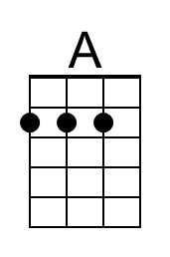 | 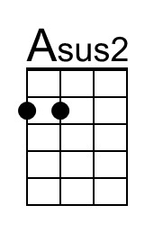
 | 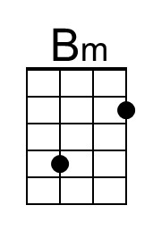 | 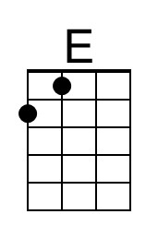
 | 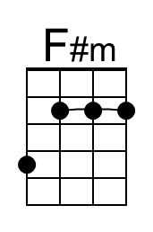 | 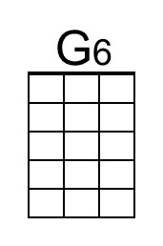
 | 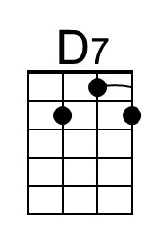 | 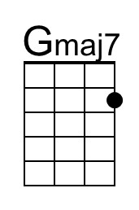
 | 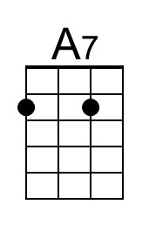 | 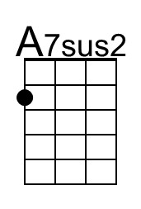
 | 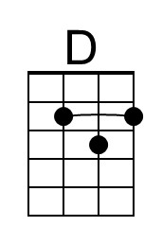 | 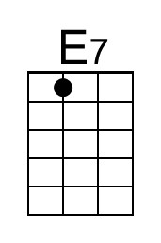

Ticket To Ride (A_G Tuning Chords) – Page 2

A Asus2 A Asus2 A - Asus2 | A Asus2
3. I think I'm gonna be sad, I think it's to-day, yeah
A Asus2 A Asus2 Bm | E
The girl that's driving me mad is going a-way, yeah!

Chorus
F#m G6 – D7 F#m G6 – Gmaj7
She's got a ticket to ride, She's got a ticket to ride,
F#m E
She's got a ticket to ride,
A Asus2 | A Asus2
But she don't care.

Bridge
D D7 D D7
I don't know why she's ridin' so high,
|¯¯¯¯ 3 ¯¯¯¯| D |¯¯¯¯ 3 ¯¯¯¯| D7 E E7
She ought to think right, She ought to do right by me.
D D7 D D7
Be-fore she gets to saying good-bye,
|¯¯¯¯ 3 ¯¯¯¯| D |¯¯¯¯ 3 ¯¯¯¯| D7 E E5
She ought to think right, She ought to do right by me.

A Asus2 A Asus2 A - Asus2 | A Asus2
4. She said that living with me is bringing her down yeah
A Asus2 A Asus2 Bm | E |
For she would never be free when I was a-round. Ah.

Chorus
F#m G6 – D7 F#m G6 – Gmaj7
She's got a ticket to ride. She's got a ticket to ride
F#m E A Asus2 |
She's got a ticket to ride. But she don't care.

Outro.
NC A Asus2 A Asus2 A Asus2
My baby don't care. _ My baby don't care.
A Asus2 A Asus2 A Asus2 A Asus2 | A (Hold)
_ My baby don't care. _ My baby don't care.

Ticket to Ride (John Lennon & Paul McCartney, 1965) (G)
Ticket To Ride by The Beatles (A)
4/4 Time – Tempo 125 bpm

Intro | G Gsus4 | (4x)

G G - Gsus4 G
I think I'm gonna be sad, I think it's to-day, yeah
G7 Am | D
The girl that's driving me mad is going away.

Chorus
Em C Em Fmaj7
She's got a ticket to ride she's got a ticket to ri-i-de.
Em Dm G | G
She's got a ticket to ride, and she don't care.

G G - Gsus4 | G
She says that living with me is bringing her down, yeah
G7 Am | D
But she will never be free when I was a-round. Chorus

Bridge
C
I don't know why she's riding so high.
D
She ought to think right, she ought to do right by me
C
Be-fore she gets to saying good-bye
D | D
She ought to think right, she ought to do right by me

G G - Gsus4 G
I think I'm gonna be sad, I think it's to-day, yeah
G7 Am | D
The girl that's driving me mad is going a-way. Chorus

 |  | 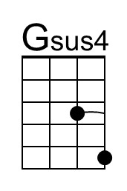 | 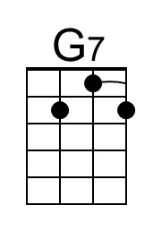
 | 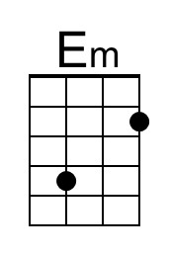 |  | 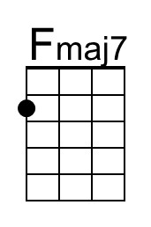
Ticket To Ride (G) – Page 2

Bridge
C
I don't know why she's riding so high.
D
She ought to think right, she ought to do right by me
C
Be-fore she gets to saying good-bye
D | D
She ought to think right, she ought to do right by me

G G - Gsus4 | G
She says that living with me is bringing her down, yeah
G7 Am | D
But she will never be free when I was a-round. Chorus

Chorus
Em C Em Fmaj7
She's got a ticket to ride she's got a ticket to ri-i-de.
Em Dm G | G
She's got a ticket to ride, and she don't care.

Outro
Tacet G Gsus4
My baby don’t care.
G Gsus4 G Gsus4 (3x) End on C
__ My baby don’t care.

 |  | Bari |  | 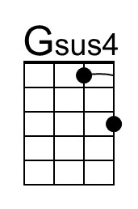 | 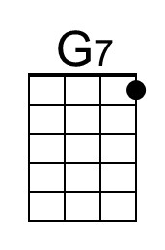
 |  |  | 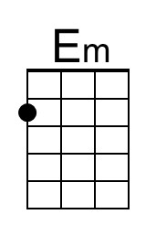 |  | 