**Ticket to Ride (John Lennon / Paul McCartney)**

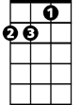

Dm

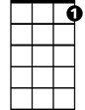

C7



C

**C Csus C**

I think I'm gonna be sad, I think it's today, yeah - h

**C7 Dm G**

The girl that's driving me mad is going away

**Am F Am Bbmaj7**

She's got a ticket t o ride she's got a ticket to ri-i-de

**Am Gm C**

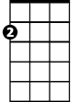

Am



G

F



She's g ot a ticket to ride, and she don't care.

**C Csus C**

She says that living with me is bringing her dow - n

**C7 Dm G**

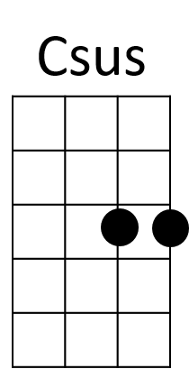But she will never be free when I was around

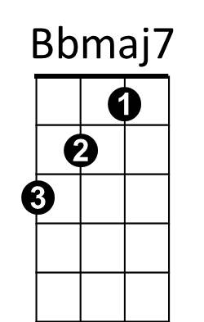**Am F Am Bbmaj7**

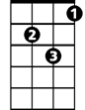

Gm

She's got a ticket to ride, s he's got a ticket to ri-i-de

**Am Gm C**

She's got a ticket to ride, and she don't care.

**Refrain:**

**F**

I don't know why she's riding so high

**G**

She ought to think twice, she ought to do right by me

**F**

Before she gets to saying goodbye

**G**

She ought to think twice, she ought to do right by me

**BARITONE**

C



Dm

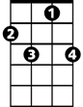

C7



Am



G



F

**C Csus C**

She says that living with me is bringing her dow - n

**C7 Dm G**

But she will never be free when I was around

**Am F Am Bbmaj7**

She's got a ticket to ride she's got a ticket to ri-i-de

**Am Gm C**

She's got a ticket to ride and she don't care.

**(Refrain)**

**C Csus C**

She says that living with me is bringing her dow - n

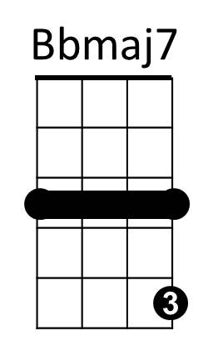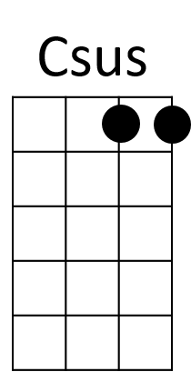 **C7 Dm G**

But she will never be free when I was around

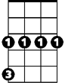

Gm

**Am F Am Bbmaj7**

She's got a ticket to ride she's got a ticket to ri-i-de

**Am Gm C**

She's got a ticket to ride and she don't care.

**TACET C**

My baby don’t care. My baby don’t care, my baby don’t care