Ticket to Ride (John Lennon & Paul McCartney, 1965)
Ticket To Ride by The Beatles
4/4 Time – Tempo = 125 bpm
Intro | C Csus4 | (4x)  C C - Csus4 C  I think I'm gonna be sad, I think it's to-day, yeah  C7 Dm | G  The girl that's driving me mad is going away.  Chorus  Am F Am Bbmaj7  She's got a ticket to ride she's got a ticket to ri-i-de  Am Gm C  She's got a ticket to ride, and she don't care.  C C - Csus4 | C  She says that living with me is bringing her down, yeah  C7 Dm | G  But she will never be free when I was a-round. Chorus  Bridge  F  I don't know why she's riding so high  G  She ought to think twice, she ought to do right by me  F  Be-fore she gets to saying good-bye  G | G  She ought to think twice, she ought to do right by me  Repeat First Verse. Chorus. Bridge.  Repeat Second Verse. Chorus  Outro  TACET C Csus4  My baby don’t care.  C Csus4 C Csus4  __ My baby don’t care. (3X)  Intro - C-Tuning  | C G E C D G | C G E C D G | (2X)  A |-------------|-------------|  E |---3-0-----3-|---3-0-----3-|  C |-0-----0-2---|-0-----0-2---|  G |-------------|-------------| | 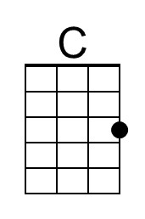 | 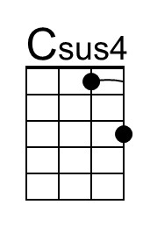 | 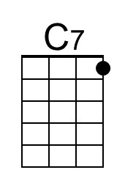
 | 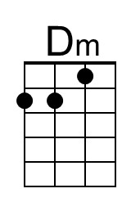 | 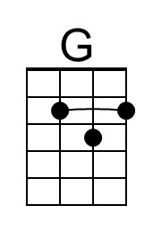 | 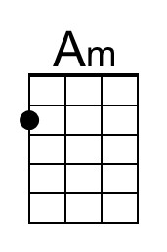
 | 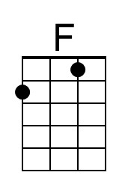 | 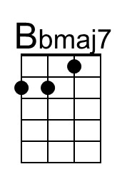 | 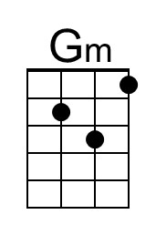
 | 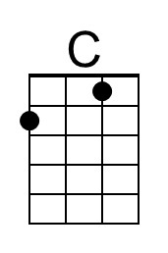 | 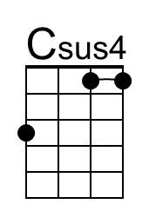 | 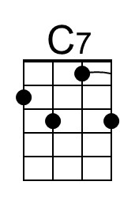
 | 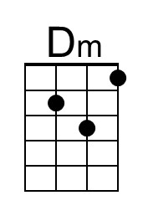 | 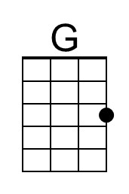 | 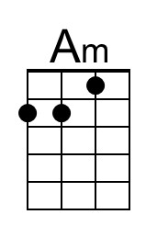
 | 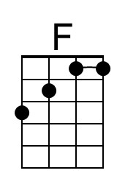 | 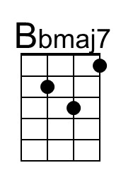 | 