Till There Was You (Meredith Willson, 1950) (C)
From the 1957 Broadway musical & 1962 movie, "The Music Man"
Till There Was You by The Beatles (In G)

Intro C Em Dm G  C Gº7 A7  There were bells on a hill,  Dm Dm7 F Fm  But I never heard them ringing  C Em Dm G7 C Dm G7  No I never heard them at all, 'Til there was you  C Gº7 A7  There were birds in the sky,  Dm Dm7 F Fm  But I never saw them winging  C Em Dm G7 C Fº7 C  No I never saw them at all, 'Til there was you  Bridge  F Fm C  Then there was music and wonderful roses  A7  They tell me  Dm D7 G G+  In sweet fragrant meadows of dawn, . . . and dew.  C Gº7 A7  There was love all a-round,  Dm Dm7 F Fm  But I never heard it singing  C Em Dm G7 C  No I never heard it at all 'Til there was you.  Instrumental Verse. Repeat from Bridge. |  |  |  |  |  |  | 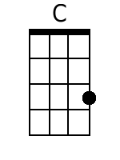 |  | 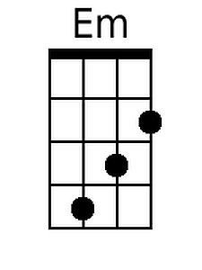 |  | 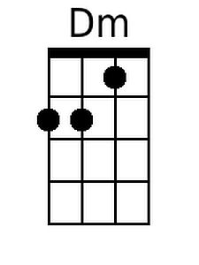
 |  |  |  |  |  |  | 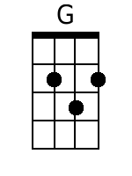 |  | 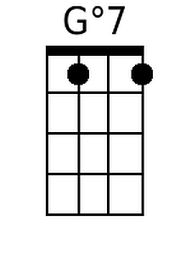 |  | 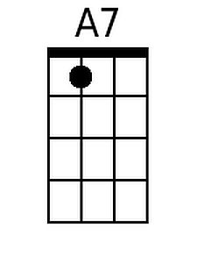
 |  |  |  |  |  |  | 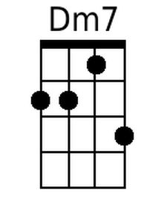 |  | 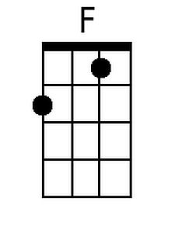 |  | 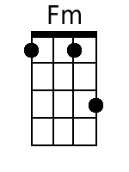
 |  |  |  |  |  |  | 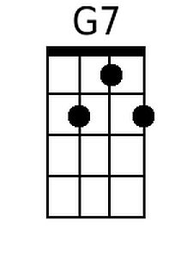 |  | 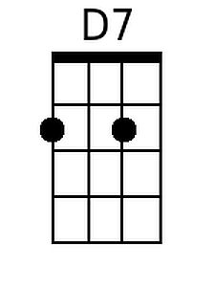 |  | 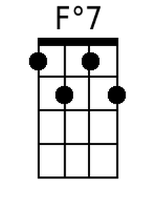
 |  |  |  |  |  |  | 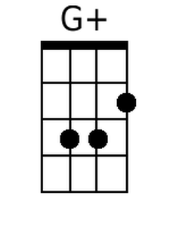
 | Bari | 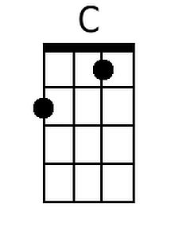 | 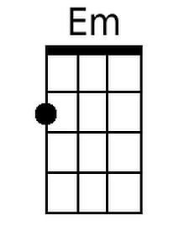 | 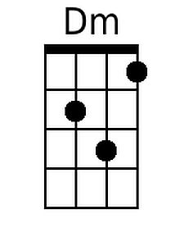 | 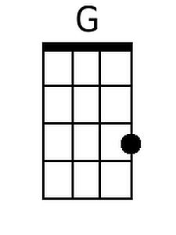 | 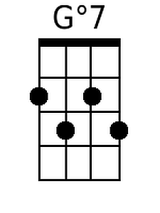 |  | 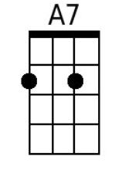 |  | 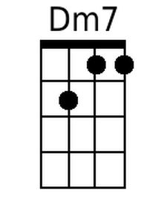
 |  | 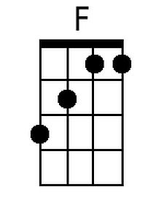 | 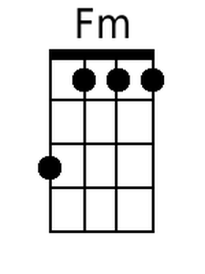 | 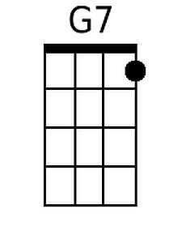 | 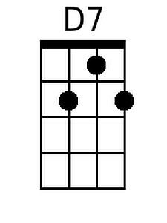 | 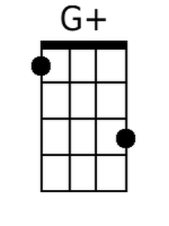 |  | 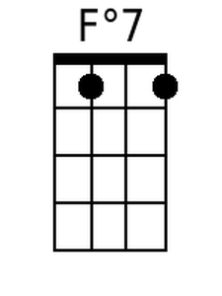

Till There Was You (Meredith Willson, 1950) (G)
From the 1957 Broadway musical & 1962 movie, "The Music Man"
Till There Was You by The Beatles (In G)

Intro: G Bm Am D  G Dº7 E7  There were bells on a hill,  Am Am7 C Cm  But I never heard them ringing  G Bm Am D7 G Am D7  No I never heard them at all, 'Til there was you  G Dº7 E7  There were birds in the sky,  Am Am7 C Cm  But I never saw them winging  G Bm Am D7 G Cº7 G  No I never saw them at all, 'Til there was you  Bridge  C Cm G  Then there was music and wonderful roses  E7  They tell me  Am A7 D Daug  In sweet fragrant meadows of dawn, . . . and dew.  G Dº7 E7  There was love all a-round,  Am Am7 C Cm  But I never heard it singing  G Bm Am D7 G  No I never heard it at all 'Til there was you.  Instrumental Verse. Repeat from Bridge. |  |  |  |  |  |  |  |  | 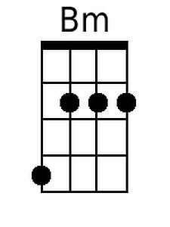 |  | 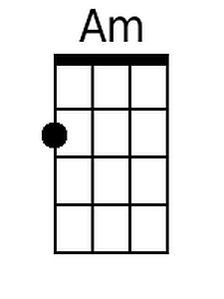
 |  |  |  |  |  |  | 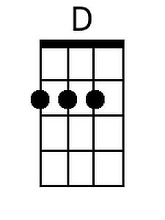 |  | 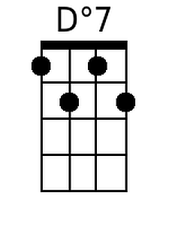 |  | 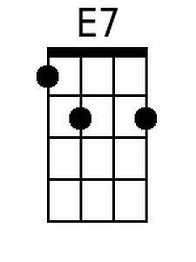
 |  |  |  |  |  |  | 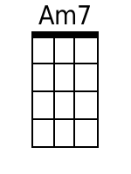 |  |  |  | 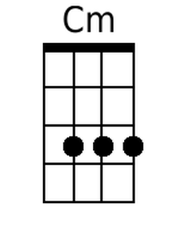
 |  |  |  |  |  |  |  |  |  |  | 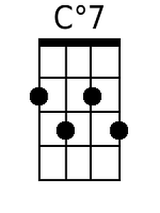
 |  |  |  |  |  |  | 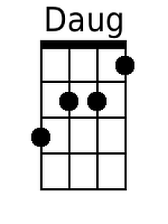
 | Bari |  | 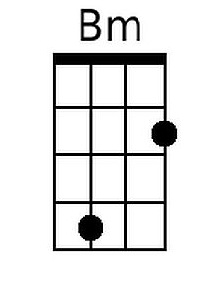 | 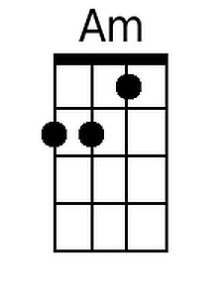 | 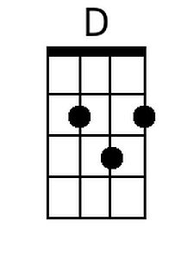 | 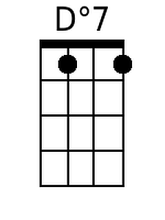 |  | 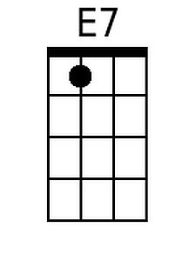 |  | 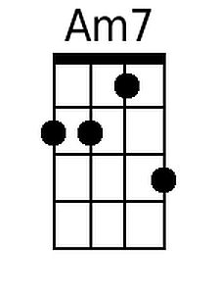
 |  |  | 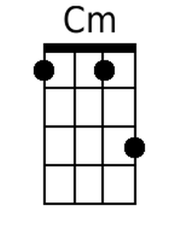 |  |  | 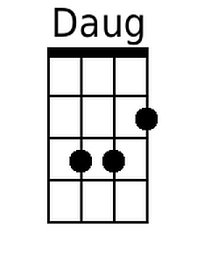 |  | 