Till There Was You (Meredith Willson, 1950) (C)
From the 1957 Broadway musical & 1962 movie, "The Music Man"
Till There Was You by The Beatles (In G)
Tempo: Moderately;  = 100
Intro (4 measures): C | Ebº7 | Dm | G7 |  G7 C C#º7  __ There were bells on a hill,  Dm Fm6  But I never heard them ringing  C Ebº7 Dm G7 C | F  No I never heard them at all, 'Til there was you  G7 C C#º7  __ There were birds in the sky,  Dm Fm6  But I never saw them winging  C Ebº7 Dm G7 C F |  No I never saw them at all, 'Til there was you  Bridge  CΔ7 F F#º7 C  ___ Then there was music and wonderful roses  A7  They tell me  Dm D7 G7 G+  In sweet fragrant meadows of dawn, . . . and dew.  G7 C C#º7  __ There was love all a-round,  Dm Fm6  But I never heard it singing  C Ebº7 Dm G7 C  No I never heard it at all 'Til there was you.  Outro: C F | CΔ7  Instrumental Verse. Repeat from Bridge. |  |  |  |  |  |  | 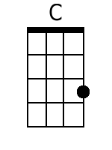 |  | 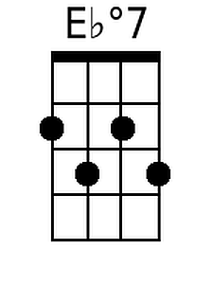 |  | 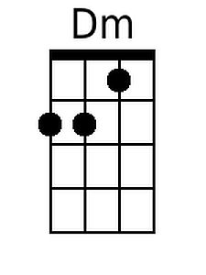
 |  |  |  |  |  |  | 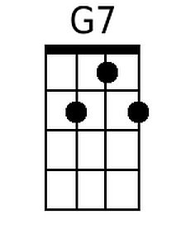 |  | 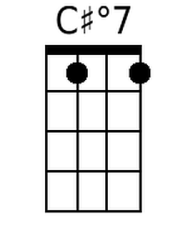 |  | 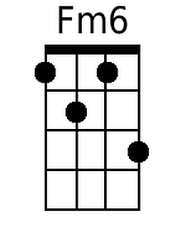
 |  |  |  |  |  |  | 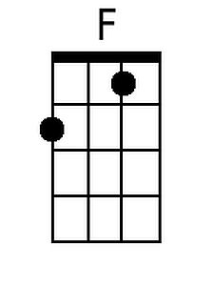 |  | 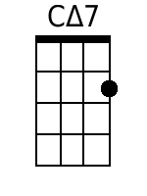 |  | 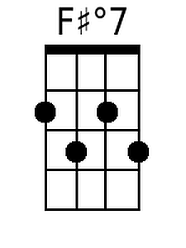
 |  |  |  |  |  |  | 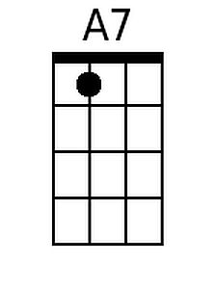 |  | 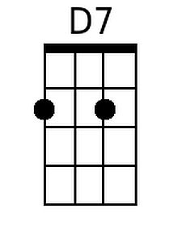 |  | 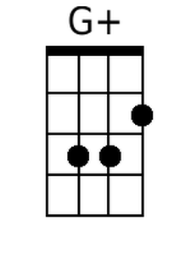
 |  | Bari | 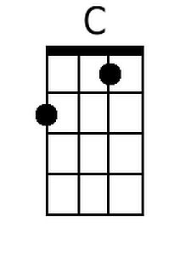 | 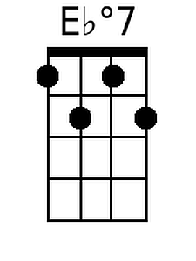 | 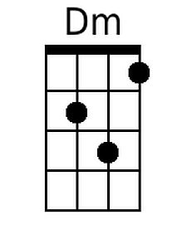 | 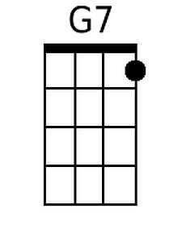 |  | 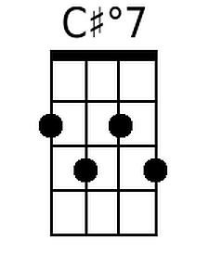 |  | 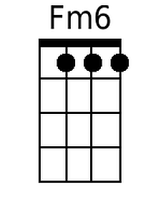
 |  |  | 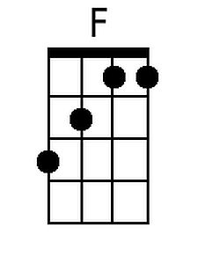 | 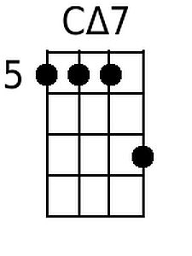 | 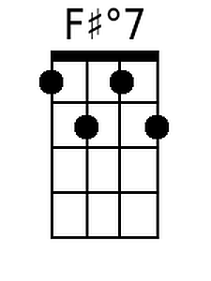 | 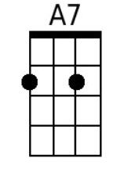 |  | 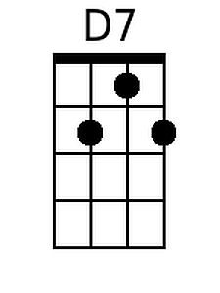 |  | 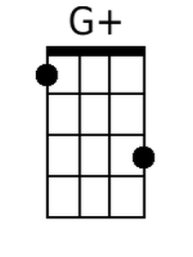

Till There Was You (Meredith Willson, 1950) (G)
From the 1957 Broadway musical & 1962 movie, "The Music Man"
Till There Was You by The Beatles (In G)
Tempo: Moderately;  = 100
Intro (4 measures): G | Bbº7 | Am | D7 |  D7 G G#º7  __ There were bells on a hill,  Am Cm6  But I never heard them ringing  G Bbº7 Am D7 G | C  No I never heard them at all, 'Til there was you  D7 G G#º7  __ There were birds in the sky,  Am Cm6  But I never saw them winging  G Bbº7 Am D7 G C |  No I never saw them at all, 'Til there was you  Bridge  GΔ7 C C#º7 G  ___ Then there was music and wonderful roses  E7  They tell me  Am A7 D7 D+  In sweet fragrant meadows of dawn, . . . and dew.  D7 G G#º7  __ There was love all a-round,  Am Cm6  But I never heard it singing  G Bbº7 Am D7 G  No I never heard it at all 'Til there was you.  Outro: G C | GΔ7  Instrumental Verse. Repeat from Bridge. |  |  |  |  |  |  | 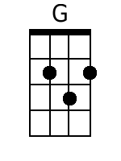 |  | 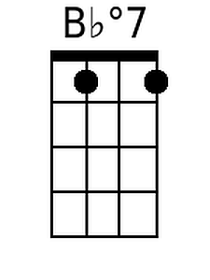 |  | 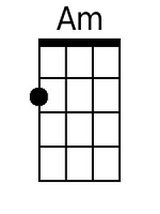
 |  |  |  |  |  |  |  |  | 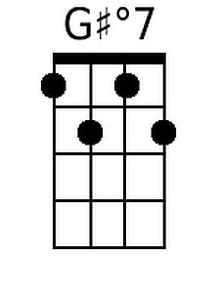 |  | 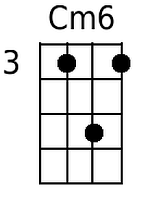
 |  |  |  |  |  |  |  |  | 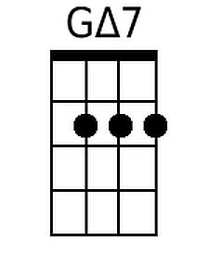
 |  |  |  |  |  |  | 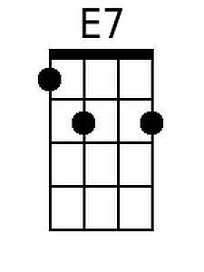 |  |  |  | 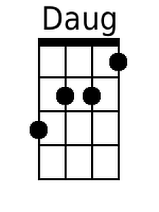
 |  | Bari | 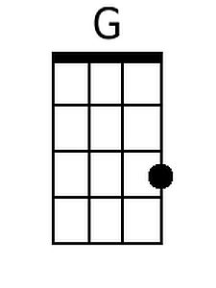 | 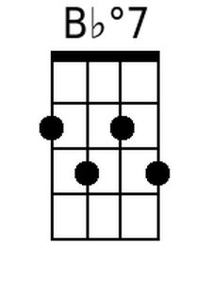 | 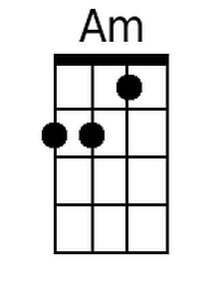 |  |  | 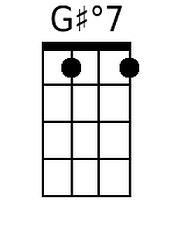 |  | 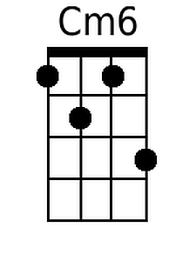
 |  |  |  | 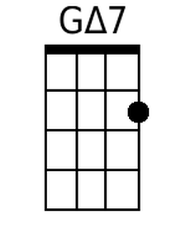 |  |  |  | 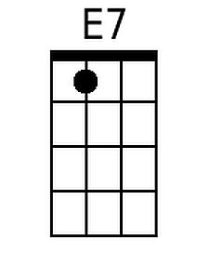 |  | 