**Time Warp (Richard O'Brien)**

**A B**

It’s astounding, time is fleeting

**G D A**

Madness takes its toll

**A B**

But listen closely, not for very much longer

**G D A**

I’ve got to - keep control

**B**

I can remember doing the Time Warp

**G D A**

Drinking those moments when

**A**

The blackness would hit me

**B**

And the void would be call-ing

**F C G D A**

Let’s do the Time Warp again

**F C G D A**

Let’s do the Time Warp again

**Chorus:**

**TACET E7**

It’s just a jump to the left

**A**

And then a step to the right

**TACET E7**

With your hands on your hips

**A**

You bring your knees in tight

**D**

But it’s the pelvic thru-st

**A**

That really drives you in-sa-a-a-a-ne

**F C G D A**

Let’s do the Time Warp again

**F C G D A**

Let’s do the Time Warp again

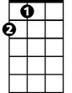

A

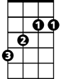

B



G

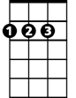

D

E7

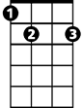

F



C

**A B**

It’s so dreamy, oh fantasy free me

**G D A**

So you can’t see me, no, not at all

**A B**

In another dimension, with voyeuristic intention

**G D A**

Well secluded, I see all

**B**

With a bit of a mind flip, you’re into the time slip

**G D A**

And nothing can ever be the same

You’re spaced out on sensation,

**B**

Like you’re under se-da-tion

**F C G D A**

Let’s do the Time Warp again

**F C G D A**

Let’s do the Time Warp again

**A**

Well I was walking down the street just having a think

When a snake of a guy gave me an evil wink

**D**

He shook me up, he took me by surprise

**A**

He had a pickup truck and the devil’s eyes

**E7 D**

He stared at me and I felt a change

**A**

Time meant nothing, never would again

**F C G D A**

Let’s do the Time Warp again

**F C G D A**

Let’s do the Time Warp again

**(Chorus)**

B

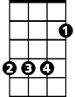

G



A



F

**BARITONE**



D

C

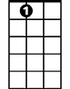

E7