**Time of the Season (Rod Argent) Key Am**

**Intro: Am (4x)**

**Am G F**

It's the time ~ of the season

**Am**



G

F

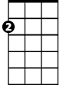

Am

When the love runs high

**G F**

In this time, give it to me easy

**Am C**

And let me try with pleasured hands

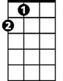

A

**Am C**



C

To take you in the sun to promised lands

**Am**

To show you everyone

**G F C Am A**

It's the time of the season for lov - ing

**Am (4x)**

**Am**

What's your name? (What's your name),

**G F**

Who's your daddy? (Who's your daddy)

**Am**

He’s rich - Is he rich like me?

**G F**

Has he taken – (Has he taken) Any time – (Any time)

**Am C**

To show - To show you what you need to live

**Am C**

**BARITONE**

Tell it to me slowly - Tell you why

**Am**



F



G

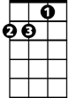

Am

C

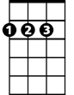

A

I really want to know - oh

**G F C Am A**

It's the time of the season for lov - ing

**Am (4x)**

**(Repeat last verse) (Last note ring out)**

**Time of the Season (Rod Argent) Key Dm**

**Intro: Dm (4x)**

**Dm C Bb**



Bb



C



Dm

**BARITONE**

It's the time ~ of the season

**Dm**

When the love runs high

**C Bb**

In this time, give it to me easy

**Dm F**



D

F



And let me try with pleasured hands

**Dm F**

To take you in the sun to promised lands

**Dm**

To show you everyone

**C Bb F Dm D**

It's the time of the season for lov - ing

**Dm (4x)**

**Dm**

What's your name? (What's your name),

**C Bb**

Who's your daddy? (Who's your daddy)

**Dm**

He’s rich - Is he rich like me?

**C Bb**

Has he taken – (Has he taken) Any time – (Any time)

**Dm F**

To show - To show you what you need to live

**Dm F**

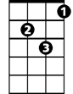

Dm

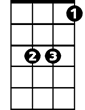

Bb

C



Tell it to me slowly - Tell you why

**Dm**

I really want to know - oh

**C Bb F Dm D**

It's the time of the season for lov - ing



F



D

**Dm (4x)**

**(Repeat last verse) (Last note ring out)**