Tip Toe Thru’ The Tulips With Me (C)
Words by Al Dubin & Music by Joe Burke From "The Gold Diggers of Broadway" (1929)
Tip Toe Thru The Tulips With Me by “Sheet Music Singer” (Fred Feild)
Arrangement by William Heney
Melody starts on G (the 5th)
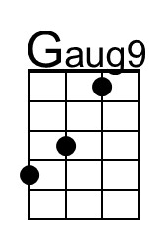
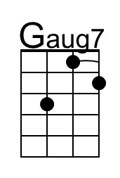
Intro (8 Measures)
G7 | C | A | Dm | G7 | C | Gm | A

C Dm7 G7 C Am
Shades of night are creeping, willow trees are weeping,
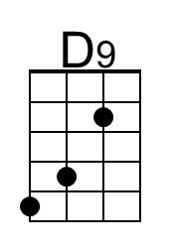
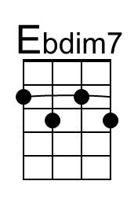
G Gaug7 C - Dm7 | Gaug9
Old folks and babies are sleeping,
C Dm7 G7 C A7
Silver stars are gleaming, all a-lone I'm scheming,
G7 Gaug7 C A7 D9 G7
Scheming to get you out here, my dear, come . . .
C - A7 Dm7 Gaug7 C - E7 F Fm
Tip toe to the window, by the window, that is where I'll be, come
C - A7 Dm7 -G7 C Dm7 Ebº7 G Gaug7
Tip toe thru the tulips with me.
C F Ebº7 Em A7 F#m7 B7 Em Ebº7 G7
Knee deep in flow-ers we'll stray, We'll keep the showers a - way,
Dm7 D9 Gaug7 C - A7 Dm7 Gaug7 C - E7 F Fm
And if I kiss you in the garden, ___ in the moonlight, will you pardon me,
C - A7 Dm7 - G7 C Dm7 Ebº7 G Gaug7
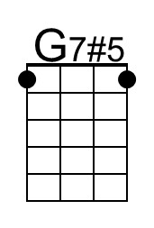
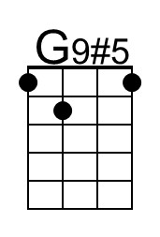
Come, tip toe thru the tulips with me.

C Dm7 G7 C Am
Come on out and pet me, come and Ju-li-et me,
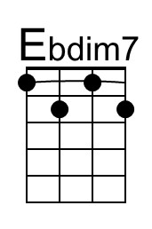
G Gaug7 C - Dm7 | Gaug9
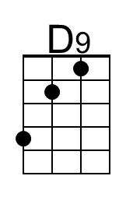
Tease me and slyly co-quette me,
C Dm7 G7 C A7
Let me Ro-me-o you, I Just want to show you,
G7 Gaug7 C A7 D9 G7
How much I'm willing to do for you, come...
C - A7 Dm7 - Gaug7 C - E7 F Fm
Tip toe from your pillow, to the shadow of a willow tree, and
C - A7 Dm7 -G7 C Dm7 Ebº7 G Gaug7
Tip toe thru the tulips with me.
C F Ebº7 Em A7 F#m7 B7 Em Ebº7 G7
Knee deep in flow-ers we'll stray, We'll keep the showers a - way,
Dm7 D9 Gaug7 C - A7 Dm7 Gaug7 C - E7 F Fm
And if I kiss you in the garden, ___ in the moonlight, will you pardon me,
C - A7 Dm7 - G7 C Dm7 Ebº7 G Gaug7
Come, tip toe thru the tulips with me.
C - A7 Dm7 - G7 C Dm7 Ebº7 G Gaug7
Come, tip toe thru the tulips with me.
Tip Toe Thru’ The Tulips With Me (C)
Words by Al Dubin & Music by Joe Burke From "The Gold Diggers of Broadway" (1929)
Tip Toe Thru The Tulips With Me by “Sheet Music Singer” (Fred Feild)
Arrangement by William Heney
Melody starts on G (the 5th)
Intro (8 Measures)
D7 | G | E | Am | D7 | G | Dm | E

G Am7 D7 G Em
Shades of night are creeping, willow trees are weeping,
D Daug7 G - Am7 | Daug9
Old folks and babies are sleeping,
G Am7 D7 G E7
Silver stars are gleaming, all a-lone I'm scheming,
D7 Daug7 G E7 A9 D7
Scheming to get you out here, my dear, come . . .
G - E7 Am7 Daug7 G - B7 C Cm
Tip toe to the window, by the window, that is where I'll be, come
G - E7 Am7 -D7 G Am7 A#º7 D Daug7
Tip toe thru the tulips with me.
G C A#º7 Em E7 C#m7 F#7 Bm A#º7 D7
Knee deep in flow-ers we'll stray, We'll keep the showers a - way,
Am7 A9 Daug7 G - E7 Am7 Daug7 G - B7 C Cm
And if I kiss you in the garden, ___ in the moonlight, will you pardon me,
G - E7 Am7 - D7 G Am7 A#º7 D Daug7
Come, tip toe thru the tulips with me.

G Am7 D7 G Em
Come on out and pet me, come and Ju-li-et me,
D Daug7 G - Am7 | Daug9
Tease me and slyly co-quette me,
G Am7 D7 G E7
Let me Ro-me-o you, I Just want to show you,
D7 Daug7 G E7 A9 D7
How much I'm willing to do for you, come...
G - E7 Am7 - Daug7 G - B7 C Cm
Tip toe from your pillow, to the shadow of a willow tree, and
G - E7 Am7 -D7 G Am7 A#º7 D Daug7
Tip toe thru the tulips with me.
G C A#º7 Bm E7 C#m7 F#7 Bm A#º7 D7
Knee deep in flow-ers we'll stray, We'll keep the showers a - way,
Am7 A9 Daug7 G - E7 Am7 Daug7 G - B7 C Cm
And if I kiss you in the garden, ___ in the moonlight, will you pardon me,
G - E7 Am7 - D7 G Am7 A#º7 D Daug7
Come, tip toe thru the tulips with me.
G - E7 Am7 - D7 G Am7 A#º7 D Daug7
Come, tip toe thru the tulips with me.

