To Sir, With Love (Don Black & Marc London, 1967)
To Sir, With Love by Lulu – Key of C

C - D  _ Those school girl days  F C  of telling tales and biting nails are gone  C - D F C  _ But in my mind, I know they will still live on and on  B7 Em  __ But how do you thank someone  B7 Em  who has taken you from crayons to per-fume  D G D A7  _ It isn't easy but I'll try  D  If you wanted the sky,  C D  I'd write across the sky in letters  C D  that would soar a thousand feet high  G A (riff)  To Sir, With Love  C - D  _ The time has come  F C  for closing books and long last looks must end  C - D  And as I leave  F C  I know that I am leaving my best friend  B7 Em  __ A friend who taught me right from wrong  B7 Em  and weak from strong, that's a lot to learn  D G D A7  What! what can I give you in re-turn? |  |  |  |  | D C  If you wanted the moon, I would try to make a start  D C D  But I would rather you let me give my heart  G A (riff)  To Sir, With Love  C - D  _ Those awkward years  F C  have hurried by why did they fly away  C - D  _ Why is it Sir?  F C  children grow up to be people some day  B7 Em  __ What takes the place of climbing trees  B7 Em  and dirty knees in the world out-side  D G D A7  _ What is there for you I can buy?  D  If you wanted the world  C D  I'd sur-round it with a wall I'd scrawl  C D  These words with letters ten feet tall  G A (riff) (end on strummed A)  To Sir, With Love.  Riff: C-Tuned | G-Tuned (A G E D C)  A|0------------| E|5--3--0------|  E|---3--0------| B|---------3--1|  C|---------2--0| G|-------------|  G|-------------| D|-------------|  Source: Ultimate Guitar.
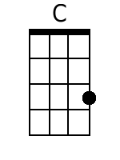 | 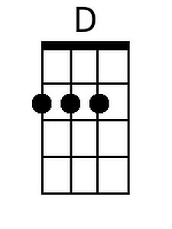 | 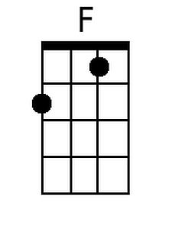 | 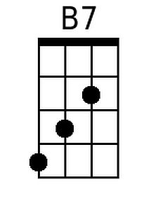 | 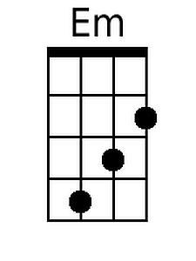 |  | 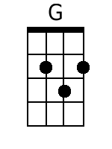 | 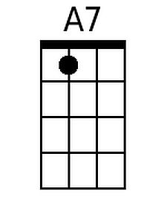 | 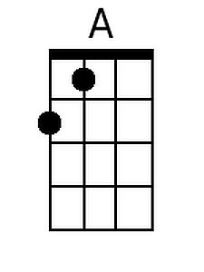
Baritone
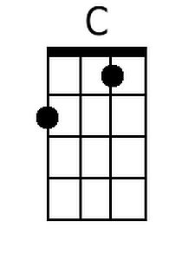 | 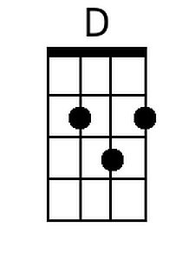 | 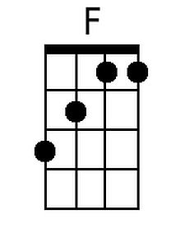 | 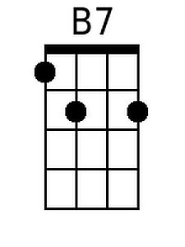 | 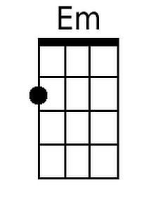 |  | 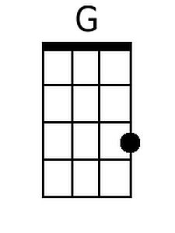 | 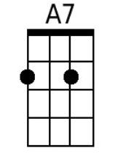 | 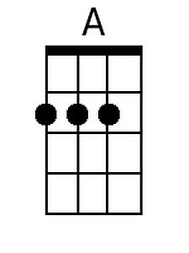

To Sir, With Love (Don Black & Marc London, 1967)
To Sir, With Love by Lulu – Key of G

G - A  _ Those school girl days  C G  of telling tales and biting nails are gone  G - A C G  _ But in my mind, I know they will still live on and on  F#7 Bm  __ But how do you thank someone  F#7 Bm  who has taken you from crayons to per-fume  A D A E7  _ It isn't easy but I'll try  A  If you wanted the sky  G A  I'd write across the sky in letters  G A  that would soar a thousand feet high  D E (riff)  To Sir, With Love  G - A  _ The time has come  C G  for closing books and long last looks must end  G - A  And as I leave  C G  I know that I am leaving my best friend  F#7 Bm  __ A friend who taught me right from wrong  F#7 Bm  and weak from strong, that's a lot to learn  A D A E7  What! what can I give you in re-turn? |  |  |  |  | A G  If you wanted the moon, I would try to make a start  A G A  But I would rather you let me give my heart  D E (riff)  To Sir, With Love  G - A  _ Those awkward years  C G  have hurried by why did they fly away  G - A  _ Why is it Sir  C G  children grow up to be people some day  F#7 Bm  __ What takes the place of climbing trees  F#7 Bm  and dirty knees in the world out-side  A D A E7  _ What is there for you I can buy?  A  If you wanted the world  G A  I'd sur-round it with a wall I'd scrawl  G A  These words with letters ten feet tall  D E (riff) (end on strummed E)  To Sir, With Love.  Riff: C-Tuned | G-Tuned (E D B A G)  A|-------------| E|0------------|  E|0------------| B|---3--0------|  C|---2---------| G|---------2--0|  G|------4--2--0| D|-------------|  Source: Ultimate Guitar.
 |  |  | 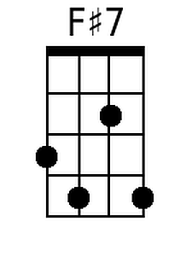 | 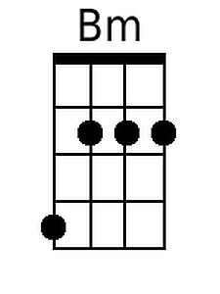 |  |  | 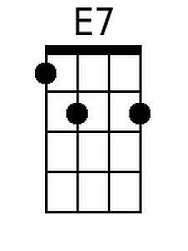 | 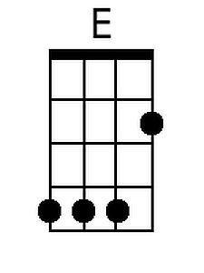
Baritone
 |  |  | 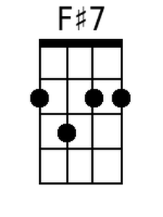 | 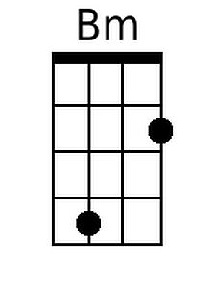 |  |  | 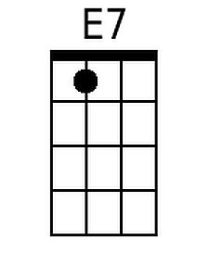 | 