Today (Randy Sparks, 1964) (C)

Intro: | C | Am | Dm | G |  Chorus  C Am Dm G  To-day, while the blos-soms still cling to the vine,  C Am Dm G  I'll taste your straw-ber-ries, I'll drink your sweet wine.  C C7 F Fm  A mill-ion to-mor-rows shall all pass a-way,  C Am Dm G C – Am – Dm – G  Ere I for-get all the joy that is mine to-day.  Outro: C – Am – Dm – G – C  C Am Dm G  I'll be a dandy, and I'll be a rover.  C Am Dm G  You'll know who I am by the songs that I sing.  C Am Dm G  I'll feast at your table, I'll sleep in your clover.  F G C – G  Who cares what the morrow shall bring? Chorus  C Am Dm G  I can't be con-ten-ted with yesterday's glory,  C Am Dm G  I can't live on promises, winter to spring.  C Am Dm G  To-day is my moment and now is my story.  F G C – G  I'll laugh and I'll cry and I'll sing. Chorus |  |  |  |  |  |  |  | 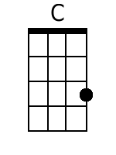
 |  |  |  |  |  |  |  | 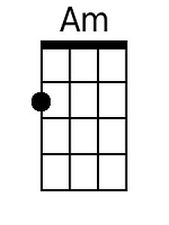
 |  |  |  |  |  |  |  | 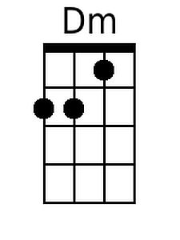
 |  |  |  |  |  |  |  | 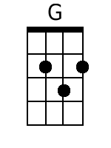
 |  |  |  |  |  |  |  | 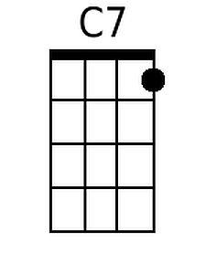
 |  |  |  |  |  |  |  | 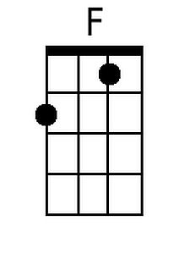
 |  |  |  |  |  |  |  | 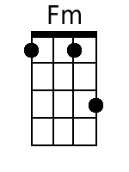
Bari
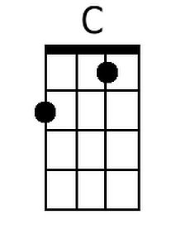 | 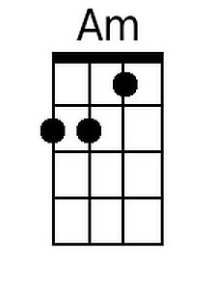 | 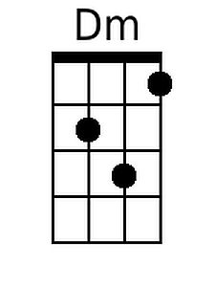 | 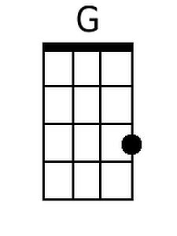 | 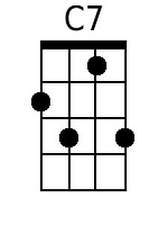 | 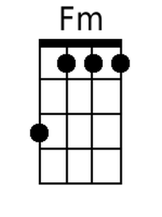

Today (Randy Sparks, 1964) (G)

Intro: | G | Em | Am | D |

Chorus
G Em Am D
To-day, while the blos-soms still cling to the vine,
G Em Am D
I'll taste your straw-ber-ries, I'll drink your sweet wine.
G G7 C Cm
A mill-ion to-mor-rows shall all pass a-way,
G Em Am D G - Em - Am - D
Ere I for-get all the joy that is mine to-day.
Outro: G - Em - Am - D - G

G Em Am D
I'll be a dandy, and I'll be a rover.
G Em Am D
You'll know who I am by the songs that I sing.
G Em Am D
I'll feast at your table, I'll sleep in your clover.
C D G - D
Who cares what the morrow shall bring? Chorus

G Em Am D
I can't be con-ten-ted with yesterday's glory,
G Em Am D
I can't live on promises, winter to spring.
G Em Am D
To-day is my moment and now is my story.
C D G - D
I'll laugh and I'll cry and I'll sing. Chorus

 |  |  |  |  |  |  |  | 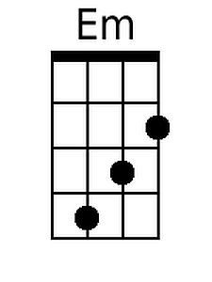
 |  |  |  |  |  |  |  | 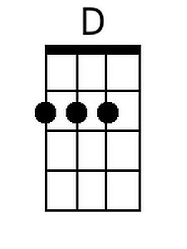
 |  |  |  |  |  |  |  | 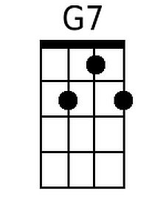
 |  |  |  |  |  |  |  | 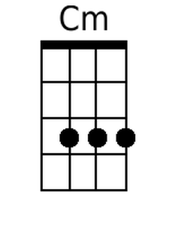
Bari
 | 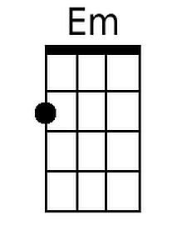 |  | 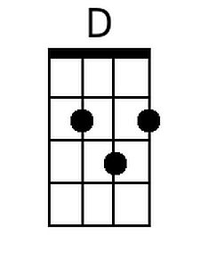 | 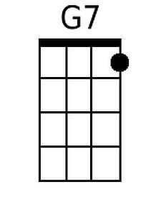 |  | 