Today (Randy Sparks, 1964) (F)
C-Tuning – Key Changes
Today by The New Christie Minstrels

Intro: Instrumental First Line  F Dm Gm C7  To-day, while the blossoms still cling to the vine,  F Dm Gm C7  To-day, while the blossoms still cling to the vine,  F Dm Gm C7  I’ll taste your straw-berries, I’ll drink your sweet wine.  F F7 Bb Bbm  A million to-mor-rows shall all pass away,  F Dm Gm C7 F Dm Gm C7  Ere I for-get all the joy that is mine . . . to-day.  F Dm Gm C7  I’ll be a dandy, and I’ll be a rover.  F Dm Gm C7  You’ll know who I am by the songs that I sing.  F Dm Gm C7  I’ll feast at your table, I’ll sleep in your clover.  Bb C F C  Who cares what the morrow shall bring?  F Dm Gm C7  To-day, while the blossoms still cling to the vine,  F Dm Gm C#7  I’ll taste your straw-berries, I’ll drink your sweet wine.  F# Ebm Abm C#7  I can’t be con-ten-ted with yesterday’s glory,  F# Ebm Abm C#7  I can’t live on promises, winter to spring.  F# Ebm Abm C#7  To-day is my moment… now is my story.  B C# F# D7  I’ll laugh and I’ll cry and I’ll sing.  G Em Am D7  To-day, while the blossoms still cling to the vine,  G Em Am D7  I’ll taste your straw-berries, I’ll drink your sweet wine.  G G7 C Cm  A million to-mor-rows shall all pass away,  G Em Am D7 G Em Am D7 G↓  Ere I for-get all the joy that is mine . . . to-day. | 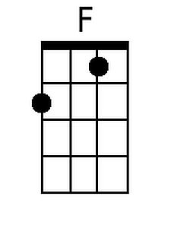 | 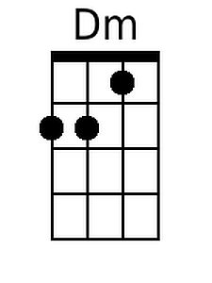 | 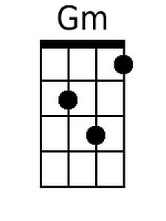
 | 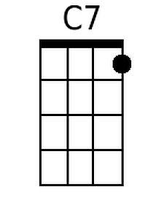 | 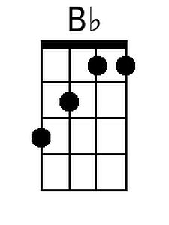 | 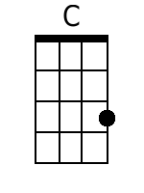
 | 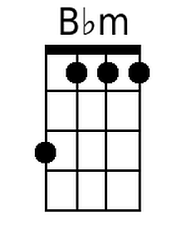 | 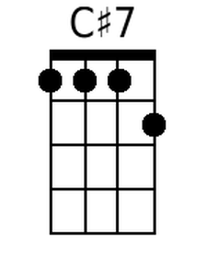 | 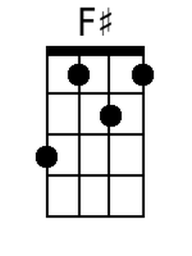
 | 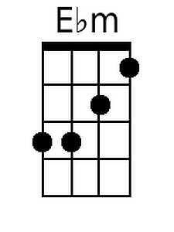 | 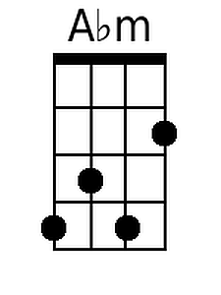 | 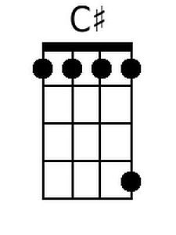
 | 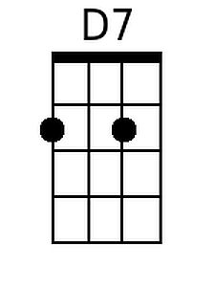 | 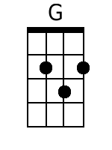 | 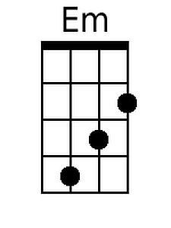
 | 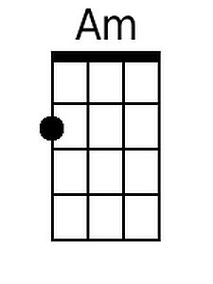 | 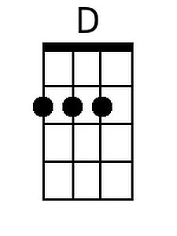 | 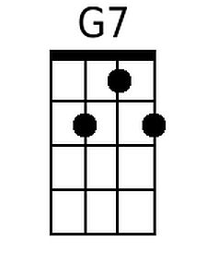
 | 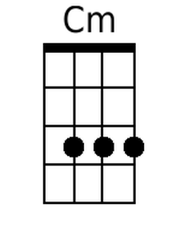

Today (Randy Sparks, 1964) (F)
G-Tuning – Key Changes
Today by The New Christie Minstrels

Intro: Instrumental First Line  F Dm Gm C7  To-day, while the blossoms still cling to the vine,  F Dm Gm C7  To-day, while the blossoms still cling to the vine,  F Dm Gm C7  I’ll taste your straw-berries, I’ll drink your sweet wine.  F F7 Bb Bbm  A million to-mor-rows shall all pass away,  F Dm Gm C7 F Dm Gm C7  Ere I for-get all the joy that is mine . . . to-day.  F Dm Gm C7  I’ll be a dandy, and I’ll be a rover.  F Dm Gm C7  You’ll know who I am by the songs that I sing.  F Dm Gm C7  I’ll feast at your table, I’ll sleep in your clover.  Bb C F C  Who cares what the morrow shall bring?  F Dm Gm C7  To-day, while the blossoms still cling to the vine,  F Dm Gm C#7  I’ll taste your straw-berries, I’ll drink your sweet wine.  F# Ebm Abm C#7  I can’t be con-ten-ted with yesterday’s glory,  F# Ebm Abm C#7  I can’t live on promises, winter to spring.  F# Ebm Abm C#7  To-day is my moment… now is my story.  B C# F# D7  I’ll laugh and I’ll cry and I’ll sing.  G Em Am D7  To-day, while the blossoms still cling to the vine,  G Em Am D7  I’ll taste your straw-berries, I’ll drink your sweet wine.  G G7 C Cm  A million to-mor-rows shall all pass away,  G Em Am D7 G Em Am D7 G↓  Ere I for-get all the joy that is mine . . . to-day. | 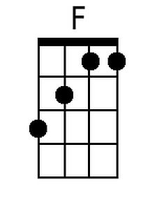 | 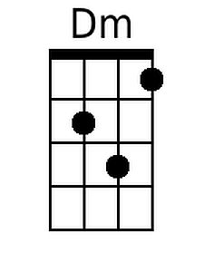 | 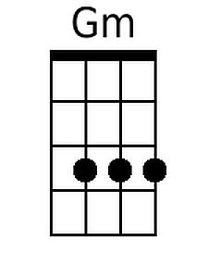
 | 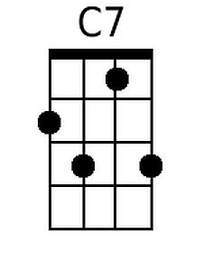 | 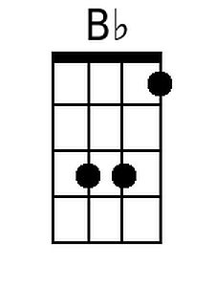 | 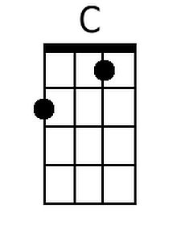
 | 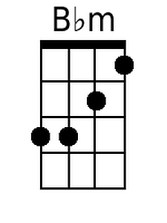 | 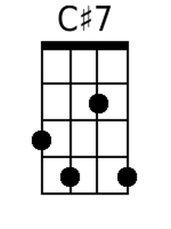 | 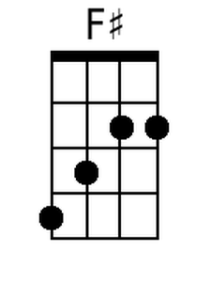
 | 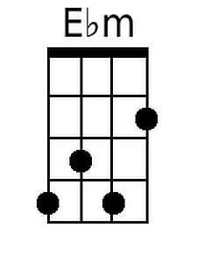 | 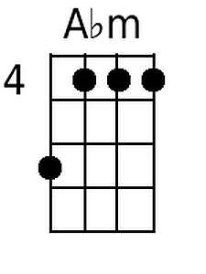 | 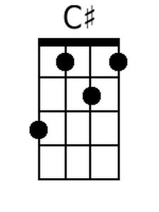
 | 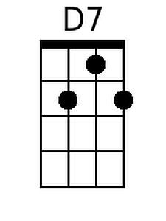 | 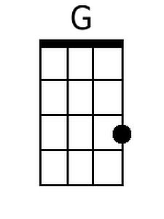 | 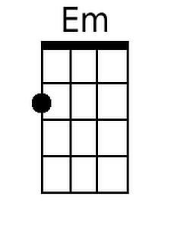
 | 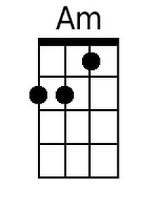 | 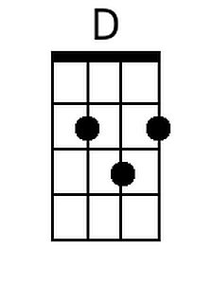 | 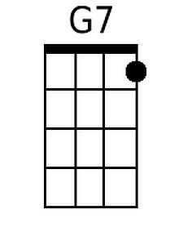
 | 