Today is the First Day of the Rest of My Life (Fugacity) (F)
(Words and music by Pat Garvey and Victoria Garvey, 1968)

F Bb Gm7  Today is the first day of the rest of my life  Gm Dm  I’ll wake as a child to see the world begin  Gm Dm  On monarch wings and birthday wander-ings.  C Gm C C7  I want to put on faces, walk in the wet and the cold  F Bb  And look forward to my growing old...  C Dm  To grow old is to change, and to change is to be new  Bb Gm7 Bb C  To be new is to be young again...I barely remember, when  Dm Gm Dm  My memory is stolen by the morning  Gm Dm  Blotted out by the sun's hypnotic eye  Dm A7 Bb C C7  Out by the sun's hypnotic light.  F Bb Gm7  Today is the first day of the rest of my life  Gm Dm  I’ll wake as a child to see the world begin  Gm Dm  On monarch wings and birthday wander-ings.  C Gm C C7  I want to put on faces, walk in the wet and the cold  F Bb //// Gm //// F/ F 5558*  And look forward to my growing old... |  |  |  |  |  |  | 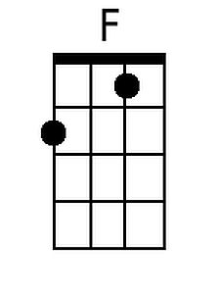 | 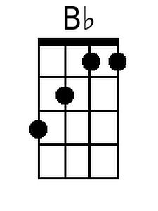
 |  |  |  |  |  |  | 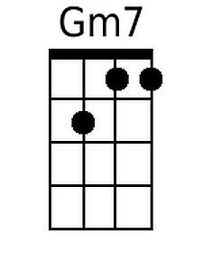 | 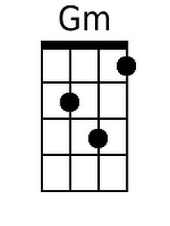
 |  |  |  |  |  |  | 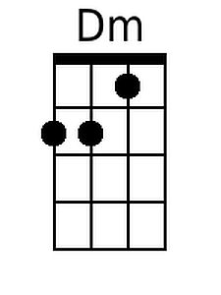 | 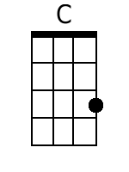
 |  |  |  |  |  |  | 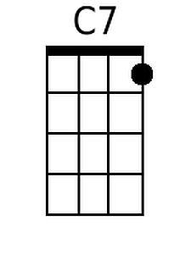 | 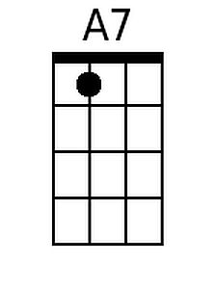
 |  |  |  |  |  |  | 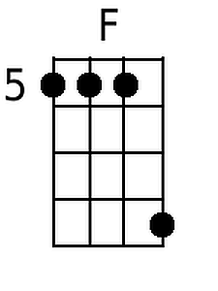
Baritone
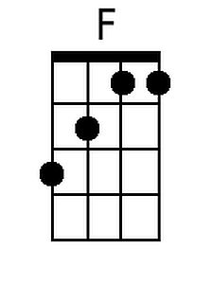 | 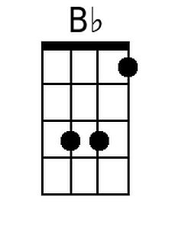 | 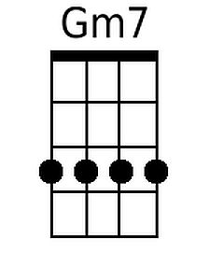 | 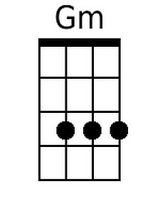 | 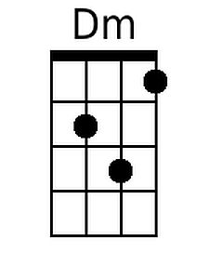 | 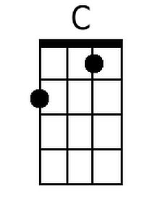 | 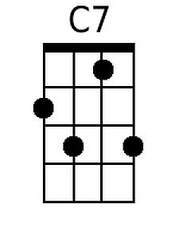 | 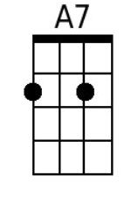 | 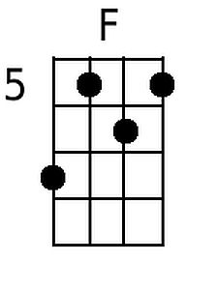

* Bari: 7565
Today is the First Day of the Rest of My Life (Fugacity) (C)
(Words and music by Pat Garvey and Victoria Garvey, 1968)

C F Dm7
Today is the first day of the rest of my life
Dm Am
I'll wake as a child to see the world begin
Dm Am
On monarch wings and birthday wander-ings.
G Dm G G7
I want to put on faces, walk in the wet and the cold
C F
And look forward to my growing old...
G Am
To grow old is to change, and to change is to be new
F Dm7 F G
To be new is to be young again...I barely remember, when
Am Dm Am
My memory is stolen by the morning
Dm Am
Blotted out by the sun's hypnotic eye
Am E7 F G G7
Out by the sun's hypnotic light.

C F Dm7
Today is the first day of the rest of my life
Dm Am
I'll wake as a child to see the world begin
Dm Am
On monarch wings and birthday wander-ings.
G Dm G G7
I want to put on faces, walk in the wet and the cold
C F //// Dm //// C/ C 9787*
And look forward to my growing old...

 |  |  |  |  |  |  | 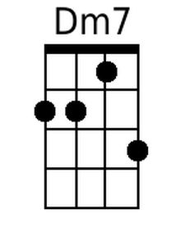
 |  |  |  |  |  |  | 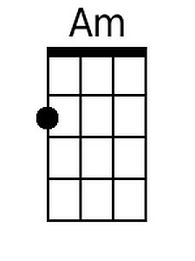 | 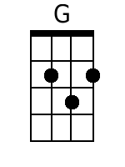
 |  |  |  |  |  |  | 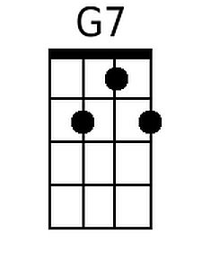 | 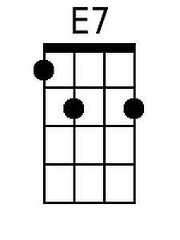
 |  |  |  |  |  |  | 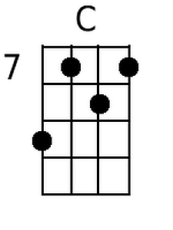
Baritone
 |  | 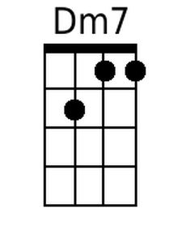 |  | 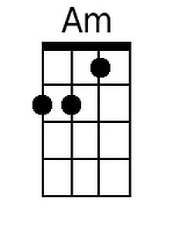 | 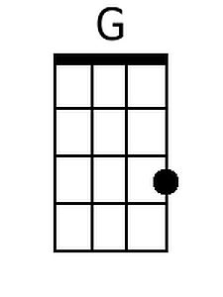 | 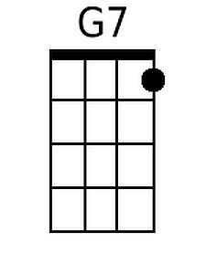 | 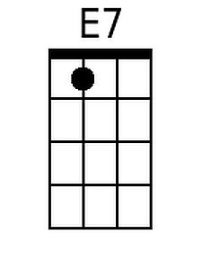 | 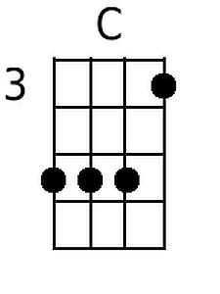

* Bari: 5553

