Today
Key of F (No Key Change) – ¾ Time – GCEA Ukulele
Written by Randy Sparks for the movie “Advance To The Rear.”
Performed on their LP of the same name by The New Christy Minstrels, 1964

GCEA  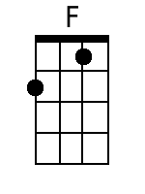  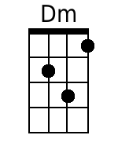  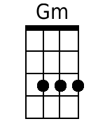  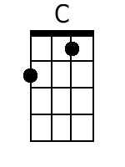  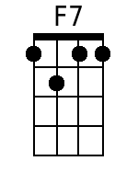  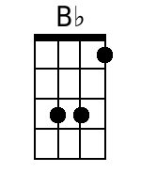  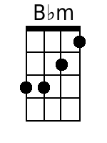 | Intro: F . . |Dm . . |Gm . . |C7 .  . |F . . |Dm . . |Gm . . |C7 .  Chorus: To-day, while the blos-soms still cling to the vine,  . |F . . |Dm . . |Gm . . |C7 .  I’ll taste your straw-ber-ries, I’ll drink your sweet wine.  . |F . . |F7 . . |B♭ . . |B♭m . .  A mill-ion to-morrows shall all pass a-way,  |F . . |Dm . . |Gm . . |C7 . . | . .  Ere I for-get all the joy that is mine-----  . |F . . |Dm . . |Gm . . |C7 .  to-day-----------------  F . . |Dm . . |Gm . . |C7 .  1. I’ll be a dan-dy, and I’ll be a ro-ver.  . |F . . |Dm . . |Gm . . |C7 .  You’ll know who I am by the songs that I sing.  . |F . . |Dm . . |Gm . . |C7 .  I’ll feast at your table, I’ll sleep in your clover.  . |B♭ . . |C . . |F . .  Who ca-ares what the mor-row shall bring? Chorus  . |F . . |Dm . . |Gm . . |C7 .  2. I can’t be con-tented with yester-day’s glory,  . |F . . |Dm . . |Gm . . |C7 .  I can’t live on promises, winter to spring.  . |F . . |Dm . . |Gm . . |C7 .  To-day is my moment and now is my story.  . |B♭ . . |C7 . . |F . . | .  I’ll laugh and I’ll cry and I’ll sing. Chorus.  . |F . . |Dm . . |Gm . . |C7 .  Chorus: To-day, while the blos-soms still cling to the vine,  . |F . . |Dm . . |Gm . . |C7 .  I’ll taste your straw-ber-ries, I’ll drink your sweet wine.  . |F . . |F7 . . |B♭ . . |B♭m . .  A mill-ion to-morrows shall all pass a-way,  |F . . |Dm . . |Gm . . |C7 . . | . .  Ere I for-get all the joy that is mine-----  . |F . . |B♭ . . |F . . |F . .  to-day-----------------

Today
Key of F (No Key Change) – ¾ Time – Bari Ukulele
Written by Randy Sparks for the movie “Advance To The Rear.”
Performed on their LP of the same name by The New Christy Minstrels, 1964

Bari  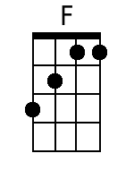  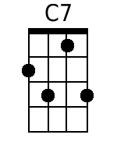 | Intro: F . . |Dm . . |Gm . . |C7 .  . |F . . |Dm . . |Gm . . |C7 .  Chorus: To-day, while the blos-soms still cling to the vine,  . |F . . |Dm . . |Gm . . |C7 .  I’ll taste your straw-ber-ries, I’ll drink your sweet wine.  . |F . . |F7 . . |B♭ . . |B♭m . .  A mill-ion to-morrows shall all pass a-way,  |F . . |Dm . . |Gm . . |C7 . . | . .  Ere I for-get all the joy that is mine-----  . |F . . |Dm . . |Gm . . |C7 .  to-day-----------------  F . . |Dm . . |Gm . . |C7 .  1. I’ll be a dan-dy, and I’ll be a ro-ver.  . |F . . |Dm . . |Gm . . |C7 .  You’ll know who I am by the songs that I sing.  . |F . . |Dm . . |Gm . . |C7 .  I’ll feast at your table, I’ll sleep in your clover.  . |B♭ . . |C . . |F . .  Who ca-ares what the mor-row shall bring? Chorus  . |F . . |Dm . . |Gm . . |C7 .  2. I can’t be con-tented with yester-day’s glory,  . |F . . |Dm . . |Gm . . |C7 .  I can’t live on promises, winter to spring.  . |F . . |Dm . . |Gm . . |C7 .  To-day is my moment and now is my story.  . |B♭ . . |C7 . . |F . . | .  I’ll laugh and I’ll cry and I’ll sing. Chorus.  . |F . . |Dm . . |Gm . . |C7 .  Chorus: To-day, while the blos-soms still cling to the vine,  . |F . . |Dm . . |Gm . . |C7 .  I’ll taste your straw-ber-ries, I’ll drink your sweet wine.  . |F . . |F7 . . |B♭ . . |B♭m . .  A mill-ion to-morrows shall all pass a-way,  |F . . |Dm . . |Gm . . |C7 . . | . .  Ere I for-get all the joy that is mine-----  . |F . . |B♭ . . |F . . |F . .  to-day-----------------

Today
Key of C – ¾ Time – GCEA Ukulele
Written by Randy Sparks for the movie “Advance To The Rear.”
Performed on their LP of the same name by The New Christy Minstrels, 1964

GCEA  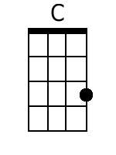  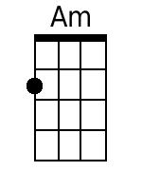  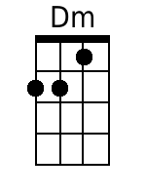  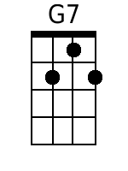  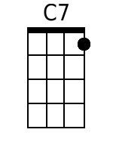  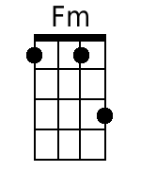 | Intro: C . . |Am . . |Dm . . |G7 .  . |C . . |Am . . |Dm . . |G7 .  Chorus: To-day, while the blossoms still cling to the vine,  . |C . . |Am . . |Dm . . |G7 .  I’ll taste your straw-berries, I’ll drink your sweet wine.  . |C . . |C7 . . |F . . |Fm . .  A mill-ion to-morrows shall all pass a-way,  |C . . |Am . . |Dm . . |G7 . . | . .  Ere I for-get all the joy that is mine  . |C . . |Am . . |Dm . . |G7 .  to-day------------------  . |C . . |Am . . |Dm . . |G7 .  1. I’ll be a dandy, and I’ll be a rover.  . |C . . |Am . . |Dm . . |G7 .  You’ll know who I am by the songs that I sing.  . |C . . |Am . . |Dm . . |G7 .  I’ll feast at your table, I’ll sleep in your clover.  . |F . . |G . . |C . . |G7 .  Who cares what the morrow shall bring? Chorus  . |C . . |Am . . |Dm . . |G7 .  2. I can’t be con-tented with yesterday’s glory,  . |C . . |Am . . |Dm . . |G7 .  I can’t live on promises, winter to spring.  . |C . . |Am . . |Dm . . |G7 .  To-day is my moment and now is my story.  . |F . . |G . . |C . . |G7 .  I’ll laugh and I’ll cry and I’ll sing. Chorus.  . |C . . |Am . . |Dm . . |G7 .  Chorus: To-day, while the blossoms still cling to the vine,  . |C . . |Am . . |Dm . . |G7 .  I’ll taste your straw-berries, I’ll drink your sweet wine.  . |C . . |C7 . . |F . . |Fm . .  A million to-morrows shall all pass a-way,  |C . . |Am . . |Dm . . |G7 . . | . .  Ere I for-get all the joy that is mine  . |C . . |F . . |C . . |C . .  to-day----------------

Today
Key of C – ¾ Time – Bari Ukulele
Written by Randy Sparks for the movie “Advance To The Rear.”
Performed on their LP of the same name by The New Christy Minstrels, 1964

Bari  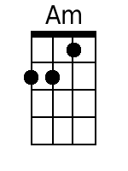  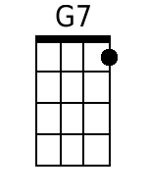  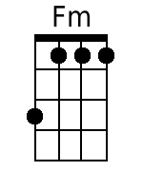 | Intro: C . . |Am . . |Dm . . |G7 .  . |C . . |Am . . |Dm . . |G7 .  Chorus: To-day, while the blossoms still cling to the vine,  . |C . . |Am . . |Dm . . |G7 .  I’ll taste your straw-berries, I’ll drink your sweet wine.  . |C . . |C7 . . |F . . |Fm . .  A mill-ion to-morrows shall all pass a-way,  |C . . |Am . . |Dm . . |G7 . . | . .  Ere I for-get all the joy that is mine  . |C . . |Am . . |Dm . . |G7 .  to-day------------------  . |C . . |Am . . |Dm . . |G7 .  1. I’ll be a dandy, and I’ll be a rover.  . |C . . |Am . . |Dm . . |G7 .  You’ll know who I am by the songs that I sing.  . |C . . |Am . . |Dm . . |G7 .  I’ll feast at your table, I’ll sleep in your clover.  . |F . . |G . . |C . . |G7 .  Who cares what the morrow shall bring? Chorus  . |C . . |Am . . |Dm . . |G7 .  2. I can’t be con-tented with yesterday’s glory,  . |C . . |Am . . |Dm . . |G7 .  I can’t live on promises, winter to spring.  . |C . . |Am . . |Dm . . |G7 .  To-day is my moment and now is my story.  . |F . . |G . . |C . . |G7 .  I’ll laugh and I’ll cry and I’ll sing. Chorus.  . |C . . |Am . . |Dm . . |G7 .  Chorus: To-day, while the blossoms still cling to the vine,  . |C . . |Am . . |Dm . . |G7 .  I’ll taste your straw-berries, I’ll drink your sweet wine.  . |C . . |C7 . . |F . . |Fm . .  A million to-morrows shall all pass a-way,  |C . . |Am . . |Dm . . |G7 . . | . .  Ere I for-get all the joy that is mine  . |C . . |F . . |C . . |C . .  to-day----------------

