**Today (While the Blossoms Still Cling to the Vine) (Randy Sparks)**

**Intro: C Am F G7 F G7 C G7**

**Chorus:**

**C Am F G7**

Today while the blossoms still cling to the vine

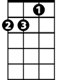

Dm



C

F

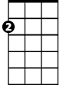

Am

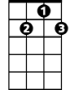

G7

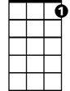

C7

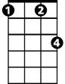

Fm

**BARITONE**



Am



F



G7

C

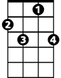

C7

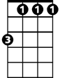

Fm

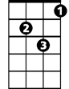

Dm

**C Am F G7**

I’ll taste your strawberries, I’ll drink your sweet wine

**C C7 F Fm**

A million to-morrows will all pass away

**C Am Dm G7 C Am Dm G7**

‘Ere I forget all the joy that is mine today

**C Am F G7**

I’ll be a dandy and I’ll be a rover

**C Am F G7**

You’ll know who I am by the song that I sing

**C Am F G7**

I’ll feast at your table, I’ll sleep in your clover

**F G7 C G7**

Who cares what tomorrow will bring

**(Chorus)**

**C Am F G7**

I can’t be contented with yesterday’s glories,

**C Am F G7**

I can’t live on promises winter to spring

**C Am F G7**

Today is my moment and now is my story

**F G7 C G7**

I’ll laugh and I’ll cry and I’ll sing

**C Am F G7**

Today while the blossoms still cling to the vine

**C Am F G7**

I’ll taste your strawberries, I’ll drink your sweet wine

**C C7 F Fm**

A million to-morrows shall all pass away

**C Am Dm G7 C Am Dm G7 C**

‘Ere I forget all the joy that is mine today