Tonight You Belong To Me (Billy Rose / Lee David) (C)

Intro: C Csus4 C (2x)  C C7  I know (I know) you beloooooong  F Fm  To sooooome-body neeeeeew  C G C  But tonight, you belong to me  C Csus4 C (2x)  C C7  Although (although) we're a-paaaaaart  F Fm  You're a paaaaart of my heaaaaart  C G C C7  And tonight, you belong to me  Reprise  Fm  Way down by the stream, how sweet it will seem  C A7 D7 G7  Once more just to dream in the moonlight, my honey,  2nd Time Through:  C A7 D7  Once more just to dream in the silvery moonlight,  G7  my honey,  C C7  I know (I know) with the daaaaaawn  F Fm  That yo-u will be goooooone  C G C  But to-night, you be-long to me. (Repeat From Reprise)  G7 C C Csus4 C  Just little old me. |  |  |  |  |  |  |  |  |  |  |  |  | 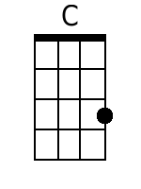 |  |  |  | 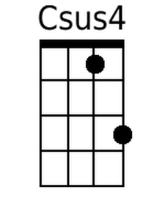
 |  |  |  |  |  |  |  |  |  |  |  |  | 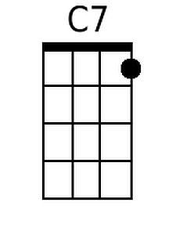 |  |  |  | 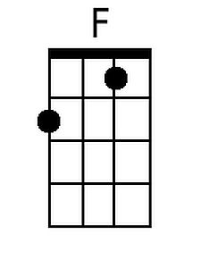
 |  |  |  |  |  |  |  |  |  |  |  |  | 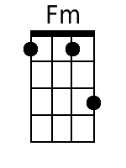 |  |  |  | 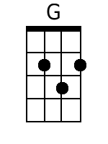
 |  |  |  |  |  |  |  |  |  |  |  |  | 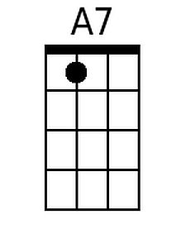 |  |  |  | 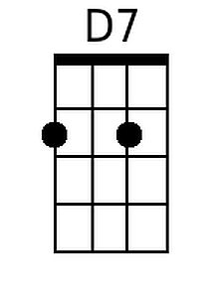
 |  |  |  |  |  |  |  |  |  |  |  |  | 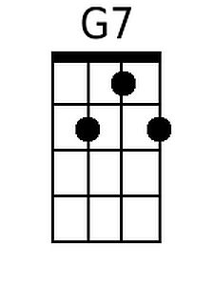
 |  |  |  |  |  |  |  |  |  |  |  |  | Note: The “Repeat From Reprise” ending is performed by Patience & Prudence, the Lennon Sisters, and Nancy Sinatra; Steve Martin and Bernadette Peters omit the repeat in the movie “The Jerk.”
Bari
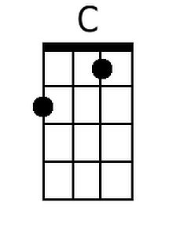 |  | 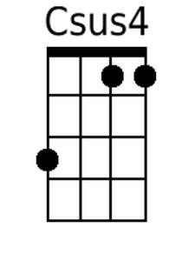 |  | 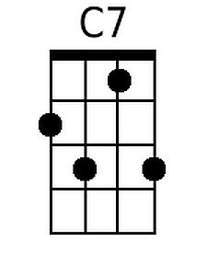 |  | 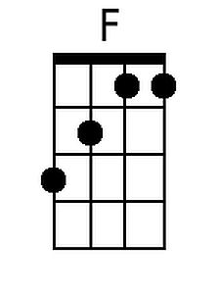 |  | 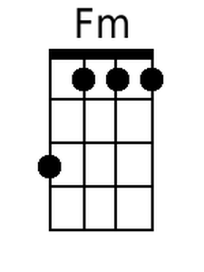 |  | 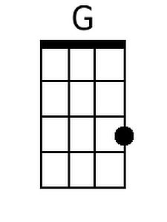 |  | 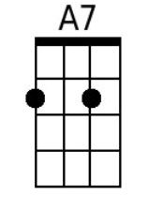 |  |  | 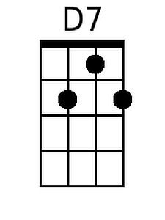 |  | 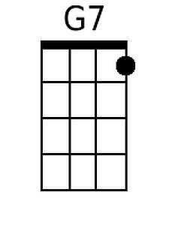

Tonight You Belong To Me (Billy Rose / Lee David) (G)

Intro: G Gsus4 G (2x)  G G7  I know (I know) you beloooooong  C Cm  To sooooome-body neeeeeew  G D G  But tonight, you belong to me  G Gsus4 G (2x)  G G7  Although (although) we're a-paaaaaart  C Cm  You're a paaaaart of my heaaaaart  G D G G7  And tonight, you belong to me  Reprise  Cm  Way down by the stream, how sweet it will seem  G E7 A7 D7  Once more just to dream in the moonlight, my honey,  2nd Time Through:  G E7 A7  Once more just to dream in the silvery moonlight,  D7  my honey,  G G7  I know (I know) with the daaaaaawn  C Cm  That yo-u will be goooooone  G D G  But to-night, you be-long to me. (Repeat From Reprise)  D7 G G Gsus4 G  Just little old me. |  |  |  |  |  |  |  | 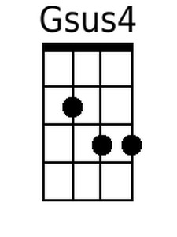
 |  |  |  |  |  |  | 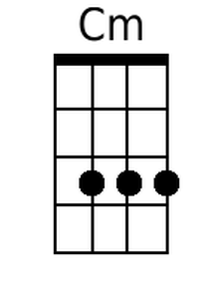 | 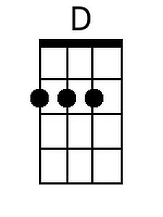
 |  |  |  |  |  |  | 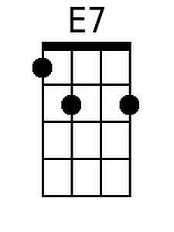
 |  |  |  |  |  |  | Note: The “Repeat From Reprise” ending is performed by Patience & Prudence, the Lennon Sisters, and Nancy Sinatra; Steve Martin and Bernadette Peters omit the repeat in the movie “The Jerk.”
Bari
 | 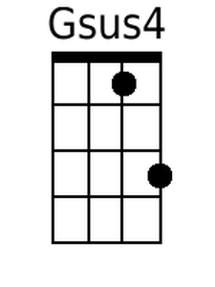 |  |  | 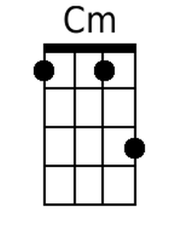 | 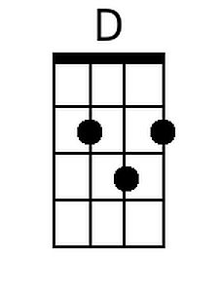 | 