**Tonight You Belong To Me (Billy Rose / Lee David)**

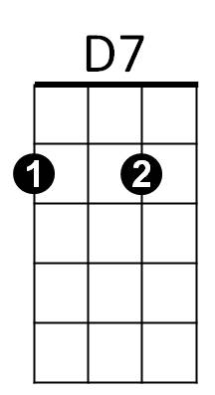**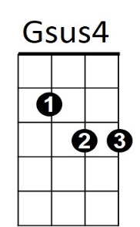Intro: G Gsus4 G 2x**

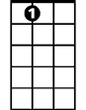

A7

E7

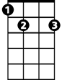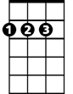

D



C



G

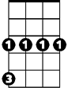

Cm

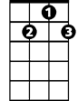

G7

**G G7**

I know - I know- you beloooooong

**C Cm**

To sooooome-body neeeeeew

**G D G**

But tonight, you belong to me

**G Gsus4 G 2x**

**G G7**

Although -although- we're apaaaaaart

**C Cm**

You're a paaaaart of my heaaaaart

**G D G G7**

And tonight, you belong to me

**Reprise:**

**Cm**

Way down by the stream, how sweet it will seem

**G E7 A7**

Once more just to dream in the moonlight

**D7**

My honey -

**G G7**

I know -I know- With the daaaaaawn

**C Cm**

That yo-u will be goooooone

**G D G**

But tonight, you belong to me

**D7 G G Gsus4 G**

Just little old me

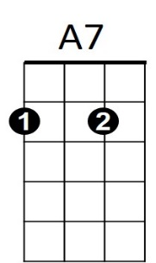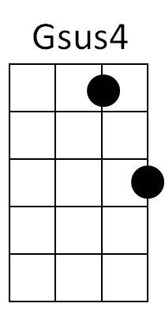



G



D7

C



**BARITONE**

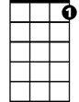

G7

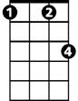

Cm



D



E7