**Toora Loora Looral (Irish Lullaby) (James Royce Shannon)**

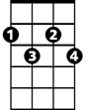

F#dim

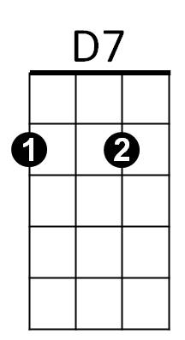**CHORUS:**

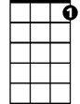

C7

F



C

**C F C C7**

Too ra loo ra loo ral

**F F#dim**

Too ra loo ra ly

**C F C**

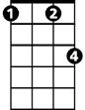

Fm

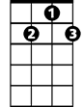

G7

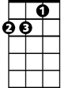

Dm

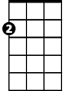

Am

Too ra loo ra loo ral

**D7 G7**

Hush now don't you cry

**C F C C7**

Too ra loo ra loo ral

**F F#dim**

Too ra loo ra ly

**BARITONE**



F

C



**C F C**

Too ra loo ra loo ral

**D7 Fm C**

That's an Irish lul – la - by

**C F C Am C G7**

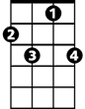

C7

Over in Killarney, many years ago

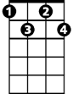

Fdim

**C F C D7 Dm G7**

My mother sang a song to me in tones so sweet and low

**C F C Am C**

Just a simple little ditty in her good old Irish way

**F C Am D7 Dm G7**



G7



D7

And I'd give the world if she could sing that song to me today

**(CHORUS)**

**C F C Am C G7**

Oft' in dreams I wander to that cot again



Am

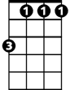

Fm

**C F C D7 Dm G7**

I feel her arms a-huggin' me as when she did back then

**C F C Am C**

I hear her softly hummin' to me as in days of yore

**F C Am D7 Dm G7**

When she used to rock me fast asleep outside that cottage door

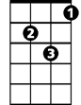

Dm

**(CHORUS)**