**Top of the World (Richard Carpenter & John Bettis, 1972)**

**Intro: C F / C F / C F / C G7**

F



G

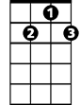

G7



C

**C G F C**

Such a feelin's comin' over me

**Em Dm G7 C C7**

There is wonder in most every-thing I see

**F G Em Am**

Not a cloud in the sky - Got the sun in my eyes

**Dm G G7**

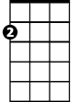

Am

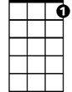

C7

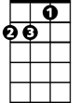

Dm

Em

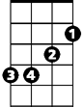

And I won't be surprised if it's a dream

**C G F C**

Everything I want the world to be

**Em Dm G7 C C7**

Is now coming true es-pecial-ly for me

**F G Em Am**

And the reason is clear - It's because you are here

**Dm G**

You're the nearest thing to heaven that I've seen

**Chorus:**

**C F**

I'm on the top of the world lookin' down on creation

**C Dm G7 C C7**

And the only expla-nation I can find

**F G C F**

Is the love that I've found ever since you've been around

**C Dm G C**

Your love's put me at the top of the world

**C F / C F /C F / C G7**

**C G F C**

Something in the wind has learned my name

**Em Dm G7 C C7**

And it's tellin' me that things are not the same



G

**BARITONE**

C



F



G7

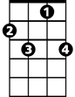

C7

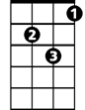

Dm

**F G Em Am**

In the leaves on the trees - and the touch of the breeze

**Dm G G7**

There's a pleasin' sense of happiness for me

**C G F C**

There is only one wish on my mind



Am



Em

**Em Dm G7 C C7**

When this day is through I hope that I will find

**F G Em Am**

That tomorrow will be - just the same for you and me

**Dm G G7**

All I need will be mine if you are here

**(Chorus) 2x (End with) C F / C F / C F / C**