Top of the World (Richard Carpenter & John Bettis, 1972) (G)

Intro: G C / G C / G C / G D7  G D C G  Such a feelin's comin' over me  Bm Am D7 G G7  There is wonder in most every-thing I see  C D Bm Em  Not a cloud in the sky - Got the sun in my eyes  Am D D7  And I won't be surprised if it's a dream  G D C G  Everything I want the world to be  Bm Am D7 G G7  Is now coming true es-pecial-ly for me  C D Bm Em  And the reason is clear - It's because you are here  Am D  You're the nearest thing to heaven that I've seen  Chorus  G C  I'm on the top of the world lookin' down on creation  G Am D7 G G7  And the only expla-nation I can find  C D G C  Is the love that I've found ever since you've been around  G Am D G  Your love's put me at the top of the world.  G C / G C / G C / G D7  G D C G  Something in the wind has learned my name  Bm Am D7 G G7  And it's tellin' me that things are not the same  C D Bm Em  In the leaves on the trees - and the touch of the breeze  Am D D7  There's a pleasin' sense of happiness for me  G D C G  There is only one wish on my mind  Bm Am D7 G G7  When this day is through I hope that I will find  C D Bm Em  That tomorrow will be - just the same for you and me  Am D D7  All I need will be mine if you are here  Chorus (2x) (End with) G C / G C / G C / G | 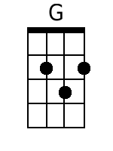 | 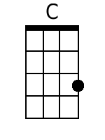 | 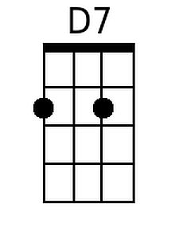 | 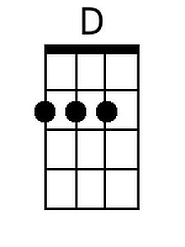
 | 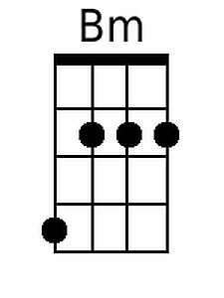 | 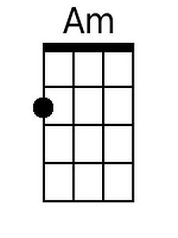 | 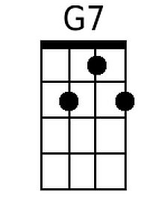 | 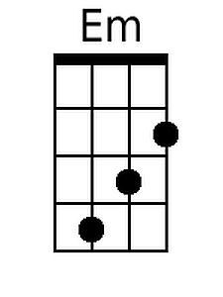
 | 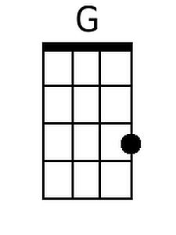 | 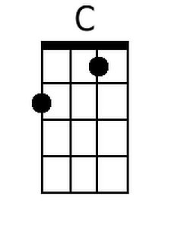 | 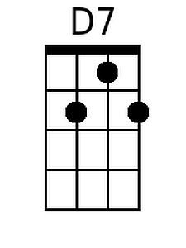 | 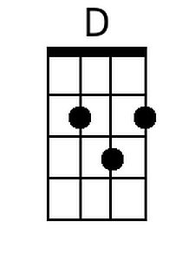
 | 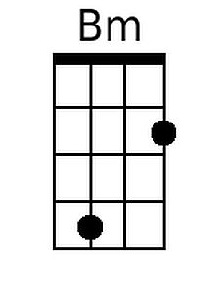 | 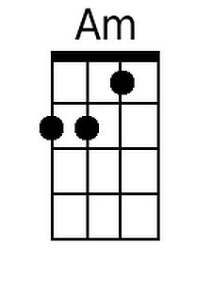 | 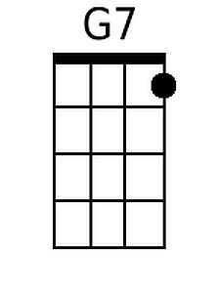 | 