**Try To Remember (Tom Jones, Harvey Schmidt, 1960) – Key of C**

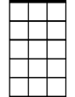

Am7

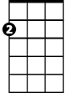

Am

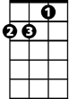

Dm



C

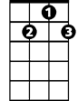

G7

Em7

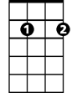

**Intro: C Am Dm G7**

**C Am Dm G7**

Try to remember the kind of September

**C Am Dm G7**

When life was slow and oh, so mellow.

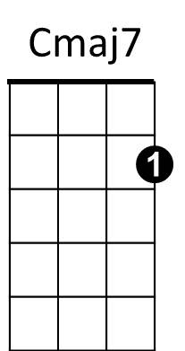**C Am Dm G7**



Bb

Try to remember the kind of September

**C Am Dm G7**

When grass was green and grain was yellow.

**Em7 Am7 Dm7 G7**

Try to remember the kind of September,

**Cmaj7 Fmaj7 Bb G7**

When you were a tender and callow fellow.

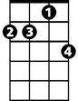

Dm7

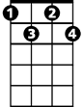

Fdim

**C Am Dm G7 C Am Fmaj7 G7**

Try to remember, and if you remember, then follow.

**C Am Dm G7**

Try to re member when life was so tender,

**C Am Dm G7**

That no one wept except the willow.

**BARITONE**

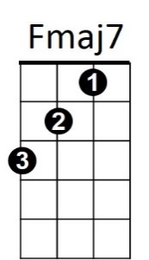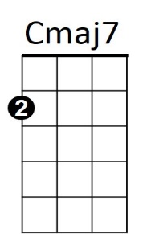**C Am Dm G7**

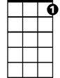

G7

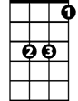

Bb



Am7



Em7

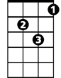

Dm

C



Am

Try to remember when life was so tender,

**C Am Dm G7**

That dreams were kept beside your pillow.

**Em7 Am7 Dm7 G7**

Try to remember when life was so tender,

**Cmaj7 Fmaj7 Bb G7**

That love was an ember about to billow.

**C Am Dm G7 C Am Fmaj7 G7**

Try to remember, and if you remember, then follow.

**C Am Dm G7**

Deep in December, it's nice to remember,

**C Am Dm G7**

Although you know the snow will follow.

**C Am Dm G7**

Deep in December, it's nice to remember,

**C Am Dm G7**

Without a hurt the heart is hollow.

**Em7 Am7 Dm7 G7**

Deep in December, it's nice to remember,

**Cmaj7 Fmaj7 Bb G7**

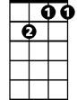

Dm7

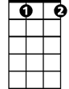

Fdim

The fire of September that makes us mellow.

**C Am Dm G7 C Am Fmaj7 Fdim C**

Try to remember, and if you remember, then follow.

**Try To Remember (Tom Jones, Harvey Schmidt, 1960) - Key of G**

[**Try to Remember**](https://www.youtube.com/watch?v=V1FdV9QgYME) **by The Brothers Four (1965)**



G

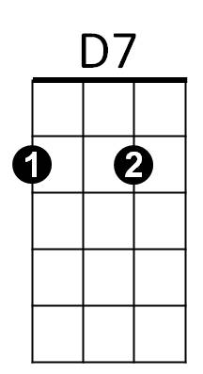

Em

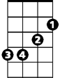

Am

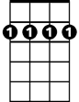

Bm7

**Intro: G Em Am D7**

**G Em Am D7**

Try to remember the kind of September

**G Em Am D7**

When life was slow and oh, so mellow.

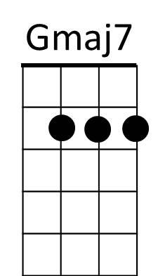**G Em Am D7**



Am7

Em7



Try to remember the kind of September

**G Em Am D7**

When grass was green and grain was yellow.

**Bm7 Em7** **Am7 D7**

Try to remember the kind of September,

**Gmaj7 Cmaj7 F D7**

F

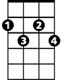

Cdim

When you were a tender and callow fellow.

**G Em Am D7 G Em Cmaj7 D7**

Try to remember, and if you remember, then follow.

**G Em Am D7**

Try to remember when life was so tender,

**G Em Am D7**

That no one wept except the willow.

**BARITONE**

**G Em Am D7**



G



Em



Am

Try to remember when life was so tender,

**G Em Am D7**

That dreams were kept beside your pillow.

**Bm7 Em7 Am7 D7**

Try to remember when life was so tender,

**Gmaj7 Cmaj7 F D7**

That love was an ember about to billow.

Bm7



D7

**G Em Am D7 G Em Cmaj7 D7**

Try to remember, and if you remember, then follow.

**G Em Am D7**

Deep in December, it's nice to remember,

**G Em Am D7**

Although you know the snow will follow.



Em7



Am7

**G Em Am D7**

Deep in December, it's nice to remember,

**G Em Am D7**

Without a hurt the heart is hollow.

**Bm7 Em7 Am7 D7**

Deep in December, it's nice to remember,

**Gmaj7 Cmaj7 F D7**



F



Cdim

The fire of September that makes us mellow.

**G Em Am D7 G Em Cmaj7 Cdim G**

Try to remember, and if you remember, then follow.