**Try to Remember (Harvey Schmidt / Tom Jones) Key C**

**C Dm 2x**

**C Am Dm G7**

Try to remember, the kind of September,

**C Am Dm G7**

When life was slow and oh, so mellow.

**C Am Dm G7**

Try to remember, the kind of September,

**C Am Dm G7**

When grass was green and grain was yellow.

**Em Am Dm G7**

Try to remember, the kind of September,

**C Am Dm G7**

When you were a tender and callow fellow.

**C A** **m Dm G7**

Try to remember, and if you remember,

**C**

then follow.

**C Am Dm G7**

Try to remember, when life was so tender,

**C Am Dm G7**

That no one wept, except the willow.

**C Am Dm G7**

Try to remember, when life was so tender,

**C Am Dm G7**

That dreams were kept, beside your pillow.

**Em Am Dm G7**

Try to remember, when life was so tender,

**C Am Dm G7**

That love was an ember, about to billow.

**C Am Dm G7**

Try to remember, and if you remember,

**C**

then follow.

**BARITONE**

C



**C Am Dm G7**

Deep in December, it's nice to remember,

**C Am Dm G7**

Although you know, the snow will follow.

**C Am Dm G7**

Deep in December, it's nice to remember,

**C Am Dm G7**

Without a hurt, the heart is hollow.

**Em Am Dm G7**

Deep in December, it's nice to remember,

**C Am Dm G7**

The fire of September, that made us mellow.

**C Am**

Deep in December,

**Dm G7**

Our hearts should remember,

**C Am C Am C**

And follow, follow, follow, follow, follow . . .

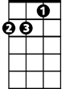

Dm

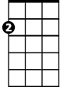

Am

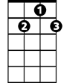

G7



C

Em

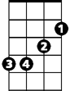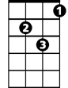

Dm



Em

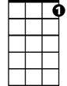

G7



Am

**Try to Remember (Harvey Schmidt / Tom Jones) Key G**

**G Am 2x**

**G Em Am D7**

Try to remember, the kind of September,

**G Em Am D7**

When life was slow and oh, so mellow.

**G Em Am D7**

Try to remember, the kind of September,

**G Em Am D7**

When grass was green and grain was yellow.

**Bm Em Am D7**

Try to remember, the kind of September,

**G Em Am D7**

When you were a tender and callow fellow.

**G Em Am D7**

Try to remember, and if you remember,

**G**

then follow.

**G Em Am D7**

Try to remember, when life was so tender,

**G Em Am D7**

That no one wept, except the willow.

**G Em Am D7**

Try to remember, when life was so tender,

**G Em Am D7**

That dreams were kept, beside your pillow.

**Bm Em Am D7**

Try to remember, when life was so tender,

**G Em Am D7**

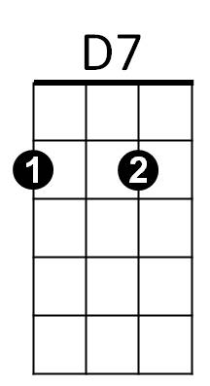That love was an ember, about to billow.

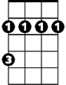

Bm

Em



Am

**G Em Am D7**



G

Try to remember, and if you remember,

**G**

then follow.



D7

**BARITONE**



Am



Em

Bm



G

**G Em Am D7**

Deep in December, it's nice to remember,

**G Em Am D7**

Although you know, the snow will follow.

**G Em Am D7**

Deep in December, it's nice to remember,

**G Em Am D7**

Without a hurt, the heart is hollow.

**Bm Em Am D7**

Deep in December, it's nice to remember,

**G Em Am D7**

The fire of September, that made us mellow.

**G Em**

Deep in December,

**Am D7**

Our hearts should remember,

**G Em G Em G**

And follow, follow, follow, follow, follow . .