Twilight Time (Buck Ram, Morty Nevins, Al Nevins, Artie Dunn, 1944) (C)
Twilight Time by the Platters (A) – (Tempo 116 BPM)

Intro (2 Measures) C  C E7  Heavenly shades of night are falling, it's Twilight Time.  Am C7  Out of the mist your voice is calling, it's Twilight Time.  F Fm C A7  __When purple colored curtains mark the end of day,  D7 G - G7  I hear you, my dear, at twilight time.  C E7  Deeping shadows gather splendor as day is done.  Am C7  Fingers of night will soon surrender the setting sun.  F Fm C A7  __I count the moments darling till you're here with me,  D7 G7 C  Together, at last, at twilight time.  Chorus  E7  Here in the after glow of day  Am  We keep our rendezvous beneath the blue.  D7  Here in the sweet and same old way  G7  I fall in love again as I did then.  C E7  Deep in the dark your kiss will thrill me __ like days of old.  Am C7  Lighting the spark of love that fills me _ with dreams untold.  F Fm C A7  __ Each day I pray for evening, just to be with you,  D7 G7 C  To-gether at last at twilight time.  Repeat from Chorus  Outro (Ritard.)  D7 G7 C  To-gether at last at twilight time. | 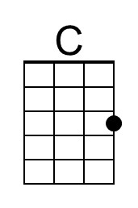 | 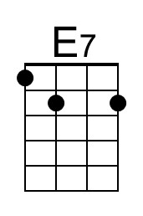 | 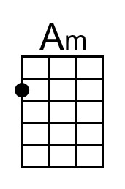
 | 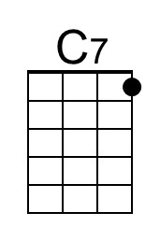 | 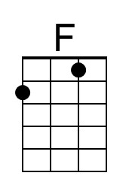 | 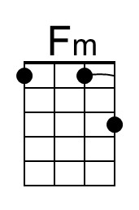
 | 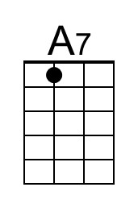 | 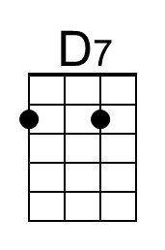 | 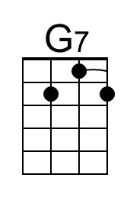
 | Bari | 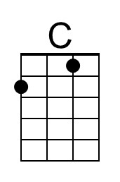 | 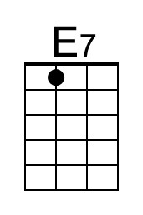
 | 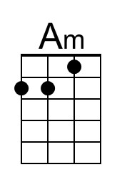 | 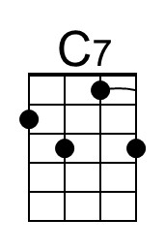 | 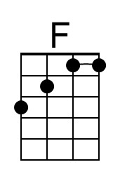
 | 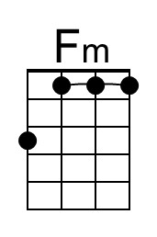 | 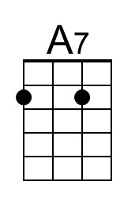 | 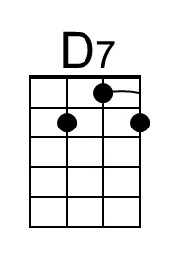
 | 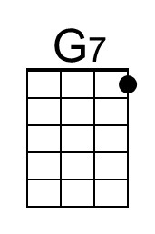

Twilight Time (Buck Ram, Morty Nevins, Al Nevins, Artie Dunn, 1944) (G)
Twilight Time by the Platters (A) – (Tempo 116 BPM)

Intro (2 Measures) G  G B7  Heavenly shades of night are falling, it's Twilight Time.  Em G7  Out of the mist your voice is calling, it's Twilight Time.  C Cm G E7  __When purple colored curtains mark the end of day,  A7 D - D7  I hear you, my dear, at twilight time.  G B7  Deeping shadows gather splendor as day is done.  Em G7  Fingers of night will soon surrender the setting sun.  C Cm G E7  __I count the moments darling till you're here with me,  A7 D7 G  Together, at last, at twilight time.  Chorus  B7  Here in the after glow of day  Em  We keep our rendezvous beneath the blue.  A7  Here in the sweet and same old way  D7  I fall in love again as I did then.  G B7  Deep in the dark your kiss will thrill me __ like days of old.  Em G7  Lighting the spark of love that fills me _ with dreams untold.  C Cm G E7  __ Each day I pray for evening, just to be with you,  A7 D7 G  To-gether at last at twilight time.  Repeat from Chorus  Outro (Ritard.)  A7 D7 G  To-gether at last at twilight time. | 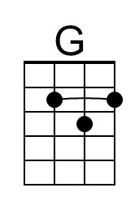 | 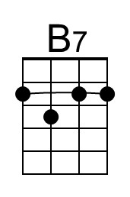 | 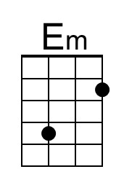
 |  |  | 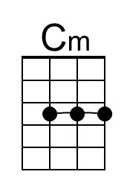
 | Bari | 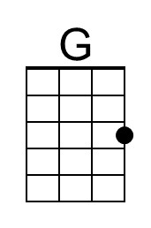 | 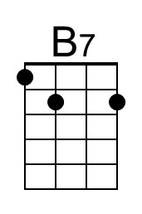
 | 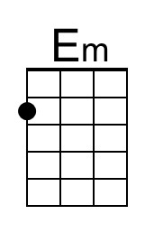
 | 