**Twilight Zone (Golden Earring)**

**Dm**

It's two AM and the fear is gone

**Gm**

I'm sittin' here waiting - the gun's still warm

**Am**

Thinking my connection is tired

**Dm**

of taking chances

**Dm**

Yeah, there's a storm on the loose,

Sirens in my head

**Gm**

Wrapped up in silence, all circuits are dead

**Am**

Cannot decode –

**Dm**

My whole life spins into a frenzy

**Chorus:**

**Dm**

Help, I'm stepping into the Twilight Zone

**C**

The place is a mad-house,

Feels like being cloned

**G**

My beacon's been moved under moon and star

**A A7**

Where am I to go now that I've gone too far?

**Dm**

Help, I'm stepping into the Twilight Zone

**C**

The place is a mad-house,

Feels like being cloned

**G**

My beacon's been moved under moon and star

**A A7**

Where am I to go now that I've gone too far?

**G Gm**

Soon you will come to know

**Dm**

When the bullet hits the bone

**G Gm**

Soon you will come to know

**Dm**

When the bullet hits the bone

**Dm**

I'm fallin' down a spiral, destination unknown

**Gm**

A double-cross messenger, all alone

**Am**

Can't get no connection - can't get through,

**Dm**

where are you?

**Dm**

Well the night weighs heavy on his guilty mind

**Gm**

This far from the border line

**Am**

And when the hitman comes

**Dm**

He knows damn well he has been cheated

And he says:

**(Chorus)**

**Gm Dm (Repeat to fade)**

When the bullet hits the bone



C

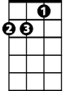

Dm

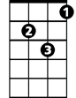

Gm

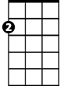

Am



G

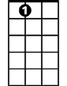

A7

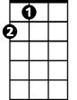

A

**BARITONE**

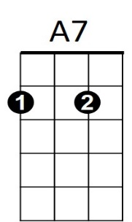



G



Am



Dm

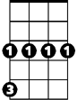

Gm

C

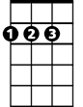

A