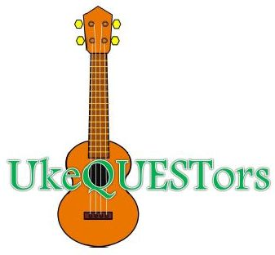

**UkeQuestors Jam Special Interest Group (SIG)**

**Every Sunday from 2:00 to 3:30 pm in the Second Floor Events Room**

**Huntsville/Madison County Public Library, 915 Monroe St SW, Huntsville, Ala.**

***If the library is closed for any reason, our Jam is canceled for that day.***

**2021 Calendar Highlights**

**All dates subject to change; check our Facebook page**

**September 5 No Meeting (Labor Day, Mon, Sept. 6)**

**September 25 Alabama Ukulele Festival performance**

**September 26 No Meeting**

**November 28 No Meeting (Thanksgiving, Thu, Nov. 25)**

**December 26 No Meeting (Christmas Day, Fri, Dec. 24)**

**January 3 No Meeting (New Year's Day, Fri, Dec. 31)**