

**Special Interest Group (SIG)**

**SONGBOOK**

**First Edition**

|  |
| --- |
|  |

**Songlist**

|  |  |  |
| --- | --- | --- |
| **Title** | **Event** | **Page** |
| **Bye, Bye, Love** | **AUF18** |  |
| **Did She Mention My Name** |  |  |
| **Let Me Be There** | **AUF18** |  |
| **Let the Love Flow** | **AUF18** |  |
| **Love Will Keep Us Alive** |  |  |
| **Save the Last Dance for Me** | **AUF18** |  |
| **Sloop John B** | **AUF18** |  |
| **Last Thing on My Mind** | **AUF18** |  |
| **When I’m 64** |  |  |
| **Solitary Man** |  |  |
| **Another Saturday Night** |  |  |
| **Will the Circle Be Unbroken** |  |  |
| **My Girl** |  |  |
| **Ring of Fire** |  |  |
| **Blowing in the Wind** | **LQ Mtg** |  |
| **This Land is Your Land** | **LQ Mtg** |  |
| **Tiny Bubbles** | **LQ Mtg/ RCUF 1** |  |
| **You Are My Sunshine** | **LQ Mtg** |  |
| **Hey Good Looking** | **RCUF 1** |  |
| **Five Foot Two** | **RCUF 1** |  |
| **I’d Like to Teach the World to Sing** | **RCUF 1** |  |
| **Jamaica Farewell** | **RCUF 1** |  |
| **Under the Boardwalk** | **RCUF 1** |  |
|  |  |  |
|  |  |  |

**Bye Bye Love**

**Intro: Chords for last line of chorus, 2x**

**Chorus:**

F



C

**F C F C F**

Bye, bye, love, bye, bye, happiness,

**C G7 C**

Hello loneliness, I think I'm gonna cry

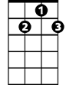

G7

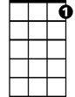

C7

**F C F C F**

Bye, bye, love, bye, bye, sweet caress,

**C G7 C**

Hello emptiness, I feel like I could die,

**G7 C**

Bye, bye, my love, bye, bye

**C G7 C**

There goes my baby with someone new

**C G7 C C7**

She sure looks happy, I sure am blue

**F G7**

She was my baby, ‘til he stepped in

**C F C**

Goodbye to romance, that might have been

**(CHORUS)**

**BARITONE**



F

C



**C G7 C**

I'm through with romance, I'm through with love

**C G7 C C7**

I'm through with counting, the stars a----bove

**F G7**



G7

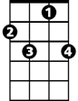

C7

And here's the reason, that I'm so free

**C F C**

My loving baby, is through with me

**(CHORUS) Repeat last line to end**

**Did She Mention My Name (Gordon Lightfoot)**



G



C

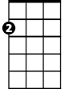

Am

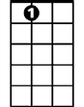

A7

**G C Am**

It's so nice to meet an old friend, and pass the time of day,

**D D7 G**

And talk about the hometown, a million miles away,

**C Am**

Is the ice still in the river, are the old folks still the same,

**D G**

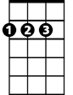

D

And by the way, did she mention my name?

**C D G Em**

Did she mention my name, just in passing, and when the morning came

**A7 D D7**

Do you remember if she dropped a name or two?

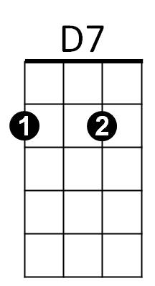

Em

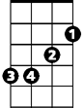

**G C Am**

Is the home team still on fire, do they still win all their games,

**D D7 G**

And by the way, did she mention my name?

**G C Am**

Is the landlord still a loser, do his signs hang in the hall,

**D D7 G**

Are the young girls still as pretty in the city in the fall?

**C Am**

**BARITONE**

Does the laughter on their faces still put the sun to shame,

C



G

**D D7 G**

And by the way, did she mention my name.

**C D G Em**

Did she mention my name just in passing, and when the talk ran high,

**A7 D D7**

Did the look in her eye seem far away,



D

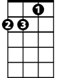

Am



D7

**G C Am**

Is the old roof still leaking, when the late snow turns to rain,

**D D7 G**

And by the way, did she mention my name?

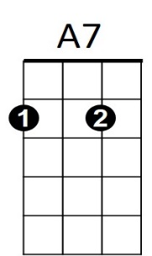 **C D G Em**

Did she mention my name just in passing, and looking at the rain,



Em

**A7 D D7**

Do you remember if she dropped a name or two?

**G C Am**

Won't you say hello from someone, there'll be no need to explain,

**D D7 G**

And by the way, did she men - tion my name?

**Let Me Be There (John Rostil)**



C

F



**Intro: Chords folr ending**

**C F C**

Wherever you go, wherever you may wander in your life,

**G7**

Surely you know, I’ll always want to be there



G7



C7

**C C7 F**

Just holding your hand, and standing by to catch you

**C G7 C F C**

When you fall, seeing you through, in everything you do

**Chorus:**

**C**

Let me be there in your morning

**F**

Let me be there in your night

**C G7**

Let me change whatever’s wrong, and make it right

**C C7**

Let me take you to that wonderland

**F**

That only two can share

**C G7 C F C**

All I ask yo-u. is let me be there

**C F C**

Watching you grow, and going through the changes in your life

**BARITONE**

**G7**

C



F

That’s how I’ll know, I’ll always want to be there

**C C7 F**

Whenever you feel you need a friend to lean on,

**C G7 C F C**

Here I am, whenever you call, you know I’ll be there



C7



G7



G7



C7

**(Chorus)**

**C G7 C F C**

**Ending:** All I ask yo-u. is let me be there

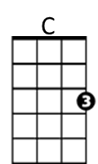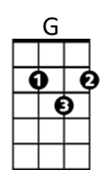**Let Your Love Flow**

**Intro: Chords for last 3 lines of chorus**

**C**

There's a reason for the sunshiny sky

There's a reason why I'm, feeling so high

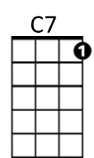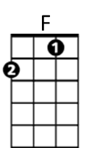 **G C**

Must be the season when those love lights shine all around us

So let that feeling grab you deep inside

And send you reeling where your love can't hide

**G C C7**

And then go stealing through the moonlit night with your lover

**Chorus:**

**F**

Just let your love flow like a mountain stream

**C**

And let your love grow with the smallest of dreams

**G C C7**

And let your love show and you'll know what I mean- it's the season

**F**

Let your love fly like a bird on the wing

**C**

And let your love bind you to all living things

**G C**

And let your love shine and you'll know what I mean- that's the reason

**BARITONE**

**C**



C7



F

C



G

There's a reason for the warm sweet nights

And there's a reason for the candle lights

**G C**

Must be the season when those love lights shine all around us

So let that wonder take you into space

And lay you under its loving embrace

**G C C7**

Just feel the thunder as it warms your face- you can't hold back

(**CHORUS TWICE AND FADE)**

**Love Will Keep Us Alive (Eagles)**

**Written by Pete Vale, Jim Capaldi & Paul Carrack**

**Key C**

**Intro.: C Am F G**



Am



C



G

**C Am**

I was standin' all alone against the world outside

**F G**

You were searchin' for a place to hide

**C Am**



Dm

F



Lost and lonely, now you've given me the will to survive

**F G C**

When we're hungry, love will keep us a-live

**C Am**

Don't you worry sometimes you've just gotta let it ride

**F G**

The world is changin' right before your eyes

**C Am**

Now I've found you, there's no more empti-ness inside

**F G C**

When we're hungry, love will keep us a-live

**Chorus:**

**F Am**

**BARITONE**

I would die for you, climb the highest mountain

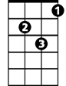

Dm



F



G

C



Am

**Dm G**

Baby, there's nothin' I wouldn't do

**C Am**

Now I've found you, there's no more empti-ness inside

**F G C**

When we're hungry, love will keep us a-live

**(Chorus)**

**Repeat first verse**

**(Ending)**

**F G C**

When we're hungry, love will keep us a-live

**F G C**

When we're hungry, love will keep us a-live

**Save The Last Dance For Me** (Doc Pomus and Mort Shuman)

**Intro: Chords for Chorus**

**C G**

You can dance, every dance with the guy who gives you the eye, let him hold you tight

**C**

********You can smile ~ every smile for the man who held your hand 'neath the pale moonlight,

But

**Chorus:**

**F C**

Don't forget who's taking you home and in whose arms you're gonna be ~~

**G C**

So darling, save the last dance for me



G

C



F

**BARITONE**

**C G**

Oh I know ~ that the music's fine like sparkling wine, Go and have your fun

**C**

Laugh and sing ~ but while we're apart, Don't give your heart to anyone, and

**(CHORUS)**

**C G C**

Baby don't you know I love you so - Can't you feel it when we touch

**G C**

I will never never let you go - Cause I love you oh so much

**C G**

You can dance ~ go and carry on, till the night is gone and it's time to go

**C**

If he asks ~ if you're all alone can he take you home, you must tell him no, and

**(CHORUS)**

**ending:**

**G C (2x)**

So darling, save the last dance for me

**Sloop John B (Traditional)**



C

F



Am



G



G7



C7

**C F C F C**

We come on the sloop John B, my grandfather and me

**Am G**

Around Nassau town we did roam

**C C7 F**

Drinking all night, got into a fight

**C G C**

I feel so broke up, I want to go home

**Chorus:**

**C F C F C**

So hoist up the John B's sail, see how the mainsail sets

**Am G G7**

Call for the Captain ashore, let me go home

**C C7 F**

Let me go home, I wanna go home,

**C G C**

I feel so broke up, I wanna go home

**C F C F C**

The first mate he got drunk and broke in the cap'n's trunk

**Am G**

The constable had to come and take him a-way

C



F



G



Am



G7



C7

**C C7 F**

**BARITONE**

Sheriff, John Stone, why don't you leave me a-lone

**C G C**

Well, I feel so broke up, I wanna go home

**(Chorus)**

**C F C F C**

The poor cook he caught the fits, threw away all my grits

**Am G**

Then he took and he ate up all of my corn

**C C7 F**

Let me go home, why don't they let me go home,

**C G C**

This is the worst trip I've ever been on

**(Chorus)**

**C G C**

This is the worst trip I've ever been on

**C G C**

This is the worst trip I've ever been on