**The U.S. Air Force (The Air Force Song) (Capt. Robert Crawford) Key C**

**C G C**

Off we go into the wild blue yonder,

**F C G**

Climbing high into the sun

**C G C**

Here they come zooming to meet our thunder,

**D G**

At 'em boys, Give 'er the gun!

**C G C**

Down we dive, spouting our flame from under,

**F E7**

Off wi th one hell of a roar!

**Am A Dm D7**

We live in fame or go down in flame,

**C G C G**

Nothing can stop the U.S. Air Force!

**C G C**

Minds of men fashioned a crate of thunder,

**F C G**

Sent it high into the blue

**C G C**

Hands of men blasted the world asunder;

**D G**

How they lived God only knew! (God only knew!)

**C G C**

Souls of men dreaming of skies to conquer,

**F E7**

Gave us wings, ever to soar!

**Am A Dm D7**

With scouts before and bombers galore,

**C G C G**

Nothing will stop the U.S. Air Force!

E7

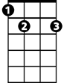

D

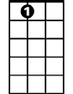

E7



F

C



G

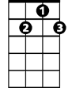

D7

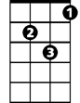

Dm

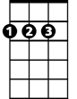

A

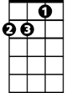

Am

**BARITONE**

**C G C**

Here's a toast to the host of those who

**F C G**

Love the vastness of the sky,

**C G C**

To a friend we send a message of his

**D G**

Brother men who fly.

**C G C**

We drink to those who gave their all of old, then,

**F E7**

Down we roar to score the rainbow's pot of gold.

**Am A Dm D7**

A toast to the host of men we boast,

**C D C G**

the U.S. Air Force!

**C G C**

Off we go into the wild sky yonder,

**F C G**

Keep the wings level and true;

**C G C**

If you'd live to be a grey-haired wonder

**D G**

Keep the nose out of the blue!

**C G C**

Flying men, guarding the nation's border,

**F E7**

We'll be there, followed by more!

**Am A Dm D7**

In ech-e-lon we carry on.

**C G C**

Nothing will stop the U.S. Air Force!

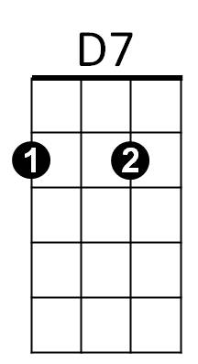

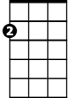

Am

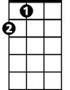

A



Dm



G

F



D



C

**The U.S. Air Force (The Air Force Song) (Capt. Robert Crawford) Key G**

**G D G**

Off we go into the wild blue yonder,

**C G D**

Climbing high into the sun

**G D G**

Here they come zooming to meet our thunder,

**A D**

At 'em boys, Give 'er the gun!

**G D G**

Down we dive, spouting our flame from under,

**C B7**

Off with one hell of a roar!

**Em E Am A7**

We live in fame or go down in flame,

**G D G D**

Nothing can stop the U.S. Air Force!

**G D G**

Minds of men fashioned a crate of thunder,

**C G D**

Sent it high into the blue

**G D G**

Hands of me n blasted the world asunder;

**A D**

How they lived God only knew! (God only knew!)

**G D G**

Souls of men dreaming of skies to conquer,

**C B7**

Gave us wings, ever to soar!

**Em E Am A7**

With scouts before and bombers galore,

**G D G D**

Nothing will stop the U.S. Air Force!



A



C



D



G

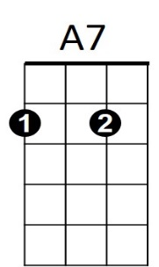

**BARITONE**

B7



Am



A

C



D



G



E



Em

**G D G**

Here's a toast to the host of those who

**C G D**

Love the vastness of the sky,

**G D G**

To a friend we send a message of his

**A D**

Brother men who fly.

**G D G**

We drink to those who gave their all of old, then,

**C B7**

Down we roar to score the rainbow's pot of gold.

**Em E Am A7**

A toast to the host of men we boast,

**G D G D**

the U.S. Air Force!

**G D G**

Off we go into the wild sky yonder,

**C G D**

Keep the wings level and true;

**G D G**

If you'd live to be a grey-haired wonder

**A D**

Keep the nose out of the blue!

**G D G**

Flying men, guarding the nation's border,

**C B7**

We'll be there, followed by more!

**Em E Am A7**

In ech-e-lon we carry on.

**G D G**

Nothing will stop the U.S. Air Force!

Em

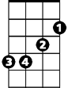

A7



Am

E

