**Ukulele Lady (Richard A. Whiting / Gus Kahn) Key C**

**C G7 C**

I saw the splendor of the moonlight

**Ab7 G7 C**

On Honolu lu Bay

**G7 C**

There something tender in the moonlight

**Ab7 G7 C**

On Honolu lu Bay

**Am**

And all the beaches are full of peaches

**Em**

Who bring their 'ukes' along

**C**

And in the glimmer of the moonlight

**D7 G7**

They love to sing this song

**Chorus:**

**C Em Am G7**

If you like-a Ukulele Lady



C

**C Em Am C**

Ukulele Lady like-a you

**Dm G7 Dm G7**

If you like to linger where it's shady

**Dm G7 C**

Ukulele Lady linger too

**Em Am G7**

If you kiss a Ukulele Lady

**C Em Am C**

While you promise ever to be true

**Dm G7 Dm G7**

And she see another Ukulele

**Dm G7 C**

**BARITONE**

Lady fool around with you

**F C**

Maybe she'll sigh, maybe she'll cry

**D7 G G7**

Maybe she'll find somebody else bye and bye

**C Em Am G7**

To sing to When it's cool and shady

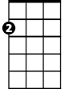

Em

**C Em Am C**

Where the tricky Wiki Wackies woo

**Dm G7 Dm G7**

If you like a Ukulele Lady

**Dm C**

Ukulele Lady like a you

**C G7 C**

She used to sing to me by moonlight

**Ab7 G7 C**

On Honolu lu Bay

**G7 C**

Fond mem'rys cling to me by moonlight

**Ab7 G7 C**

Although I'm far a way

**Am**

Someday I'm going where eyes are glowing

**Em**

And lips are made to kiss

**C**

To see somebody in the moonlight

**D7 G7**

And hear the song I miss

**(CHORUS)**

**Dm C**

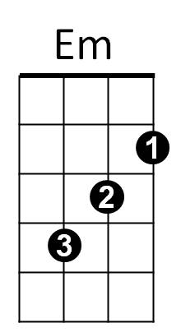Ukulele Lady like a you –oo -oo



Am

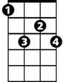

Ab7

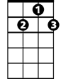

G7

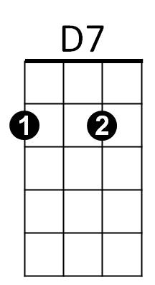



G

F

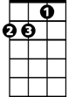

Dm

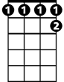

Ab7

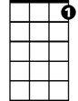

G7

C



Am



D7

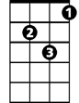

Dm



G



F

**Ukulele Lady (Richard A. Whiting / Gus Kahn) Key F**

**F C7 F**

I saw the splendor of the moonlight

**Db7 C7 F**

On Honolu lu Bay

**C7 F**

There something tender in the moonlight

**Db7 C7 F**

On Honolu lu Bay

**Dm**

And all the beaches are full of peaches

**Am**

Who bring their 'ukes' along

**F**

And in the glimmer of the moonlight

**G7 C7**

They love to sing this song

**Chorus:**

**F Am Dm C7**

If you like-a Ukulele Lady

**F Am Dm F**

Ukulele Lady like-a you

**Gm C7 Gm C7**

If you like to linger where it's shady

**Gm C7 F**

Ukulele Lady linger too

**F Am Dm C7**

If you kiss a Ukulele Lady

**F Am Dm F**

While you promise ever to be true

**Gm C7 Gm C7**

And she see another Ukulele

**Gm C7 F**

Lady fool around with you

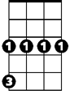

Gm



Am



G7

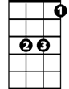

Bb



F

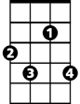

Db7

**BARITONE**

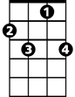

C7

C



**Bb F**

Maybe she'll sigh, maybe she'll cry

**G7 C C7**

Maybe she'll find somebody else bye and bye

**F Am Dm C7**

To sing to when it's cool and shady

**F Am Dm F**

Where the tricky Wiki Wackies woo

**Gm C7 Gm C7**

If you like a Ukulele Lady

**Gm F**

Ukulele Lady like a you

**F C7 F**

She used to sing to me by moonlight

**Db7 C7 F**

On Honolu lu Bay

**C7 F**

Fond mem'rys cling to me by moonlight

**Db7 C7 F**

Although I'm far a way

**Dm**

Someday I'm going where eyes are glowing

**Am**

And lips are made to kiss

**F**

To see somebody in the moonlight

**G7 C7**

And hear the song I miss

**(CHORUS)**

**Gm F**

Ukulele Lady like a you –oo -oo



C7

F



Db7



Dm



Am



Dm



Gm



C



G7



Bb