**Un Poco Loco (Adrian Molina / Germaine Franco) Key C**

**Intro: F C Bb F C F**

Ahhhhhh-ahhoo ayy!

**C F**

What color's the sky?

**C F**

Ay, mi amor, ay, mi amor

**C F**

You tell me that it's red,

**C F**

Ay, mi amor, ay, mi amor

**C F**

Where should I put my shoes?

**C F**

Ay , mi amor, ay, mi amor

**C F**

You say, "put them on your head!"

**C F**

Ay, mi amor, ay, mi amor

**Chorus:**

**Bb**

You make me un poco loco,

**C F**

Un poquititito loco

**Bb**

The way you keep me guessing,

**C F**

I'm nodding and I’m yessing

**C**

I'll count it as a blessing

**Bb C F D7**

That I'm only - un poco loco

**BARITONE**

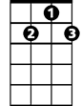

D7



F

C

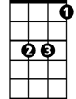

Bb

**G C**

The loco that you make me

**D G**

It is just un poco crazy

**C**

The sense that you're not making

**D G**

The liberties you're taking

**D**

Leaves my cabeza shaking

**C D G**

You're just - un poco loco

**(4X) G C**

He's just un poco crazy

**D G**

Leaves my cabeza shaking

**Ending:**

**G C D G**

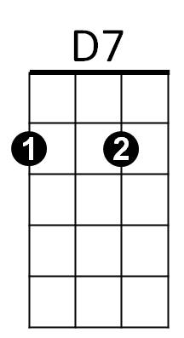Un poquitititi titi titi titi tititito loco

F



Bb



C

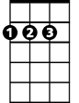

D



G



G



D

**Un Poco Loco (Adrian Molina / Germaine Franco) Key G**

**Intro: C G F C G C**

Ahhhhhh-ahhoo ayy!

**G C**

What color's the sky?

**G C**

Ay, mi amor, ay, mi amor

**G C**

You tell me that it's red,

**G C**

Ay, mi amor, ay, mi amor

**G C**

Where should I put my shoes?

**G C**

Ay, mi amor, ay, mi amor

**G C**

You say, "put them on your head!"

**G C**

Ay, mi amor, ay, mi amor

**Chorus:**

**F**

You make me un poco loco,

**G C**

Un poquititito loco

**F**

The way you keep me guessing,

**G C**

I'm nodding and I’m yessing

**G**

I'll count it as a blessing

**F G C A7**

That I'm only - un poco loco

**D G**

The loco that you make me

**A D**

It is just un poco crazy

**G**

The sense that you're not making

**A D**

The liberties you're taking

**A**

Leaves my cabeza shaking

**G A D**

You're just - un poco loco

**(4X) D G**

He's just un poco crazy

**A D**

Leaves my cabeza shaking

**Ending:**

**D G A D**

Un poquitititi titi titi titi tititito loco



D

F



G

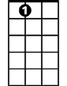

A7



C

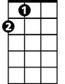

A



D

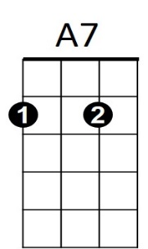

**BARITONE**



G



F



A

C

