Unchained Melody (Alex North & Hy Zaret, 1955) (A)
Unchained Melody by The Righteous Brothers (solo by Bobby Hatfield) (1965) (C)
2/2 Time – 𐛠 = 100 BPM

Intro A | F#m | D | E |  A F#m D E E7 A  Oh my love my darling. I've hungered for your touch,  F#m E | E7 | A F#m D  A long lonely time. __ And time goes by so slowly  E E7 A F#m C#m7 | E7  And time can do so much. Are you still mine?  A | . . E F#m C#m7  I need your love, I need your love,  Bm | . . E A Amaj7 | A7  God speed your love to me.  Bridge  D E D C  Lonely rivers flow to the sea to the sea,  D E A | A7  To the open arms of the sea ( yeah )  D E D C  Lonely rivers sigh: “Wait for me wait for me;  D E A | A  I'll be coming home, wait for me.”  A F#m D E E7 A  Oh my love my darling. I've hungered for your touch,  F#m E | E7 | A F#m D  A long lonely time. __ Time goes by so slowly,  E E7 A F#m C#m7 | E7  And time can do so much. Are you still mine?  A | . . E F#m C#m7  I need your love, I need your love,  Bm | . . E A | F#m | D | Dm | A  God speed your love to me. |  |  |  |  |  | 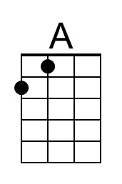 | 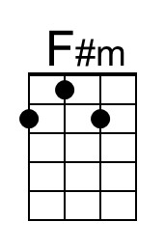
 |  |  |  |  |  | 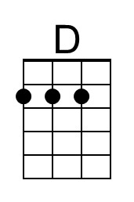 | 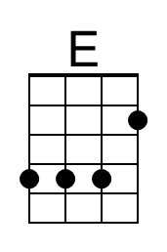
 |  |  |  |  |  | 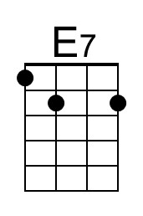 | 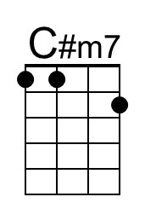
 |  |  |  |  |  | 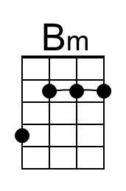 | 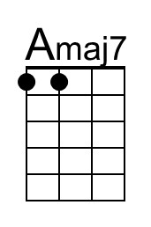
 |  |  |  |  |  | 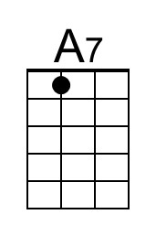 | 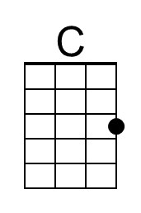
 |  |  |  |  |  | 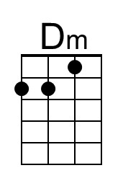
Bari | 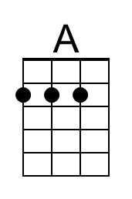 | 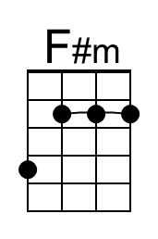 | 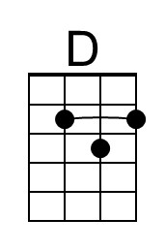 | 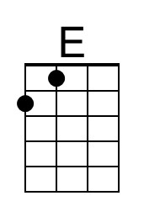 | 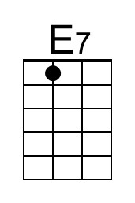
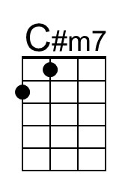 | 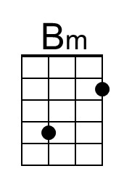 | 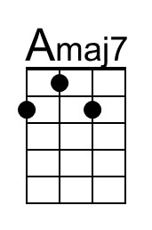 | 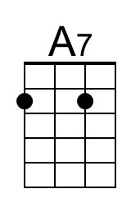 | 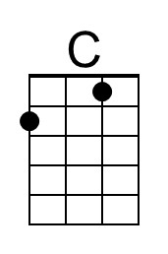 | 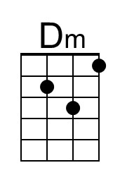

Unchained Melody (Alex North & Hy Zaret, 1955) (C)
Unchained Melody by The Righteous Brothers (solo by Bobby Hatfield) (1965) (C)
2/2 Time – 𐛠 = 100 BPM

Intro C | Am | F | G |  C Am F G G7 C  Oh my love my darling. I've hungered for your touch,  Am G | G7 | C Am F  A long lonely time. __ And time goes by so slowly  G G7 C Am Em7 | G7  And time can do so much. Are you still mine?  C | . . G Am Em7  I need your love, I need your love,  Dm | . . G C Cmaj7 | C7  God speed your love to me.  Bridge  F G F E ♭  Lonely rivers flow to the sea to the sea,  F G C | C7  To the open arms of the sea ( yeah )  F G F E ♭  Lonely rivers sigh: “Wait for me wait for me;  F G C | C  I'll be coming home, wait for me.”  C Am F G G7 C  Oh my love my darling. I've hungered for your touch,  Am G | G7 | C Am F  A long lonely time. __ Time goes by so slowly,  G G7 C Am Em7 | G7  And time can do so much. Are you still mine?  C | . . G Am Em7  I need your love, I need your love,  Dm | . . G C | Am | F | Fm | C  God speed your love to me. |  |  |  |  |  |  | 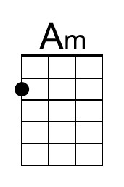
 |  |  |  |  |  | 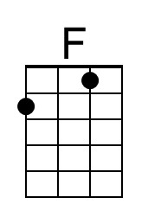 | 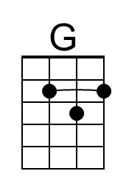
 |  |  |  |  |  | 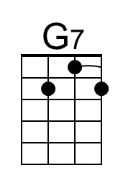 | 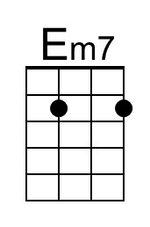
 |  |  |  |  |  |  | 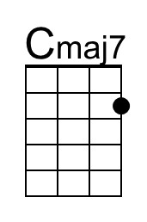
 |  |  |  |  |  | 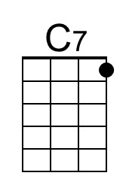 | 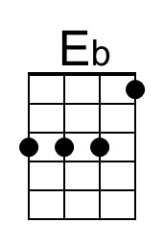
 |  |  |  |  |  | 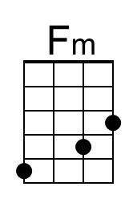
Bari |  | 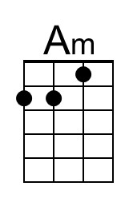 | 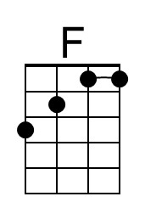 | 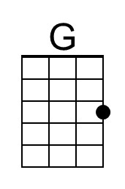 | 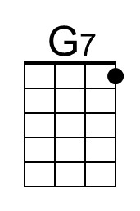
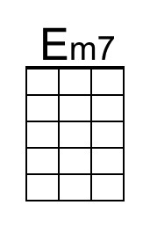 |  | 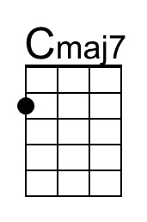 | 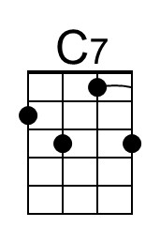 | 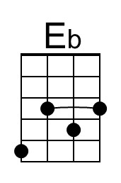 | 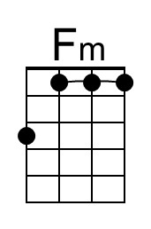

Unchained Melody (Alex North & Hy Zaret, 1955) (D)
Unchained Melody by The Righteous Brothers (solo by Bobby Hatfield) (1965) (C)
2/2 Time – 𐛠 = 100 BPM

Intro D | Bm | G | A |

D Bm G A A7 D
Oh my love my darling. I've hungered for your touch,
Bm A | A7 | D Bm G
A long lonely time. __ And time goes by so slowly
A A7 D Bm F#m7 | A7
And time can do so much. Are you still mine?
D | . . A Bm F#m7
I need your love, I need your love,
Em | . . A D Dmaj7 | D7
God speed your love to me.

Bridge
G A G F
Lonely rivers flow to the sea to the sea,
G A D | D7
To the open arms of the sea ( yeah )
G A G F
Lonely rivers sigh: “Wait for me wait for me;
G A D | D
I'll be coming home, wait for me.”

D Bm G A A7 D
Oh my love my darling. I've hungered for your touch,
Bm A | A7 | D Bm G
A long lonely time. __ Time goes by so slowly,
A A7 D Bm F#m7 | A7
And time can do so much. Are you still mine?
D | . . A Bm F#m7
I need your love, I need your love,
Em | . . A D | Bm | G | Gm | D
God speed your love to me.

 |  |  |  |  |  |  | 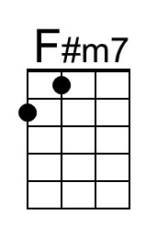
 |  |  |  |  |  | 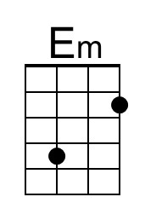 | 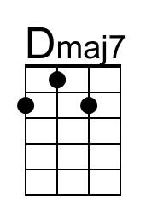
 |  |  |  |  |  | 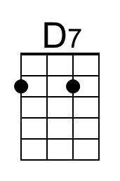 | 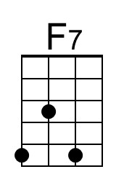
 |  |  |  |  |  | 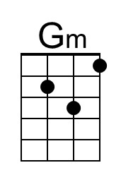
Bari
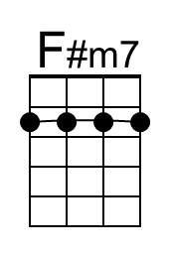 | 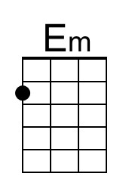 | 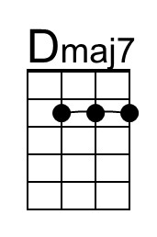 | 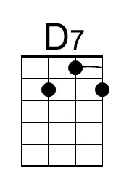 |  | 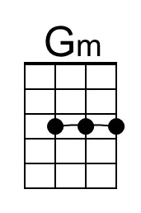

Unchained Melody (Alex North & Hy Zaret, 1955) (F)
Unchained Melody by The Righteous Brothers (solo by Bobby Hatfield) (1965) (C)
2/2 Time – 𐛠 = 100 BPM

Intro F | Dm | B ♭ | C |

F Dm B ♭ C C7 F
Oh my love my darling. I've hungered for your touch,
Dm C | C7 | F Dm B ♭
A long lonely time. __ And time goes by so slowly
C C7 F Dm Am7 | C7
And time can do so much. Are you still mine?
F | . . C Dm Am7
I need your love, I need your love,
Gm | . . C F Fmaj7 | F7
God speed your love to me.

Bridge
B ♭ C B ♭ A ♭
Lonely rivers flow to the sea to the sea,
B ♭ C F | F7
To the open arms of the sea ( yeah )
B ♭ C B ♭ A ♭
Lonely rivers sigh: “Wait for me wait for me;
B ♭ C F | F
I'll be coming home, wait for me.”

F Dm B ♭ C C7 F
Oh my love my darling. I've hungered for your touch,
Dm C | C7 | F Dm B ♭
A long lonely time. __ Time goes by so slowly,
C C7 F Dm Am7 | C7
And time can do so much. Are you still mine?
F | . . C Dm Am7
I need your love, I need your love,
Gm | . . C F | Dm | B ♭ | B ♭m | F
God speed your love to me.

 |  |  |  |  |  | 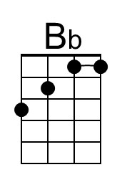
 |  |  |  |  |  |  | 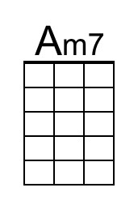
 |  |  |  |  |  |  | 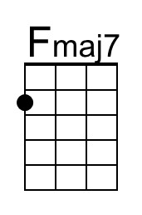
 |  |  |  |  |  |  | 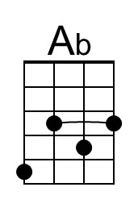
 |  |  |  |  |  | 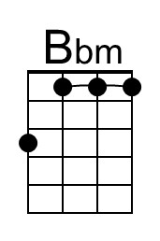
Bari |  |  | 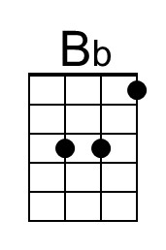
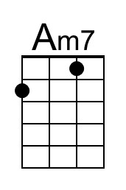 |  | 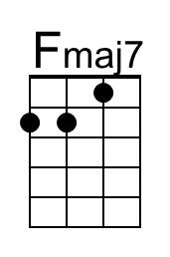 | 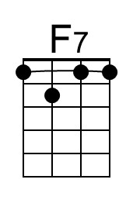 | 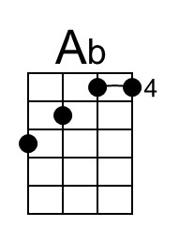 | 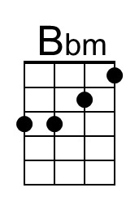

Unchained Melody (Alex North & Hy Zaret, 1955) (G)
Unchained Melody by The Righteous Brothers (solo by Bobby Hatfield) (1965) (C)
2/2 Time – 𐛠 = 100 BPM

Intro G | Em | C | D |

G Em C D D7 G
Oh my love my darling. I've hungered for your touch,
Em D | D7 | G Em C
A long lonely time. __ And time goes by so slowly
D D7 G Em Bm7 | D7
And time can do so much. Are you still mine?
G | . . D Em Bm7
I need your love, I need your love,
Am | . . D G Gmaj7 | G7
God speed your love to me.

Bridge
C D C B ♭
Lonely rivers flow to the sea to the sea,
C D G | G7
To the open arms of the sea ( yeah )
C D C B ♭
Lonely rivers sigh: “Wait for me wait for me;
C D G | G
I'll be coming home, wait for me.”

G Em C D D7 G
Oh my love my darling. I've hungered for your touch,
Em D | D7 | G Em C
A long lonely time. __ Time goes by so slowly,
D D7 G Em Bm7 | D7
And time can do so much. Are you still mine?
G | . . D Em Bm7
I need your love, I need your love,
Am | . . D G | Em | C | Cm | G
God speed your love to me.

 |  |  |  |  |  |  | 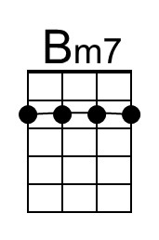
 |  |  |  |  |  |  | 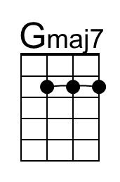
 |  |  |  |  |  | 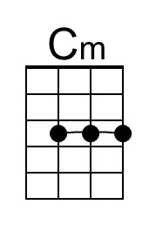
Bari
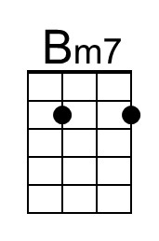 |  | 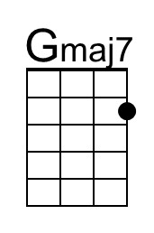 |  |  | 