Under the Boardwalk (Kenny Young & Arthur Resnick, 1964) (C)
Under the Boardwalk by The Drifters

Intro (4 Measures) C | G | C | G  C G  Oh when the sun beats down and burns the tar up on the roof  G7 C C7  And your shoes get so hot you wish your tired feet were fire-proof  F C  Under the boardwalk, down by the sea  G C  On a blanket with my baby is where I'll be  Chorus  Am  Under the boardwalk, out of the sun  G  Under the boardwalk, we'll be having some fun  Am  Under the boardwalk, people walking above  G  Under the boardwalk, we'll be falling in love  Am  Under the board-walk, board-walk  C G  From the park we hear the happy sound of a carousel  G7 C C7  You can almost taste the hot dogs and french fries they sell  F C  Under the boardwalk, down by the sea  G C  On a blanket with my baby is where I'll be. Chorus  F C  Under the boardwalk, down by the sea  C G C  On a blanket with my baby is where I'll be. Chorus |  |  |  |  |  |  | 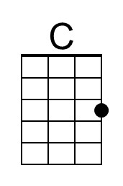
 |  |  |  |  |  |  | 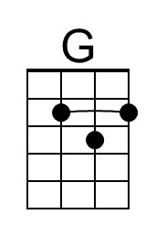
 |  |  |  |  |  |  | 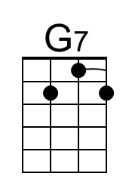
 |  |  |  |  |  |  | 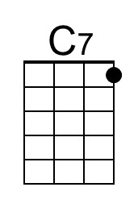
 |  |  |  |  |  |  | 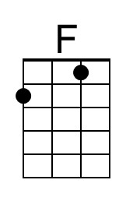
 |  |  |  |  |  |  | 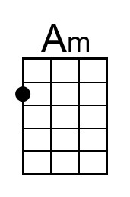
Bari | 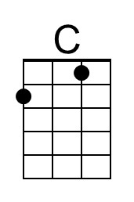 | 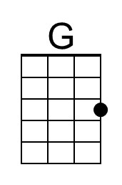 | 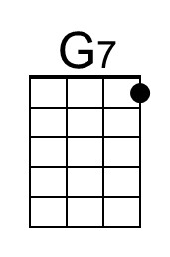 | 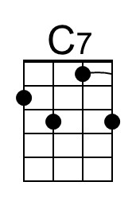 | 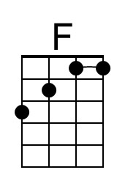 | 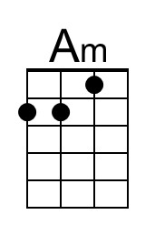

Under the Boardwalk (Kenny Young & Arthur Resnick, 1964) (G)
Under the Boardwalk by The Drifters

Intro (4 Measures) G | D | G | D

G D
Oh when the sun beats down and burns the tar up on the roof
D7 G G7
And your shoes get so hot you wish your tired feet were fire-proof
C G
Under the boardwalk, down by the sea
D G
On a blanket with my baby is where I'll be

Chorus
Em
Under the boardwalk, out of the sun.
D
Under the boardwalk, we'll be having some fun
Em
Under the boardwalk, people walking above
D
Under the boardwalk, we'll be falling in love
Em
Under the board-walk, board-walk

G D
From the park we hear the happy sound of a carousel
D7 G G7
You can almost taste the hot dogs and french fries they sell
C G
Under the boardwalk, down by the sea
D G
On a blanket with my baby is where I'll be. Chorus

C G
Under the boardwalk, down by the sea
G D G
On a blanket with my baby is where I'll be. Chorus

 |  |  |  |  |  |  | 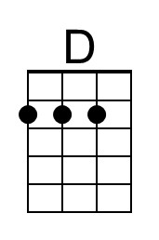
 |  |  |  |  |  |  | 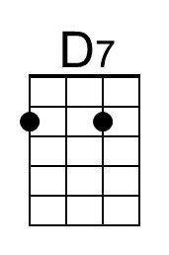
 |  |  |  |  |  |  | 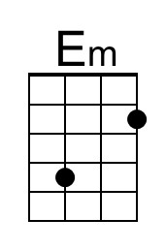
Bari |  | 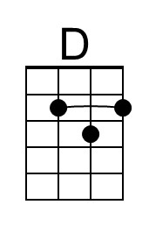 | 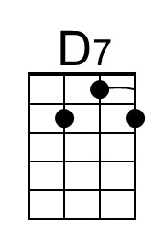 |  |  | 