**Under the Boardwalk (The Drifters)**

**C G**

Oh when the sun beats down and burns the tar up on the roof

**G7 C C7**

And your shoes get so hot you wish your tired feet were fire-proof

**F C**

Under the boardwalk, down by the sea



C

F



G

**G C**

On a blanket with my baby is where I'll be

**Chorus:**

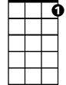

C7

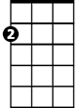

Am

**Am**

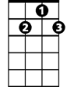

G7

Under the boardwalk, out of the sun

**G**

Under the boardwalk, we'll be having some fun

**Am**

Under the boardwalk, people walking above

**G**

Under the boardwalk, we'll be falling in love

**Am**

Under the board-walk, board-walk

**C G**

From the park we hear the happy sound of a carousel

**G7 C C7**

You can almost taste the hot dogs and french fries they sell

**F C**

Under the boardwalk, down by the sea

**G C**

**BARITONE**

C



G



F

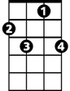

C7



G7

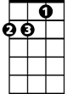

Am

On a blanket with my baby is where I'll be

**(Chorus)**

**F C**

Under the boardwalk, down by the sea

**C G C**

On a blanket with my baby is where I'll be

**(Chorus)**