Until Its Time For You To Go (Buffy Sainte-Marie) (C)
Until Its Time For You To Go by Buffy Sainte-Marie

Intro C G C G  C Cmaj7 C7 - A7  You're not a dream, you're not an Angel, you're a man  Dm Am/M7 Dm7 - G  I'm not a queen, I'm a woman, take my hand  C Cmaj7 C7 - A7  We'll make a space in the lives that we planned  Dm G C  And here we'll stay until it's time for you to go.  C Cmaj7 C7 - A7  Yes we're different worlds a- part we're not the same  Dm Am/M7 Dm7 G  We laughed and played at the start like in a game  C Cmaj7 C7 - A7  You could have stayed outside my heart but in you came  Dm G C  And here you'll stay until it's time for you to go  Chorus  C# Bb C C# Bb C  _ Don't ask why. _ Don't ask how  E7 A Dm G  Don't ask for-ever, Love me now.  C Cmaj7 C7 - A7  This love of mine had no be-ginning it had no end  Dm Am/M7 Dm7 -G  I was an oak now I'm a willow now I can bend  C Cmaj7 C7 - A7  And though I'll never in my life see you a-gain  Dm G C  Still I'll stay until it's time for you to go. Chorus  Repeat Verse One  Dm G C C# Bb C  And here we'll stay until it's time for you to go. Oooh ooh oohhh. |  |  |  |  |  | 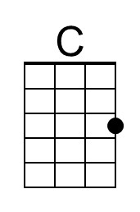 | 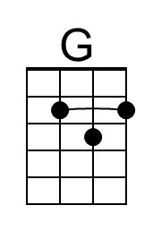
 |  |  |  |  |  | 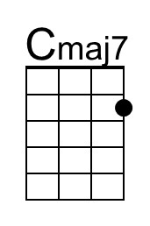 | 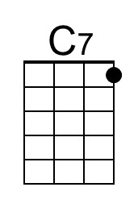
 |  |  |  |  |  | 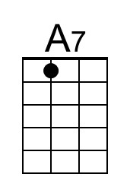 | 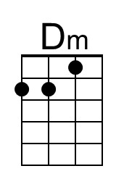
 |  |  |  |  |  | 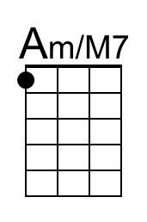 | 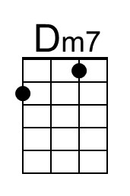
 |  |  |  |  |  | 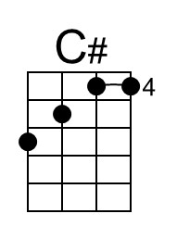 | 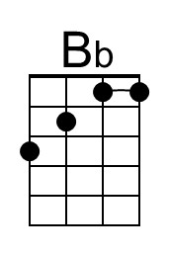
 |  |  |  |  |  | 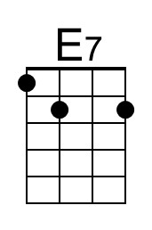 | 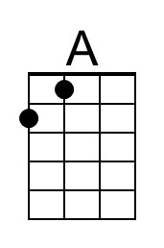
 | Bari | 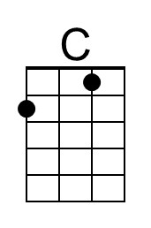 | 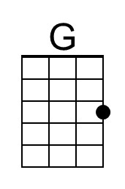 | 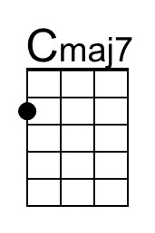 | 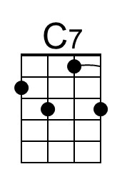 | 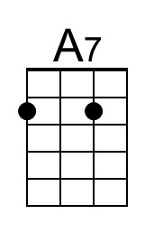 | 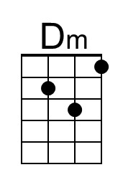
 |  | 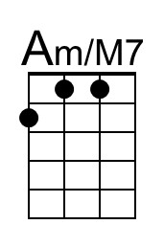 | 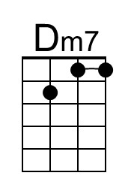 | 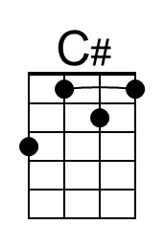 | 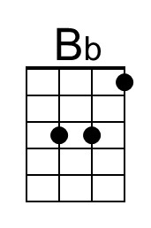 | 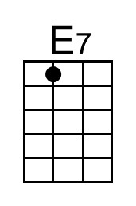 | 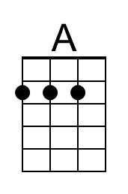

Until Its Time For You To Go (Buffy Sainte-Marie) (G)
Until Its Time For You To Go by Buffy Sainte-Marie

Intro G D G D  G Gmaj7 G7 - E7  You're not a dream, you're not an Angel, you're a man  Am Em/M7 Am7 - D  I'm not a queen, I'm a woman, take my hand  G Gmaj7 G7 - E7  We'll make a space in the lives that we planned  Am D G  And here we'll stay until it's time for you to go.  G Gmaj7 G7 - E7  Yes we're different worlds a- part we're not the same  Am Em/M7 Am7 D  We laughed and played at the start like in a game  G Gmaj7 G7 - E7  You could have stayed outside my heart but in you came  Am D G  And here you'll stay until it's time for you to go  Chorus  Ab F G Ab F G  _ Don't ask why. _ Don't ask how  B7 E Am D  Don't ask for-ever, Love me now.  G Gmaj7 G7 - E7  This love of mine had no be-ginning it had no end  Am Em/M7 Am7 -D  I was an oak now I'm a willow now I can bend  G Gmaj7 G7 - E7  And though I'll never in my life see you a-gain  Am D G  Still I'll stay until it's time for you to go. Chorus  Repeat Verse One  Am D G Ab F G  And here we'll stay until it's time for you to go. Oooh ooh oohhh. |  |  |  |  |  |  | 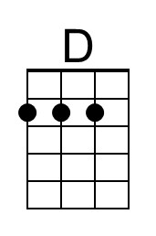
 |  |  |  |  |  | 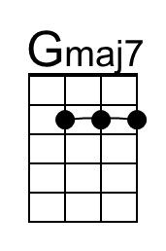 | 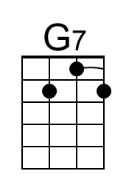
 |  |  |  |  |  |  | 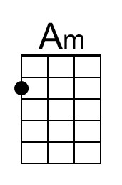
 |  |  |  |  |  | 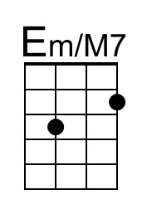 | 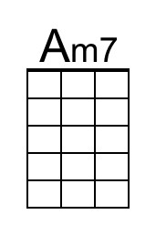
 |  |  |  |  |  | 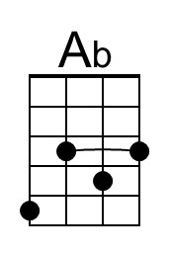 | 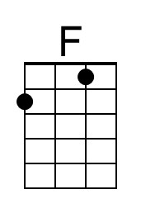
 |  |  |  |  |  | 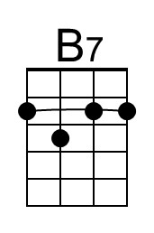 | 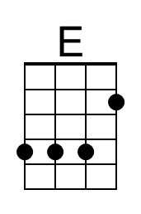
 | Bari |  | 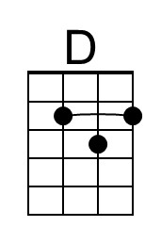 | 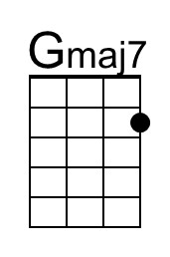 | 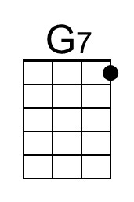 |  | 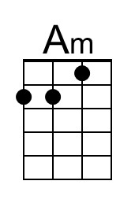
 |  | 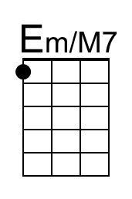 | 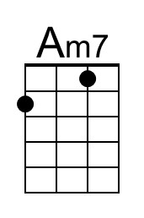 | 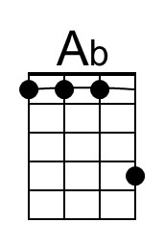 | 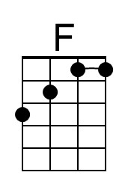 | 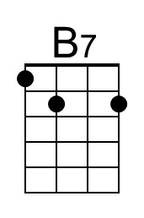 | 