
Up on the Housetop
C35 C
(Benjamin Hanby, 1864) – Up On The Housetop by Gene Autry (1953)

Intro Last 2 lines of Chorus  C  Up on the house top reindeer paused  F C G  Out jumps good old Santa Claus  C  Down through the chimney with lots of toys  F C G C  All for the little ones’ Christmas joys  Chorus  F C  Ho ho ho, who wouldn't go?  G7 C  Ho ho ho, who wouldn't go?  F  Up on the house top, click click click  C G C  Down through the chimney with good St. Nick.  C  First comes the stocking of little Nell  F C G  Oh dear Santa fill it well.  C  Give her a doll that laughs and cries  F C G C  One that will open and shut her eyes. Chorus  C  Look in the stocking of little Bill.  F C G  Oh just see what a glorious fill.  C  Here is a little hammer and lots of tacks  F C G C  A whistle and a ball and whip that cracks. Chorus (2x)  Outro (Ritard.)  C G C  Down through the chimney with good St. Nick. | 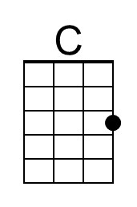 | 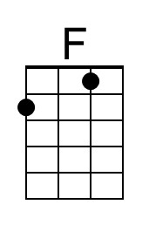
 | 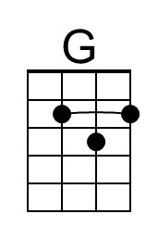 | 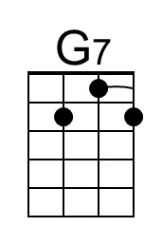
 | Baritone
 | 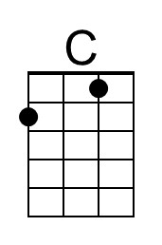 | 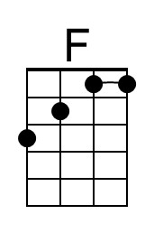
 | 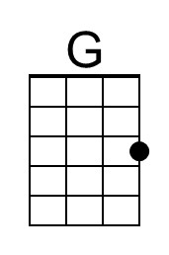 | 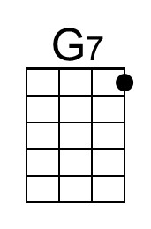

Up on the Housetop
C35 G
(Benjamin Hanby, 1864) – Up On The House Top by Gene Autry (1953)

Intro Last 2 lines of Chorus

G
Up on the house top reindeer paused
C G D
Out jumps good old Santa Claus
G
Down through the chimney with lots of toys
C G D G
All for the little ones’ Christmas joys

Chorus
C G
Ho ho ho, who wouldn't go?
D7 G
Ho ho ho, who wouldn't go?
C
Up on the house top, click click click
G D G
Down through the chimney with good St. Nick.

G
First comes the stocking of little Nell
C G D
Oh dear Santa fill it well.
G
Give her a doll that laughs and cries
C G D G
One that will open and shut her eyes. Chorus

G
Look in the stocking of little Bill.
C G D
Oh just see what a glorious fill.
G
Here is a little hammer and lots of tacks
C G D G
A whistle and a ball and whip that cracks. Chorus (2x)

Outro (Ritard.)
G D G
Down through the chimney with good St. Nick.
 | 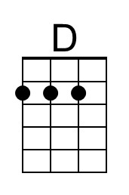 | 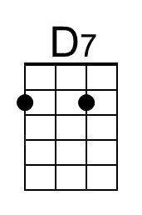
 | Baritone
 | 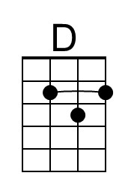 | 