**Venus in Blue Jeans (Howard Greenfield / Jack Keller) Key C**

**C Em Dm G / C Em Dm G**



C

Em

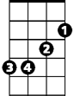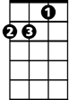

Dm

**C Em**

She's Venus in blue jeans,

**Dm G C**

Mona Lisa with a ponytail

**Dm G Em Am**

She's a walking talking work of art,



G

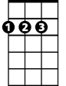

D

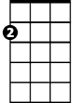

Am

**D G**

She's the girl who stole my heart

**C Em**

My Venus in blue jeans,

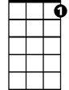

C7

F



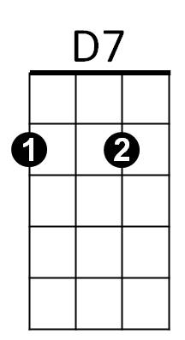 **Dm G C**

Is th e Cinderella I a - dore

**Dm G Em Am**

She's my very special angel too,

**Dm G C C7**

A fairy tale come true

**F Em**

They say there's sev en wonders in the world,

**Dm G C C7**

**BARITONE**

But what they say is out of date



F

C



Em

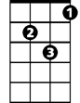

Dm



G



Am



D

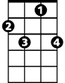

C7

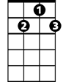

D7

**F Em**

There's more seven wonders in the world,

**D D7 G**

I just met number eight

**(2X) EXTEND LAST LINE AT END)**

**C Em**

My Venus in blue jeans,

**Dm G Em**

Is everything I hoped she'd be

**Dm G Em A**

A teenage goddess from above,

**Dm G G7 C**

And she belongs to me

**C Em Dm G / C Em Dm G**

**Venus in Blue Jeans (Howard Greenfield / Jack Keller) Key F**

**F Am Gm C / F Am Gm C**



Gm

F



Am

**F Am**

She's Venus in blue jeans,

**Gm C F**

Mona Lisa with a ponytail

**Gm C Am Dm**



C



Dm



G

She's a walking talking work of art,

**G C**

She's the girl who stole my heart

**F Am**

My Venus in blue jeans,



Bb



F7



G7

**Gm C F**

Is the Cinderella I a - dore

**Gm C Am Dm**

She's my very special angel too,

**Gm C F F7**

A fairy tale come true

**Bb Am**

They say there's seven wonders in the world,

**Gm C F F7**

**BARITONE**

But what they say is out of date



G7

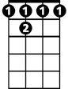

F 7



G



Dm



Am



F

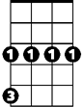

Gm

C

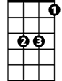

Bb

**Bb Am**

There's more seven wonders in the world,

**G G7 C**

I just met number eight

**(2X) EXTEND LAST LINE AT END)**

**F Am**

My Venus in blue jeans,

**Gm C Am**

Is everything I hoped she'd be

**Gm C Am D**

A teenage goddess from above,

**Gm C C7 F**

And she belongs to me

**F Am Gm C / F Am Gm C**

**Venus in Blue Jeans (Howard Greenfield / Jack Keller) Key G**

**G Bm Am D / G Bm Am D**

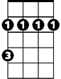

Bm



G



Am

**G Bm**

She's Venus in blue jeans,

**Am D G**

Mona Lisa with a ponytail

**Am D Bm Em**

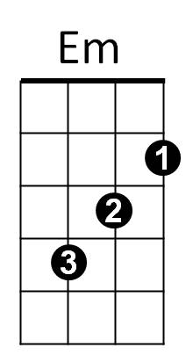She's a walking talking work of art,

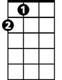

A



D

**A D**

She's the girl who stole my heart

**G Bm**

My Venus in blue jeans,

**Am D G**



C

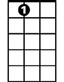

A7



G7

Is the Cinderella I a - dore

**Am D Bm Em**

She's my very special angel too,

**Am D G G7**

A fairy tale come true

**C Bm**

They say there's seven wonders in the world,

**BARITONE**

**Am D G** **G7**

Bm



Am



G

But what they say is out of date

**C Bm**

There's more seven wonders in the world,

**A A7 D**

I just met number eight



A



Em



D

**(2X) EXTEND LAST LINE AT END)**

**G Bm**

My Venus in blue jeans,

**Am D Bm**

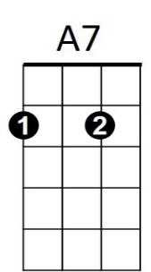Is everything I hoped she'd be



G7

C



**Am D Bm E**

A teenage goddess from above,

**Am D D7 G**

And she belongs to me

**G Bm Am D / G Bm Am D**