Wagon Wheels (Billy Hill & Peter Derose) (C)
Recorded by Sons Of The Pioneers

C G7  Wagon wheels (rollin' rollin' rollin') wagon wheels  C C#dim7 G7  Keep on a-turnin' (turnin') wagon wheels  C G7  Roll along (rollin' rollin' rollin') sing your song  C G7 C  Carry me over the hill (carry me over the hill)  C - F C F C  Roll on mule there's a steamer at the landin'  F C G7  Waitin' for this cotton to load  C F C F C  Roll on mule the boss is under- standin'  Am D7 G7  There's a pasture at the end of each road  C G7  Wagon wheels (rollin' rollin' rollin') wagon wheels  C C#dim7 G7  Keep on a-turnin' (turnin') wagon wheels  C F Fm  Roll along sing your song  C G7 Am F G7 C F C E7  Wag-on wheels carry me ho-o-o-o-ome  F G7 C  Wagon wheels carry me home  F C  (Wagon wheels carry me home) |  |  |  |  |  |  | 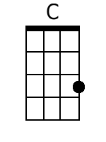 | 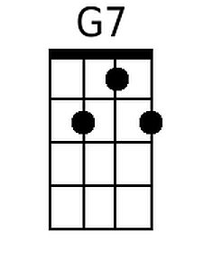
 |  |  |  |  |  |  | 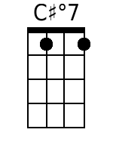 | 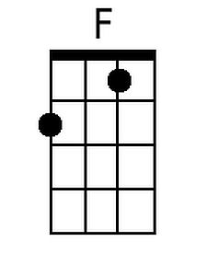
 |  |  |  |  |  |  | 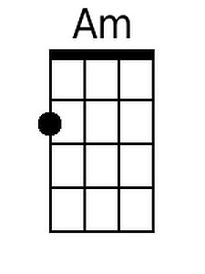 | 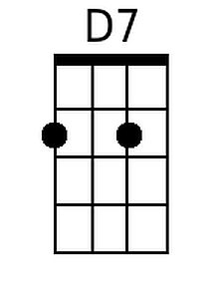
 |  |  |  |  |  |  | 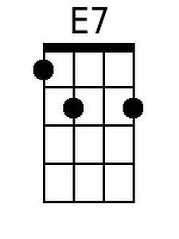 | 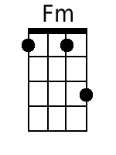
Baritone
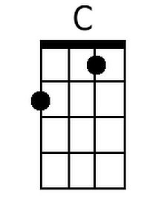 | 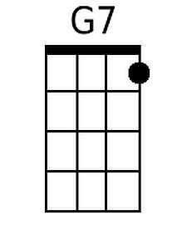 | 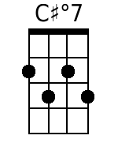 | 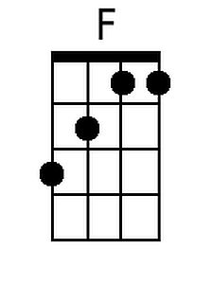 | 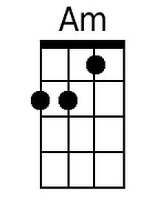 | 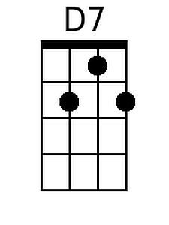 | 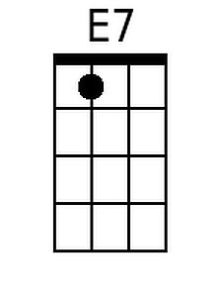 |  | 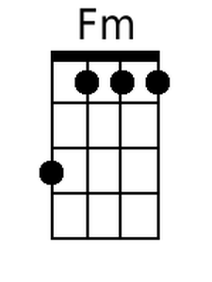

Wagon Wheels by Sons of the Pioneers (1)
Wagon Wheels by Sons of the Pioneers (2)
Wagon Wheels by Eddy Arnold
Wagon Wheels (Billy Hill & Peter Derose) (G)
Recorded by Sons Of The Pioneers

G D7  Wagon wheels (rollin' rollin' rollin') wagon wheels  G G#dim7 D7  Keep on a-turnin' (turnin') wagon wheels  G D7  Roll along (rollin' rollin' rollin') sing your song  G D7 G  Carry me over the hill (carry me over the hill)  G - C G C G  Roll on mule there's a steamer at the landin'  C G D7  Waitin' for this cotton to load  G C G C G  Roll on mule the boss is under- standin'  Em A7 D7  There's a pasture at the end of each road  G D7  Wagon wheels (rollin' rollin' rollin') wagon wheels  G G#dim7 D7  Keep on a-turnin' (turnin') wagon wheels  G C Cm  Roll along sing your song  G D7 Em C D7 G C G B7  Wag-on wheels carry me ho-o-o-o-ome  C D7 G  Wagon wheels carry me home  C G  (Wagon wheels carry me home) |  |  |  |  |  |  | 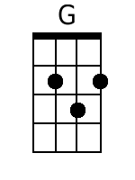
 |  |  |  |  |  |  | 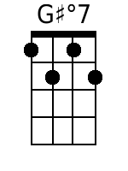
 |  |  |  |  |  |  | 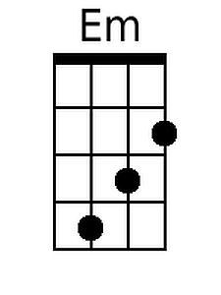 |  | 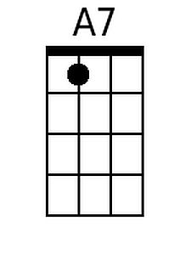
 |  |  |  |  |  |  | 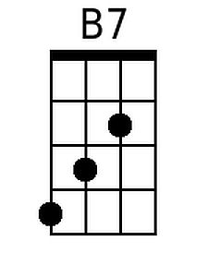 |  | 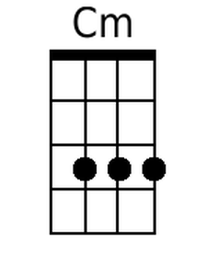
Baritone
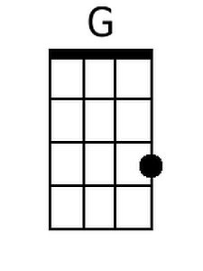 |  | 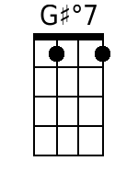 |  | 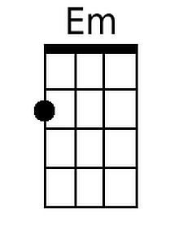 | 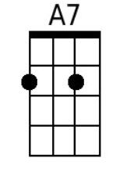 | 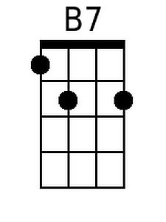 |  | 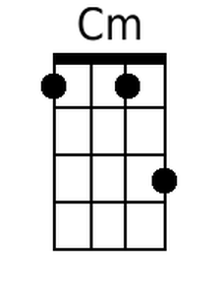

Wagon Wheels by Sons of the Pioneers (1)
Wagon Wheels by Sons of the Pioneers (2)
Wagon Wheels by Eddy Arnold

