Wagon Wheels
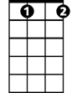
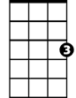
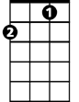
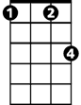
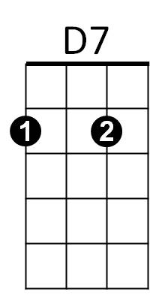
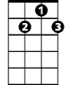
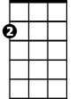
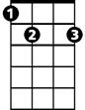
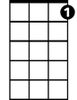
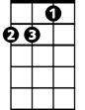
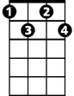
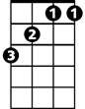
Recorded by Sons Of The Pioneers / Written by Billy Hill and Peter Derose
C G7
Wagon wheels (rollin' rollin' rollin') wagon wheels
C C#dim G7
Keep on a-turnin' (turnin') wagon wheels
C G7
Roll along (rollin' rollin' rollin') sing your song
C G7 C
Carry me over the hill (carry me over the hill)
C - F C F C
Roll on mule there's a steamer at the landin'
F C G7
Waitin' for this cotton to load
C F C F C
Roll on mule the boss is under- standin'
Am D7 G7
There's a pasture at the end of each road
C G7
Wagon wheels (rollin' rollin' rollin') wagon wheels
C C#dim G7
Keep on a-turnin' (turnin') wagon wheels
C F Fm
Roll along sing your song
C G7 Am F G7 C F C E7
Wag-on wheels carry me ho-o-o-o-ome
F G7 C
Wagon wheels carry me home
F C
(Wagon wheels carry me home)
C#dim
C
F
Fm
G7
Am
E7
G7
Am
C
Cdim
D7
F
BARITONE
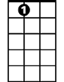
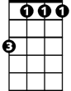
E7
Fm

(chords from https://www.classic-country-song-lyrics.com/wagonwheelslyricschords.html)

Sons of the Pioneers
https://www.youtube.com/watch?v=-oZg1ku6zzY
https://www.youtube.com/watch?v=Ral9IZVKVrE
This big band version has a lead-in intro verse
Singing doesn’t start until 1:15

Trains rushing here and there
Flying machines flashing through the air
Automobiles all shiny and new
For folks with nothin’ else to do
But when I want to travel to the soil I cling
I climb on my wagon and sing

Eddy Arnold version
https://www.youtube.com/watch?v=duZwkeO7Sv8

