Wagoner's Song
Subtitle: Land of the Sacramento
Words: Randy Sparks
Music and Arrangements: Ralph Grasso & Art Podell
Key of C (Original Key of G). 3/4 Time. "With A Steady Beat."
Ukulele.
Wagoner's Song
Subtitle: Land of the Sacramento
Words: Randy Sparks
Music and Arrangements: Ralph Grasso & Art Podell
Key of C (Original Key of G). 3/4 Time. "With A Steady Beat." Ukulele.

GCEA  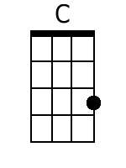  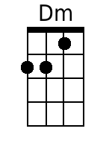  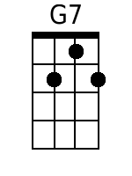  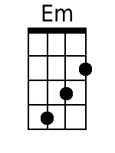  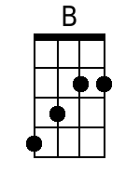  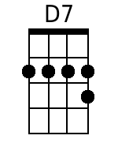  Bari  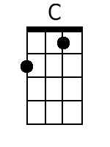  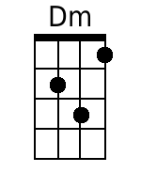  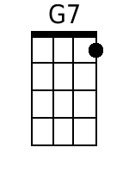  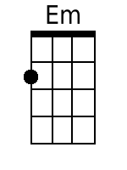  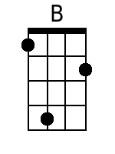  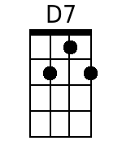 | Four measure introduction.  [No chords indicated … C Dm C Dm would fit]  C Dm C Dm  1. Far a-cross the wild country a-way,  C Dm C Dm  Come a-long.  G7 C Em  Hi up! Oh, Su-san-nah,  B D7 G7  We're leavin' to-day  Em  We'll cross the wide prairie,  B D7 G7  Through the mountains we'll go;  C Dm C Dm C Dm  And we're bound for the land of the Sacramento.  C Dm C Dm  2. There's a new land of treasures un-told,  C Dm C Dm  Come a-long.  G7 C Em  I've seen her green valleys,  B D7 G7  Her rivers of gold.  Em  The wagons are ready,  B D7 G7  We're anxious to go;  C Dm C Dm C Dm  And we're bound for the land of the Sacramento.  C Dm C Dm  3. Oo (instrumental first line - 3 2/3 measures)  C Dm C Dm  Come a-long;  G7 C Em  Oo (instrumental third line - 3 2/3 measures)  B D7 G7  Oo (instrumental fourth line - 3 2/3 measures)  Em  We'll cross the wide prai-rie,  B D7 G7  Through the mountains we'll go;  C Dm C Dm C Dm  Yes, we're bound for the land of the Sacramento.  Instrumental Exit:  C . . . Dm . . . C . . . Dm . . .  [Four measure instrumental]  C . . . Dm . . . C . . . Dm . . .  [Four measure instrumental]  C . . . Dm . . . C . . . Dm . . .  [Four measure instrumental]  C . . . Dm . . . C . . . Dm . . .  [Four measure instrumental]  [Fade out on repeat]

